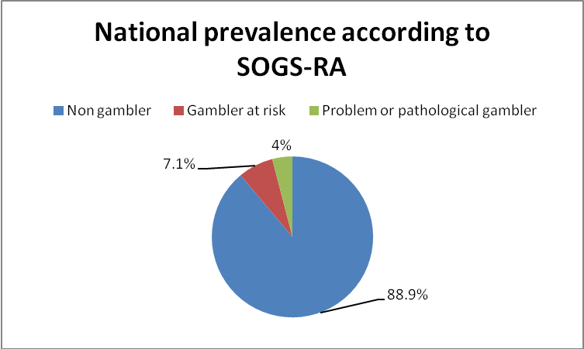
Fig1. Problem and pathological gambling according to answers given at SOGS-RA

