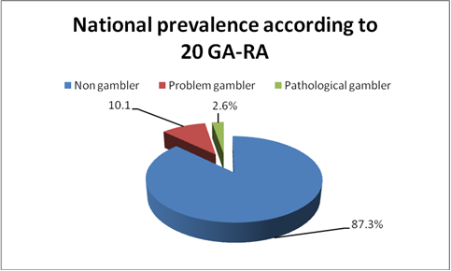
Fig2. Prevalence of problem and pathological gambling according to answers at 20 GA-RA

