Hemodynamic monitoring using thoracic bioimpedance – a optim solution for treatment hypertension

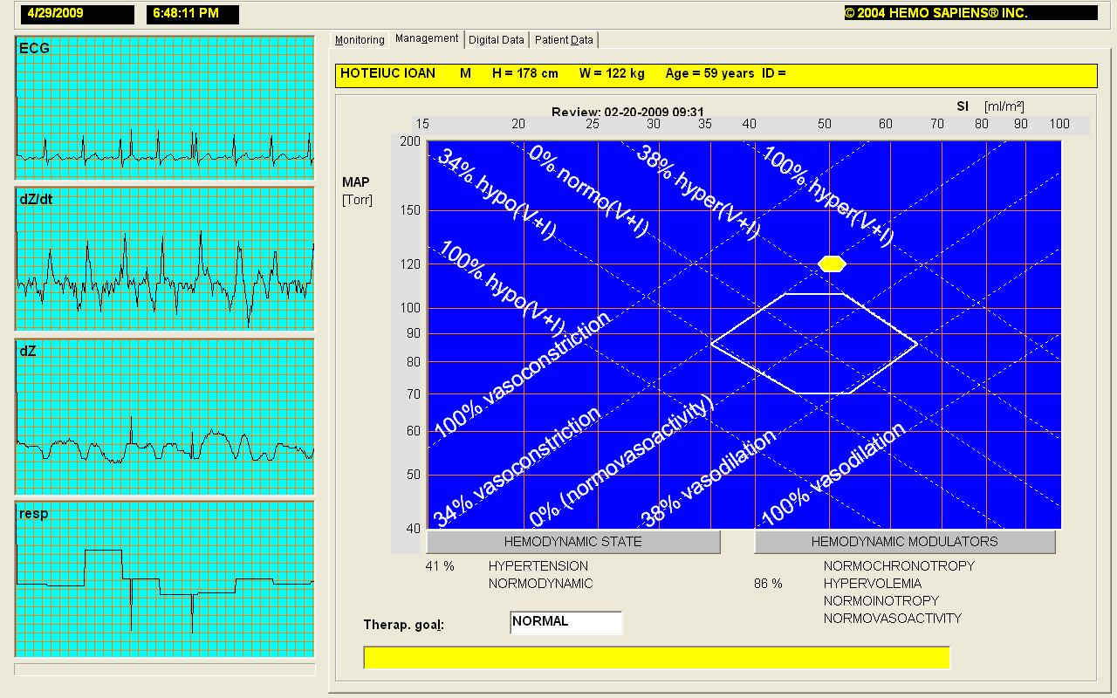

Figure 1. Hemodynamic status at first evaluation

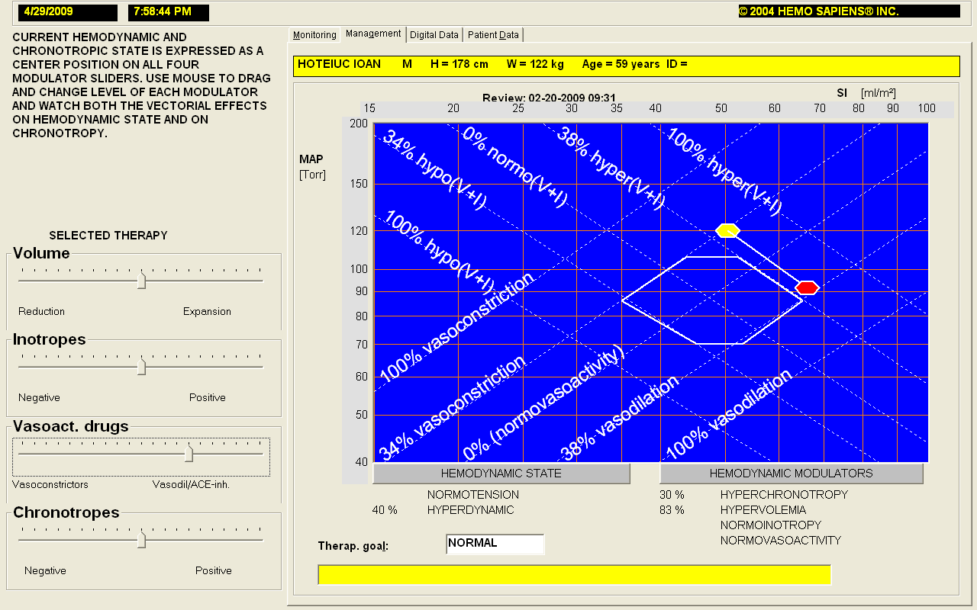

Figure 2. Worsed hemodinamic status after with added a vasodilatator-

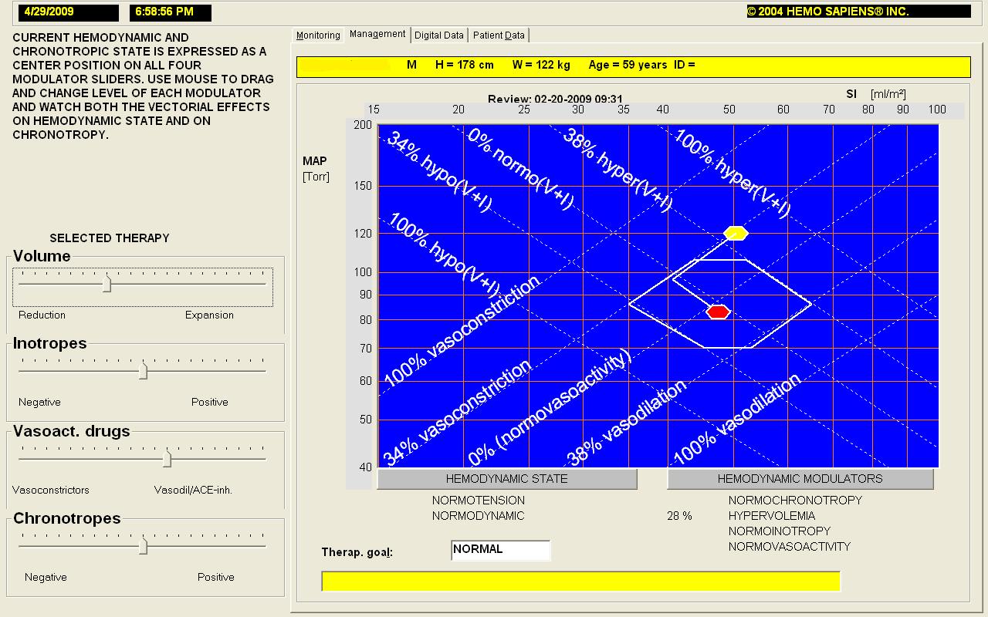

Figure 3. Improved hemodynamic status after added a diuretic

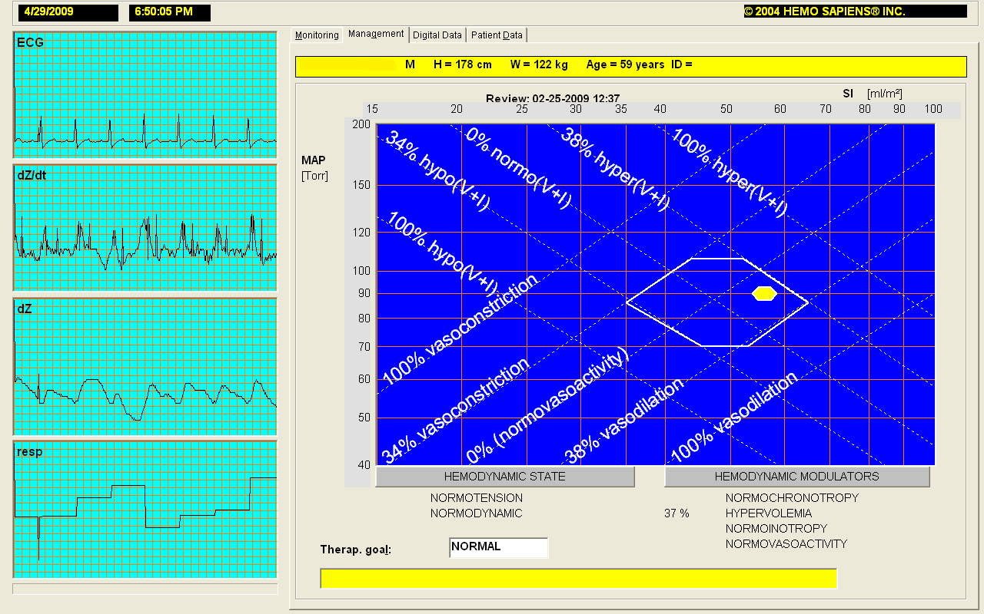

Figure 4. Hemodynamic status after 5 days of new treatment

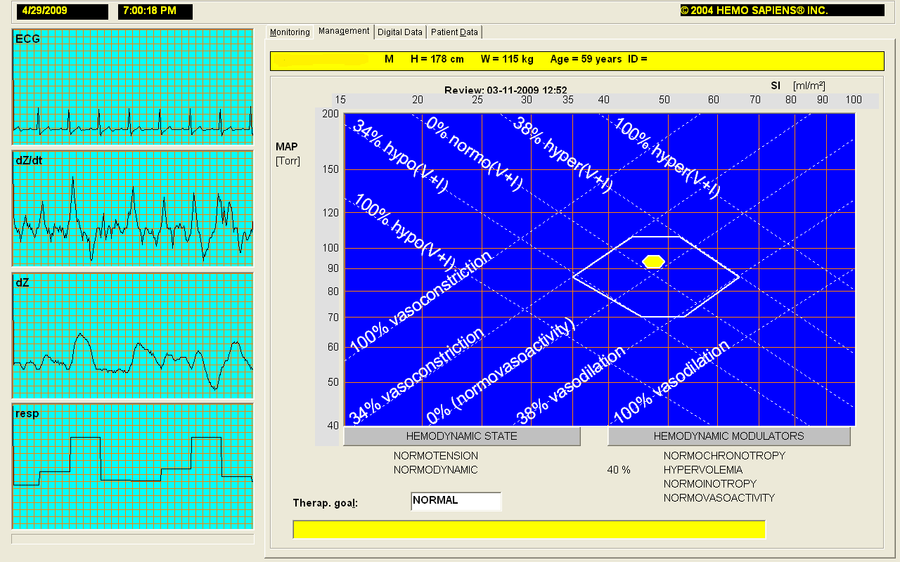

Figure 5. A normotensive/normodynamic status after 20 days of new treatment

