Redacţia revistei
CLUJUL MEDICAL
Str. Moţilor nr. 33
RO-400 001 Cluj-Napoca, ROMANIA
Tel/Fax : 0040 - 264- 596086
clujulmedical@umfcluj.ro

Declaration of Conflict of Interest

Manuscript number …

Title: CT-guided procedures: an initial experience

Names of all authors in the order in which they appear in the article

Andrei Roman
Patriciu Achimas-Cadariu
Bogdan Fetica
Vlad Gata
Andrada Seicean

Conflict of Interest disclosure

No | x

Yes

If yes, please specify…………………………………………………………………….
……………………………………………………………………………………………
……………………………………………………………………………………………
…………………………………………………………………………………………………………………………………………………………………………………………
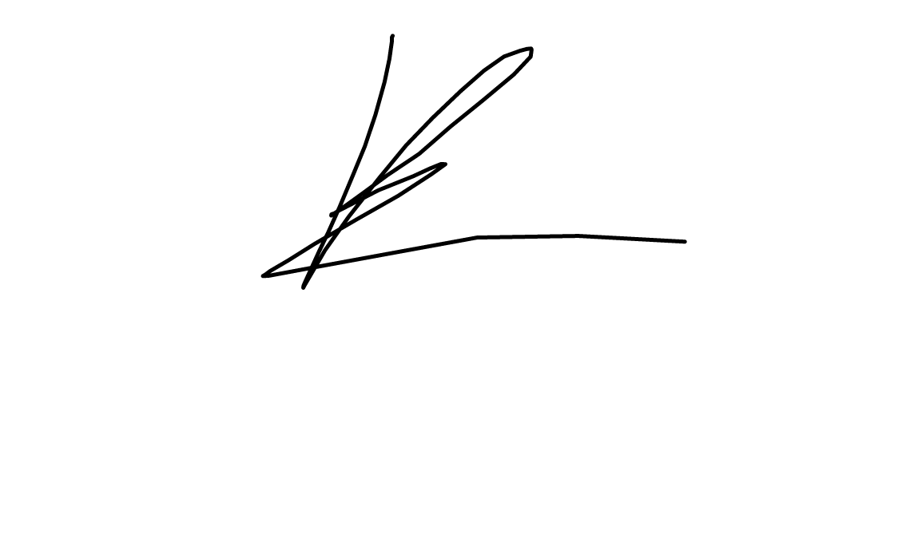

Roman Andrei 18.08.2018
……………………………………………………………. ..………..
(signature) date

The filled in, signed and scanned image of this file has to be uploaded at the last step of the submission process (Step 4. Uploading Supplementary Files)

