Redacţia revistei
CLUJUL MEDICAL
Str. Moţilor nr. 33
RO-400 001 Cluj-Napoca, ROMANIA
Tel/Fax : 0040 - 264- 596086
clujulmedical@umfcluj.ro

Copyright Assignment Form

Manuscript number ……………..

Title: Elastic stable intramedullary nailing for fractures in children – principles, indications, surgical technique

Corresponding author’s name: Dana Vasilescu

Names of all authors in the order in which they appear in the article

Dana Vasilescu
Dan Cosma

I certify that this article is an original work, has not been published before, and is not being considered for publication elsewhere. To the best of my knowledge, the article contains no statement that is unlawful or in any other way actionable.
Each author identified in the manuscript confirms that she/he is fully familiar with the final form of the article and agrees for its publication.
I hereby assign and transfer the copyright of this paper to Clujul Medical.

Signature date
Dana Vasilescu ………………………………………… 27.04. 2014
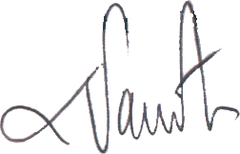

Dan Cosma ……………………………………………… 27.04.2014
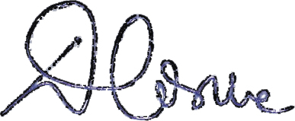

The filed in, signed and scanned image of this file has to be uploaded at the last step of the submission process (Step 4. Uploading Supplementary Files)

