Redacţia revistei
CLUJUL MEDICAL
Str. Moţilor nr. 33
RO-400 001 Cluj-Napoca, ROMANIA
Tel/Fax : 0040 - 264- 596086
clujulmedical@umfcluj.ro

Declaration of Conflict of Interest

Manuscript number …

Title: Elastic stable intramedullary nailing for fractures in children – principles, indications, surgical technique

Names of all authors in the order in which they appear in the article:
Dana Vasilescu
Dan Cosma

Conflict of Interest disclosure

No | X

Yes

If yes, please specify…………………………………………………………………….
……………………………………………………………………………………………
……………………………………………………………………………………………
…………………………………………………………………………………………………………………………………………………………………………………………

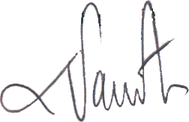
Dana Vasilescu

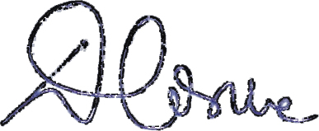
Dan Cosma

27.04.2014

