Description of focal liver lesions by using Gd-EOB-DTPA

Introduction: Imaging procedures play a fundamental role in the therapeutic management of focal liver lesions. Based on the information provided by these procedures, we can choose either to monitor the lesion, or to treat it - surgically or by percutaneous, minimally invasive procedures. The type of treatment shall also be selected depending on the results of the imaging procedures.
In recent years we have witnessed major changes in the therapy of focal liver lesions. The development of minimally invasive procedures, such as percutaneous ablation has been accompanied by the proliferation of new surgical techniques, such as atypical liver resections or liver transplant (1,2). We have seen an increase of liver surgical interventions for primitive or secondary neoplasms, which in the last decade were considered "inoperable" (2). Other techniques developed were intra-arterial chemoembolization, as well as percutaneous therapy of small-sized liver tumours. They all require accurate pre- and post-intervention imaging assessment. The purpose of imaging is both to provide morphological information on focal liver lesions (number, dimensions, localisation), as well as to give a differential diagnosis (1). In addition, imaging techniques should allow early diagnosis of malignant liver lesions, which require adequate sensitivity in identifying small focal liver lesions, sometimes even subcentimetric. False-negative results in detecting small liver lesions lead to diagnosis delays, which have a significant influence on the patient's outcome and life duration (2,3).
The selected imaging technique must be characterised by a high sensitivity and specificity, required in the diagnosis of focal liver lesions. Sensitivity is required for accurate detection of lesions for a correct staging, whereas specificity prevents incorrect labelling of some inoperable tumours as being operable and thus unnecessary interventions in patients (3).
Imaging is also used for treatment monitoring and detection of tumour relapses.
Computed tomography with contrast material injection and dynamic gadolinium-enhanced MRI have shown similar accuracy in detecting liver lesions. However, dynamic MRI is more specific that computed tomography in the differential diagnosis of focal liver lesions (4). But there are some limitations which imposed the use of new techniques in the diagnosis of focal liver lesions. Krinsky and his collaborators conducted a study on 71 patients with cirrhosis scheduled for liver transplants. The preoperative MRI only revealed 11 HCC nodules from a total of 20 lesions identified by histopathological examination. It discovered 80% of lesions larger than 2 cm and under 50% of lesions smaller than 2 cm (5). Computed tomography recorded similar results in a study on 430 patients, the sensitivity in detecting hepatocellular carcinoma lesions being 68% (6). Another limitation of MRIs with non-specific gadolinium chelates and of CTs with contrast material injection is represented by the use of the vascular criteria for hepatocellular carcinoma diagnosis. The exclusive use of this criteria leads both to a reduction in sensitivity by failure to diagnose hypovascular hepatocellular carcinoma nodules, as well as to false-positive results of hepatocellular carcinoma caused by benign lesions such as dysplastic nodules, focal nodular hyperplasia or arteriovenous fistulas (7,8,9).
The role of imaging is to determine the HCC stage before liver transplant. In a study on 789 patients proposed for liver transplant (the largest group of patients with HCC included in a study), Freeman determines an accuracy of 49% in pre-operative staging of HCC, 29% of the lesions being overstaged and 22% understaged. The techniques used for pre-staging were either biphasic spiral CT or MRI with non-specific gadolinium chelates. The importance of correct staging resides in the fact that only stage T2 HCC patients are candidates for liver transplant (table 1).

TABLE 1: American Liver Tumor Study Group Modified TNM Staging
Classification

T0 | No hepatocellular carcinoma
T1 | One hepatocellular carcinoma smaller than 1.9cm
T2 | One hepatocellular carcinoma 2 to 5cm; two or three nodules smaller than 3cm
T3 | One hepatocellular carcinoma biger than 5cm; two or three nodules, at least one biger than 3cm
T4a | Four or more nodules of any size
T4b | Stage T2, T3, or T4a plus gross intrahepatic portal or hepatic vein involvement
N1, M1 | Lymph node or distant metastasis or extrahepatic portal or hepatic vein involvement

Based on these values, it recommends the use of other imaging techniques, so as MRI with liver-specific contrast agents, for HCC staging in patients with cirrhosis candidates for liver transplant (10).
The use of MRI with liver-specific contrast material offers superior accuracy in detecting focal liver lesions, as well as a specificity superior to spiral CT regarding differential diagnosis (1).
Another option proposed for the positive and differential diagnosis of focal hepatic lesions, computed tomography during arterial portography (CTAP), is an invasive technique and generates a high number of false-positive results, probably due to some liver arterial vascularisation variations (11).

Hepatocyte-specific contrast agents:

Most MRI liver scans use gadolinium, a non-specific extracellular contrast agent. This method is limited by small-sized nodules and hepatocellular carcinomas in patients with advanced-stage cirrhosis. Krimsky et al. have proven that 46% of patients with advanced cirrhosis and not diagnosed with HCC after an MR scan with Gd-DTPA present hepatocellular carcinoma at the histopathological examination of the explanted liver. An increasing number of centres prefer the use of hepatocyte-specific contrast agents, ensuring a better accuracy in the detection and classification of focal liver lesions (12,13,14). Hepatocyte-specific contrast agents are represented by superparamagnetic iron oxides (SPIO), manganese derivatives (mangafodipir trisodium) and gadolinium-containing contrast agents (gadobenate dimeglumine - Gd-BOPTA and gadoxetic acid-Gd-EOB-DTPA-Primovist).
SPIO are T2 contrast agents having as main effect a reduction of the T2 relaxation time, accompanied by a decrease of liver signal intensity for these sequences. As for the safety and possible side effects of SPIO administration, the most comprehensive clinical trial included 208 patients. 8% of the patients reported mild adverse effects. The most important adverse effects were severe back pain (2 patients) and intense rush (1 patient) (12).
There are several studies comparing MR with SPIO and MR with Gd-DTPA in the diagnosis of focal liver lesions. The study carried out by Simon and his collaborators does not reflect significant sensitivity differences in hepatocellular carcinoma diagnosis by MR with iron oxides and MR with Gd-DTPA. There is however a small number of false positive results and a higher specificity of MR with SPIO in comparison with Gd-DTPA (13). The high number of false positive results recorded with Gd-DTPA is due to the incorrect interpretation of hypervascular lesions as being HCC. The same study concluded that all hypervascular lesions in hypersignal T2 after administration of SPIO are hepatocellular carcinomas - the combined application of the two techniques thus resulted in 100% specificity (13). The identified limitations of SPIO use are: the risk of false-positive results due to the aspect of hypersignal T2 of vascular structures and the reduced uptake of the superparamagnetic contrast material in livers with major fibrotic lesions; the risk of false negative results due to SPIO uptake in Kupffer cells contained by well-differentiated HCCs (13,14).
In a study on patients presumed to have malignant focal liver lesions, Matsuo describes a clearly superior sensitivity of Gd-DTPA in comparison with iron oxides in detecting malignant liver lesions (81% were detected by Gd-DTPA, only 61% by iron oxides). The specificity in malignant liver lesions diagnosis was equal, estimated to 94% (15).
Pauleit and Tang (16, 17) describe a superior sensitivity of MR with Gd-DTPA in the diagnosis of hepatocellular carcinoma in comparison with MR with SPIO. Pauleit describes differences regarding the diagnosis of small focal liver lesions (smaller than 1.5 cm), while Tang uses reduced iron oxide doses (10 µmol/kgc).
These studies have shown that the use of MR with SPIO does not improve detection of malignant liver lesions in comparison with MR with Gd-DTPA; however, MR with SPIO allows for a better classification (benign/malignant differentiation) of known focal liver lesions.
Several studies acknowledge a superior accuracy of double contrast MR (with both non-specific, extracellular contrast material, as well as SPIO) in the diagnosis of hepatocellular carcinoma, compared to the monocontrast MR (18-22). Ward shown a highly superior sensitivity of double contrast MR in detecting infracentimetric HCC lesions compared to monocontrast MR with SPIO (46% of the lesions were identified by using the double contrast technique, compared to only 14% with SPIO) (18). Kwak and collaborators prove a 95% sensitivity in hepatocellular carcinoma diagnosis following the administration of both contrast materials, superior to both MR with Gd-DTPA (87%), and MR with SPIO (88%) (19).
A recent study (23) compared the accuracy of double contrast MR with monocontrast MR (both with non-specific gadolinium chelates or ferucarbotran) in the detection and characterisation of focal liver lesions. This study differs from many other conducted until now, in the fact that the patient selection area did not include solely patients with cirrhosis, believed to have hepatocellular carcinomas. The classification of lesions as benign or malignant was better with the double contrast or ferucarbotran MR compared to the gadolinium chelates MR. The accuracy of the hepatocellular carcinoma was significantly higher after the double contrast MR than after the monocontrast one. Two of the four radiologists analysing the images reported significant differences in the accuracy of the metastasis diagnosis between the double contrast MR and both monocontrast techniques. There were no significant differences between the three techniques used regarding the diagnosis of benign focal liver lesions. Double contrast MR has no advantages in the differential diagnosis of hepatic adenoma compared to HNF (23).
The manganese derivative used as hepatocyte-specific contrast agent is mangafodipir trisodium (24, 25). Once it reaches the liver, it generates an important increase of the signal in the healthy liver parenchyma in weighted T1 sequences. A meta-analysis on the efficacy of mangafodipir trisodium in diagnosis of focal liver lesions highlights significant statistical differences between the number of lesions detected in the liver pre-contrast as compared to post-contrast (p< 0.001) (24). As for the correct diagnosis of focal liver lesions, the same meta-analysis finds a statistically significant improvement in the characterisation of focal liver lesions compared to non-contrast MR, in the cirrhotic liver, but not in the non-cirrhotic liver. All cases wrongly diagnosed by pre-contrast exploration and correctly diagnosed after the administration of MnDPDP, in cirrhotic livers, were hepatocellular carcinomas (24).
Another study analyses the sensitivity of MRI with MnDPDP compared with biphasic multislice CT in the diagnosis of hepatocellular carcinoma in cirrhotic livers. The study included 50 patients with 80 hepatocellular carcinomas. The sensitivity of the MR without contrast material in detecting the lesions reached 48%, whereas after the administration of MnDPDP it increases to 86%. The sensitivity of biphasic CT was 80%.
Oudkerk and collaborators (26) prove a superior accuracy of MR with MnDPDP in comparison with biphasic multislice CT regarding the characterisation of focal liver lesions. There is also a comparative study between Mn-DPDP and Ferucarbotran (SPIO), proving a similar accuracy of the two contrast agents in detecting and characterising liver metastasis in patients known to be suffering from colorectal cancer (27). Another study proves a higher accuracy of SPIO compared to MnDPDP in detecting hepatocellular carcinoma nodules smaller than 1 cm (28).

Gadoxetic acid (Gd-EOB-DTPA; Primovist) is the latest hepatocyte-specific contrast agent approved for use in Europe. It started being used for clinical applications in 2004. Gd-EOB-DTPA is a new-generation contrast agent, captured by functional hepatocytes. Gd-EOB-DTPA has the property of attaching itself to proteins and is integrated in functional hepatocytes by way of the anion transporters. It eliminates equally by the biliary duct and renal path, regardless of the administered dose (29, 30). This 50% biliary excretion rate of the contrast material is the highest of all hepatocyte-specific contrast agents.
Clinical trials, as well as subsequent studies, showed no major adverse effects of Gd-EOB-DTPA (29, 30, 31), which is better tolerated than manganese derivatives or iron superoxides (25). Hammerstingl and collaborators report 11 patients with mild adverse effects after the administration of Gd-EOB-DTPA, in a multicentric study carried out on 162 patients (1). The adverse effects were nausea, vasodilation, headache, temporary alteration of taste and pain at the injection site. It was proven that Gd-EOB-DTPA has a safe pharmacological and toxicological profile, without generating clinically relevant modifications of vital signs, biological parameters, cardiovascular activity or renal function during the examination and afterwards (1, 25, 29, 31).
Although initial clinical trials considered that the injection of a 0.0125 mmol/kgc dose was sufficient, the standard dose applied and recommended by recent studies is 0.025 mmol/kgc, due to a better delimitation of focal lesions and improvement of the contrast/noise ratio (30, 31). Due to the fact that the administered Gd-EOB-DTPA dose is approximately a quarter of the gadolinium dose, injected during scans with non-specific contrast material, the intensity of contrast material burden is weaker. There are no studies proving that this weaker burden influences the sensitivity and specificity of Gd-EOB-DTPA in the diagnosis of focal liver lesions.
It provides both the possibility of a dynamic liver study, similar to non-specific contrast materials, as well as of hepatocyte-specific acquisition in case of an accurate delimitation of lesions which do not contain functional hepatocytes (32). The maximum intensity in the liver parenchyma and, implicitly, the best parenchyma/lesion contrast, are reached 20 minutes after the injection of the contrast material, followed by a "plateau" phase, which lasts for approximately 2 hours (30).
Its massive excretion by biliary duct allows for MR cholangiographies (32). Typically, in patients without biliary tree obstructions, Gd-EOB-DTPA is visualised in the duodenum a few minutes after injection. MRs with Gd-EOB-DTPA may represent an alternative diagnosis procedure for patients with post-surgical biliary fistulas (33).
Animal studies show the existence of some drug interactions of Gd-EOB-DTPA. Rifampicin decreases liver uptake of the contrast material, reducing the liver parenchyma signal intensity in the hepatocyte-specific phase, while prednisolone, doxorubicin, cisplatin and propanol cause a slight increase of the liver signal in the hepatocyte-specific phase. However, none of these medicines generates a significant modification of the image quality in humans, thus preserving diagnosis accuracy (34).

Gd-EOB-DTPA in focal liver lesions

The information provided by MR with Gd-EOB-DTPA comes both from the dynamic MR with non-specific contrast material and the hepatocyte-specific phase. There are no differences between the behaviour in dynamic exploration of Gd-EOB-DTPA and non-specific contrast materials (1).
Liver hemangiomas exhibit intense uptake, initially nodular peripheral, subsequently centripetal, in the first 10 minutes after injection (Figure 1 a,b,c and d).
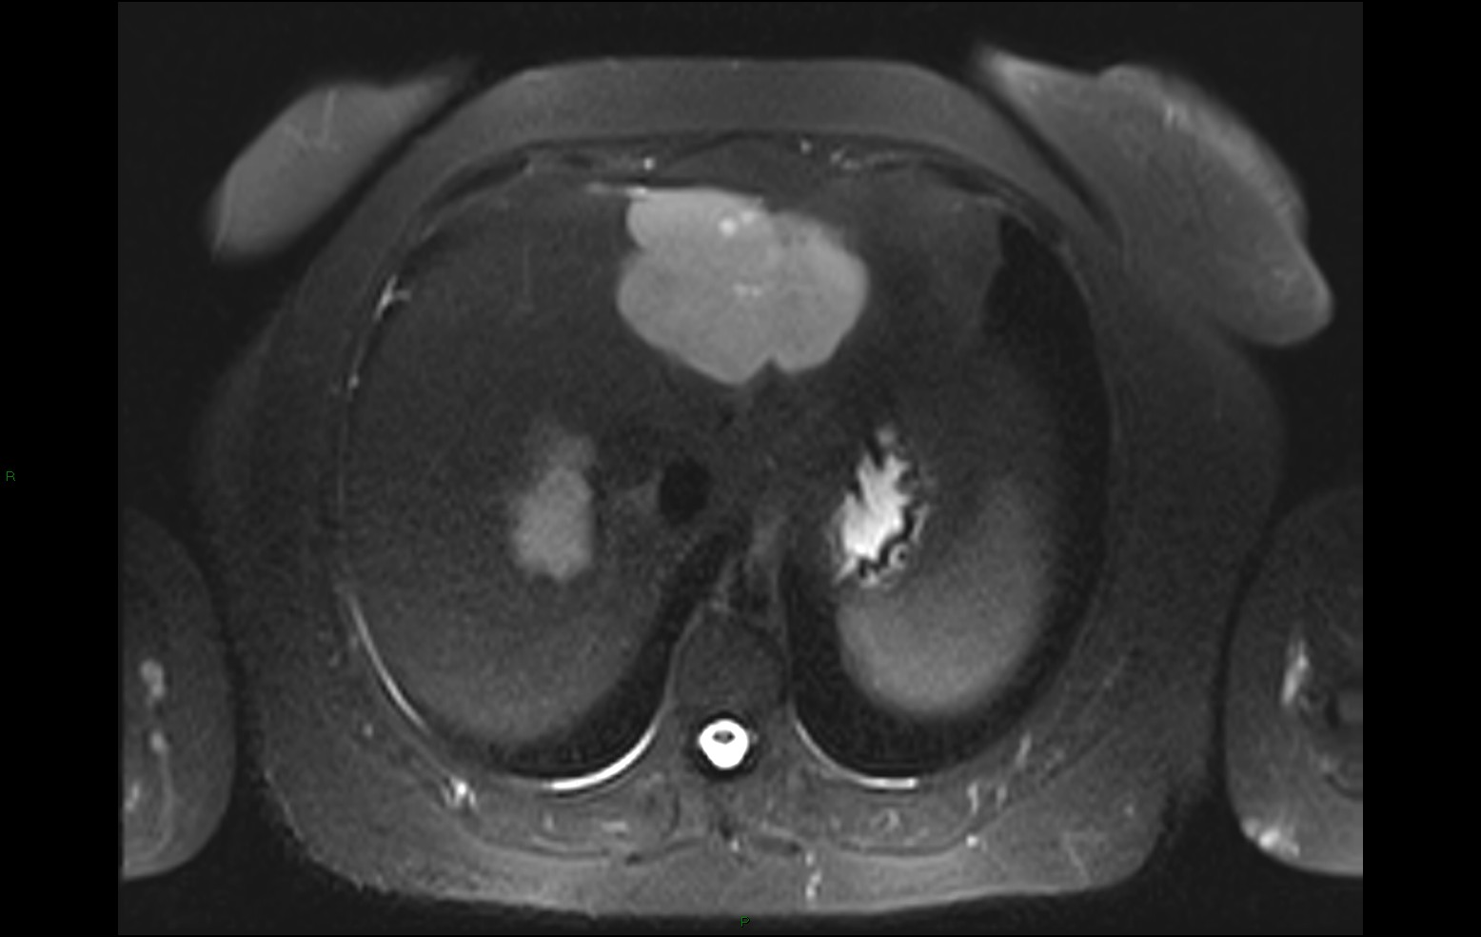a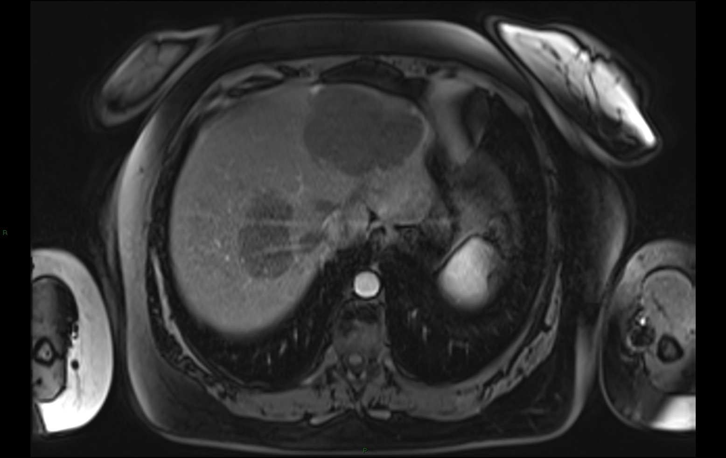b
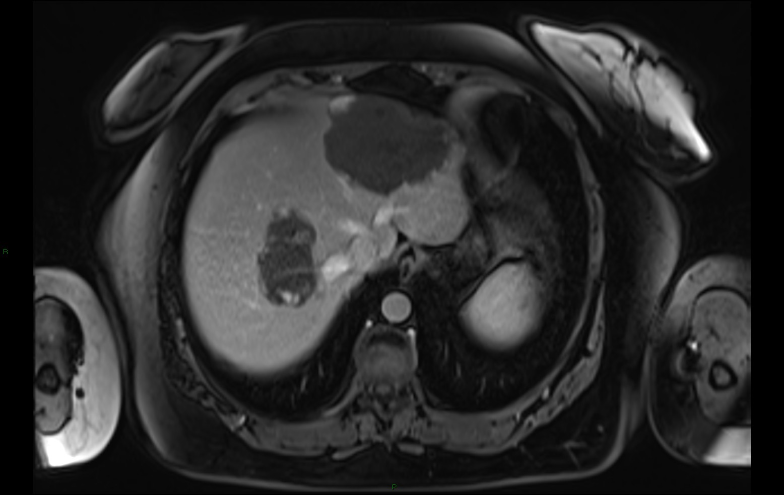c
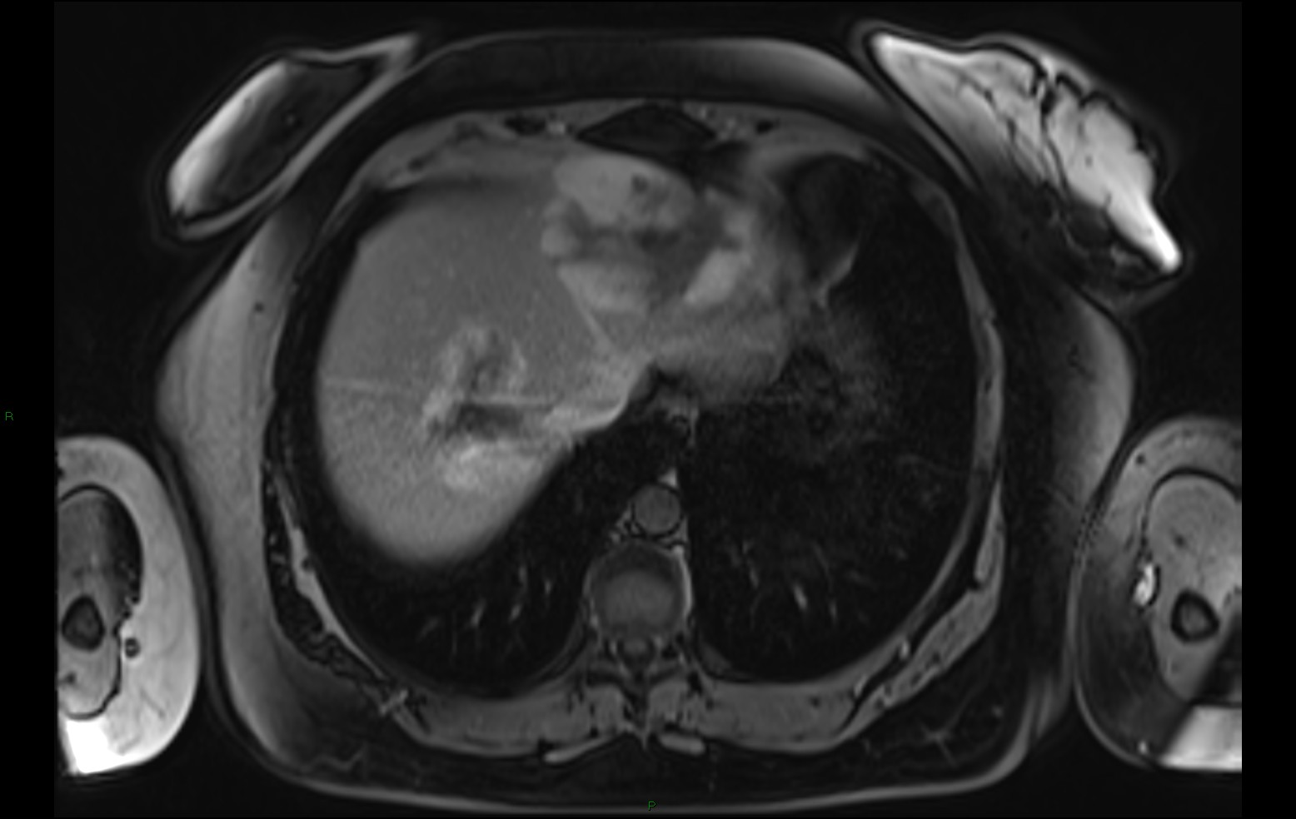d
Figure 1 a, b, c and d: MRI of a liver hemangioma shows hyperintensity on the T2 weighted image (much more intense than for malignant lesions). After contrast administration hemangiomas show progressive, nodular and centripetal uptake in the arterial, portal-venous and late phase.

The signal intensity after injection of the contrast material is lower than in the case of non-specific contrast material injection (35). In the late, hepatocyte-specific phase, hemangiomas are in hyposignal compared to the liver parenchyma.
Focal nodular hyperplasia (FNH) uptake the contrast material in the early, arterial phase, and preserve the hypersignal to the adjacent liver parenchyma both during the portal phase and the balance phase (3 minutes from injection) (Figure 2).
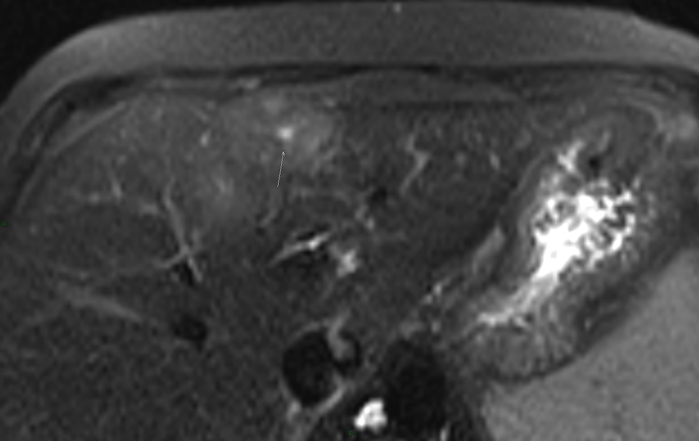a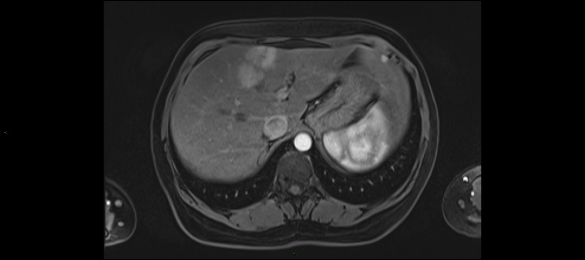b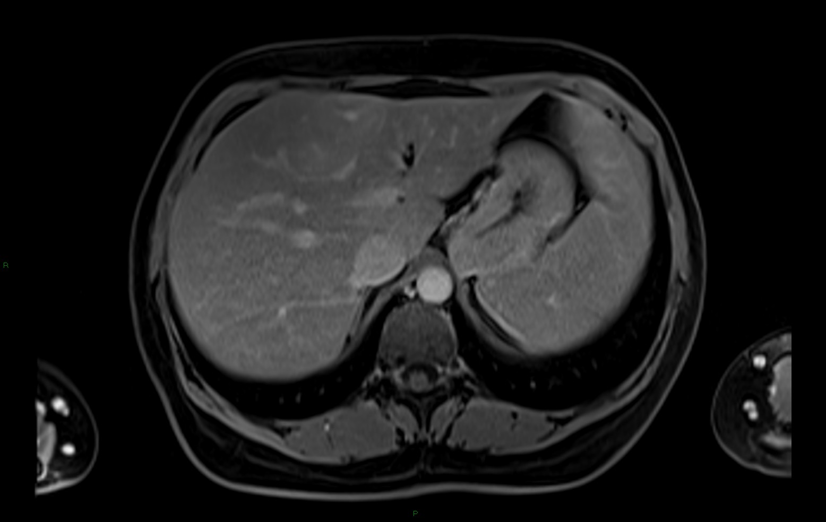c
Figure 2 a, b and c: MRI of a focal nodular hyperplasia with a central scar which is hyperintense on the T2 weighted image. After injection of contrast the lesion is hypervascular in the arterial phase in comparison to the liver parenchyma and does not wash out in the portal venous and late phase. The central scar is hypointense in the arterial phase and becames hyperintense in the late phase.

They preserve the hypersignal appearance during the hepatobiliary phase (20 minutes from injection), as well as 4 hours from the injection of the contrast material. This characteristic is due to the presence inside FNH of modified biliary ducts which retain the contrast material, and may be useful in the differential FNH diagnosis versus hepatocellular adenomas (36). Large dimension FNH present a central portion in the hyposignal, corresponding to the central scar. Smaller dimension FNH are, in most of the cases, homogeneous (37).
Hepatocellular adenomas Specialised literature makes few references to adenoma behaviour after administration of Gd-EOB-DTPA. Huppertz and collaborators analyse the behaviour of three adenomas - two of them present Gd-EOB-DTPA uptake in the hepatobiliary phase and one does not. All three adenomas included in the study are accompanied by a histopathological result, which shows that the adenoma which does uptake the material has cellular atypia. A study on three patients with liver adenomatosis (with a total number of approximately 100 adenomatous lesions) shows the absence of enhancement or minimal enhancement of Gd-EOB-DTPA during the late phase - therefore the diagnosis of these cases with liver metastasis or multicentric hepatocellular carcinoma becomes difficult. A possible explanation of this adenoma behaviour could be the absence from their structure of liver ducts. In the dynamic phase, almost all adenomas present intense uptake of the contrast material in the arterial phase; uptake in the venous and delayed phase depends on the adenoma histological type- some adenomas may show wash-out and some adenomas may not. (38).
Liver metastases have the most intense uptake of Gd-EOB-DTPA, in their periphery, at 90-120 seconds from injection (they present as hypovascular lesions surrounded by a hypervascular rim) (Figure 3).
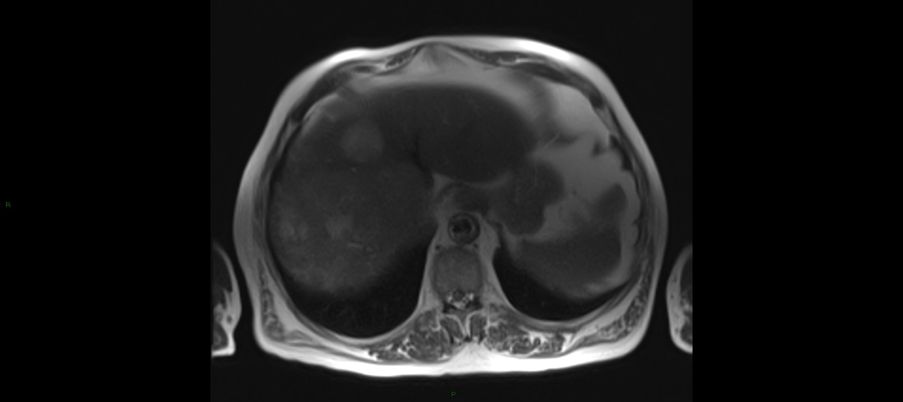a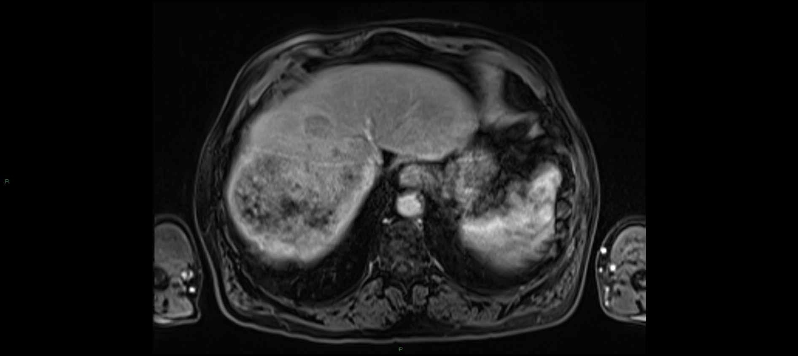b
Figure 3 a and b:Liver metastases appearing as lesions with a discrete hypersignal to the adjacent liver in the T2 weighted image and with less uptake of contrast media in regard to the surrounding liver.

3 minutes after the injection, the contrast material uptake will be more significant in the liver parenchyma than in the metastases. Central enhancement in metastases is rare, the uptake is in general peripheral. They are in hyposignal in the hepatobiliary phase, the best liver/lesion contrast being recorded between 20 and 45 minutes after injection (39).
Hepatocellular carcinomas exhibit intense Gd-EOB-DTPA uptake in the early phase (first 60 seconds after injection) and present a delayed wash-out compared to metastases (Figure 4).
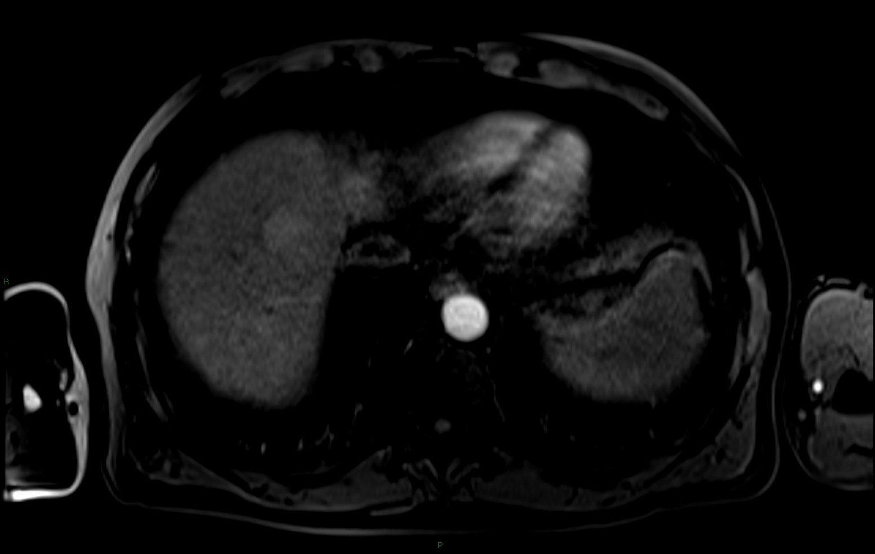a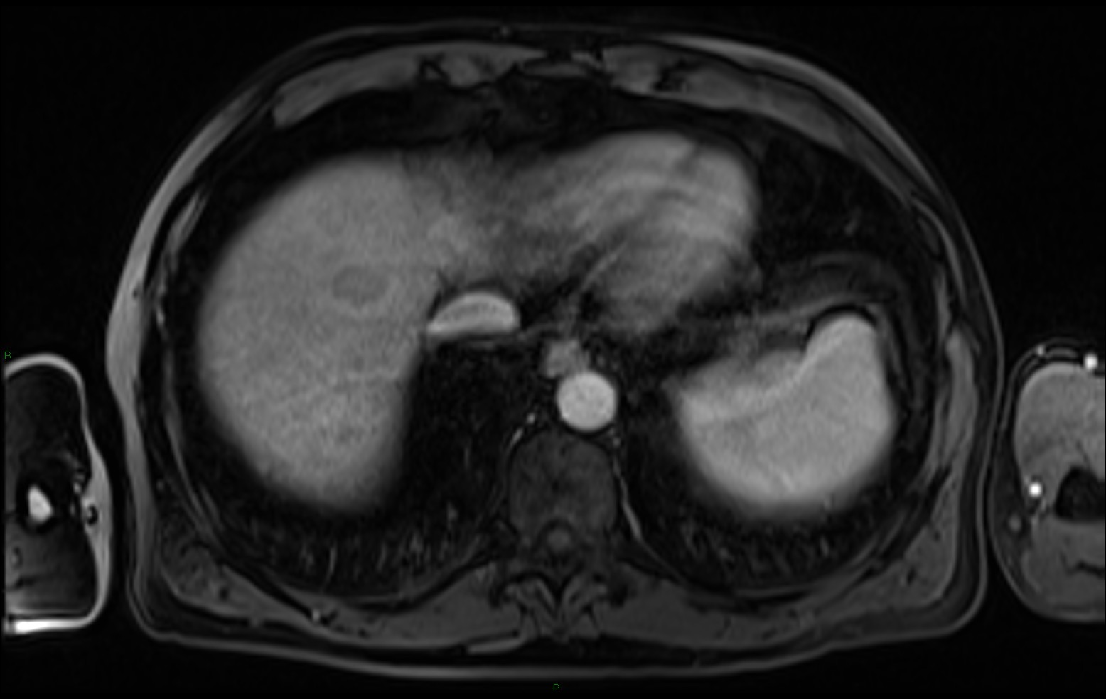b
Figure 4 a and b: HCC nodule with a hypervascular character in regard to the surrounding liver in the arterial phase and showing wash-out in the portal phase.

Hepatocellular carcinomas in iso- or even hypersignal compared to the liver parenchyma may be observed 3 minutes after injection (hepatocellular carcinomas with absent wash-out), as well as hypovascular hepatocellular carcinomas with no uptake in the arterial phase (37, 39). In the hepatobiliary phase, most hepatocellular carcinomas are in hyposignal compared to the parenchyma (Figure 5).
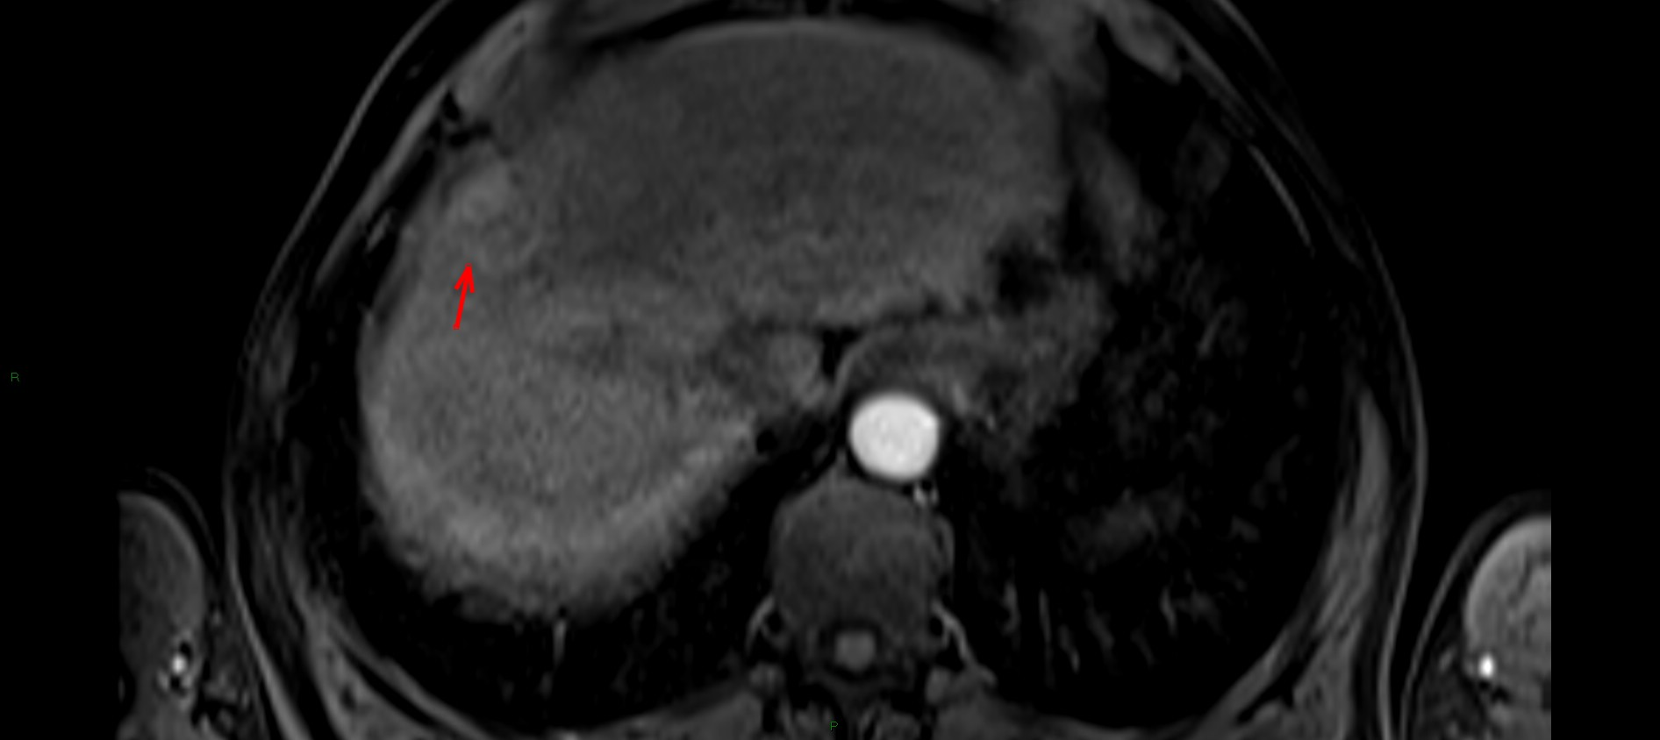a
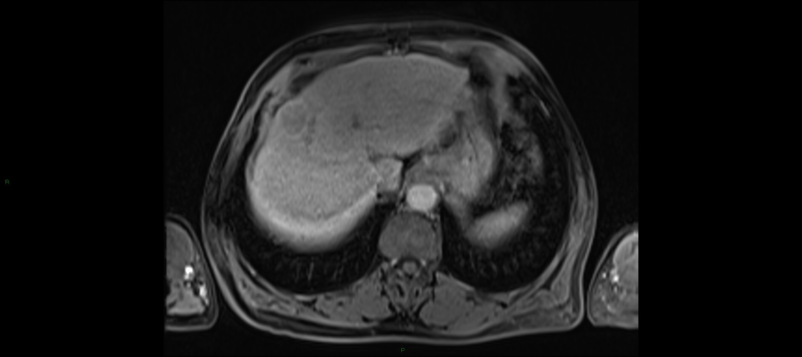b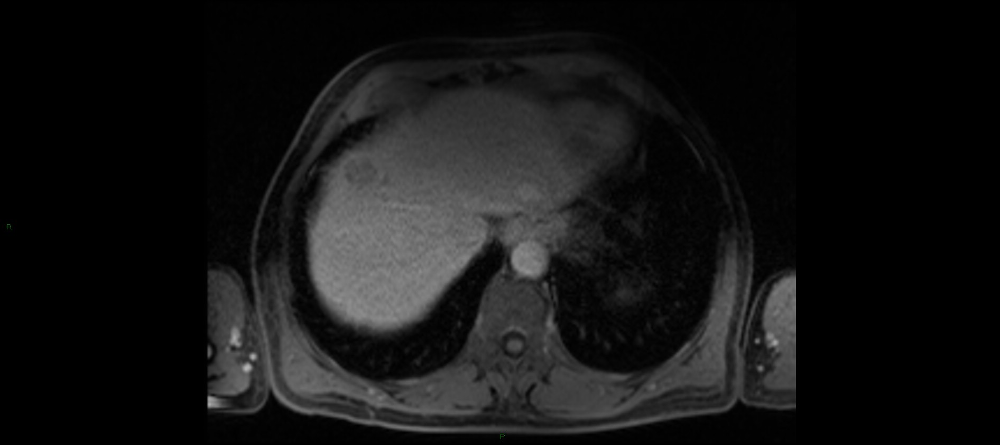c
Figure 5 a,b and c: Behaviour of an HCC nodule after administration of Gd-EOB-DTPA. The nodule has a hypervascular, nodule in a nodule aspect in the arterial phase, typical for HCC. it shows wash-out and it’s surrounded by a hypervascular capsule in the late phase. In the hepatobiliary phase the HCC nodule is typically hypointense to the surrounding liver parenchyma.

However, well-differentiated HCCs containing functional hepatocytes can exhibit uptake of the contrast material in the hepatobiliary phase. A study correlating contrast material uptake with hystopathology records two HCCs with uptake in the hepatobiliary phase. From a hystological point of view, both hepatocellular carcinomas are G1 (well-differentiated) (37).
Specialised literature includes two major study categories regarding Gd-EOB-DTPA's possibilities of detecting and characterising focal liver lesions. The first category includes all patients with focal liver lesions, detected by other imaging techniques. The second category analyses the capacity of GD-EOB-DTPA-enhanced MR to detect and characterise focal liver lesions discovered after the histopathologic diagnosis of cirrhotic liver.
There are studies proving that GD-EOB-DTPA-enhanced MR is superior to CT with contrast material injection or dynamic MR as regards the detection and characterisation of focal liver lesions (1,35, 37, 40). Haalavara's study included 176 patients with 252 focal liver lesions, of which 104 malignant and 148 benign. He shows a significant statistical improvement of the classification and characterisation of focal liver lesions (40). Huppertz and collaborators state, in a study on 131 patients with 302 focal liver lesions, that gadoxetic acid MR changes the diagnosis compared to the pre-contrast MR in 17% of the cases. The detection of focal liver lesions was also improved by using the hepatocyte-specific contrast material, increasing from 80.8% in the pre-contrast exam to 87.7% in post-contrast exams. It is important to note that, out of the 20 focal liver lesions detected only by the post-contrast exam, 12 were smaller than 1 cm. Another conclusion was that the classification (division of lesions into malignant and benign) and characterisation of lesions was improved after administration of the hepatocyte-specific contrast material (3). However, a weak part of this study was that it included few cases of histopathologically diagnosed hepatocellular carcinomas (31 cases).
There are more studies proving the superiority of MRs with hepatocyte-specific contrast material compared to pre-contrast MR in the diagnosis of focal liver lesions with dimensions smaller than 1 cm (41).
A recent study on 169 patients recommended for surgical intervention compared the results of Gd-EOB-DTPA-enhanced MRI with biphasic multislice CT in detecting and characterising focal liver lesions (1). This study states there are significant statistical differences between CTs and Gd-EOB-DTPA-enhanced MRI in detecting focal liver lesions. The detection percentage by Ct is 77.1%, whereas by MRI 87.5%. It has been proven that Gd-EOB-DTPA-enhanced MRI is clearly superior to CT in detection lesions smaller than 1 cm. The MR detected 42 out of 68 such lesions, whereas the CT detected 25 out of 67 such lesions. The detection of these infracentimetric lesions is extremely important since there are studies proving that 50% of liver metastases, diagnosed by intraoperative ultrasound, are smaller than 1 cm, and a diagnosis in this stage would significantly influence the patient's prognosis and therapy (42). Gd-EOB-DTPA-enhanced MRI also proved superior in the differential diagnosis of focal liver lesions. It diagnosed correctly 82.1% of detected lesions, while computed tomography made an accurate assessment of 71% of the cases. For 16.8% of the patients included in the study, the MR with hepatocyte-specific contrast material led to a modification of the surgical protocol. The changes in procedure involved either extension of the resection due to the discovery of new focal liver lesions with malignant characteristics, or its limitation due to the fact that some lesions, initially considered malignant, proved to be benign after the Gd-EOB-DTPA-enhanced MRI; in some cases the surgical procedure was cancelled due to the fact that the MR showed some lesions to be inoperable (1).
In their studies, both Huppertz and Hammerstiegl recorded a significant number of false-positive diagnoses of focal liver lesions. This may be due to the fact that - a limitation of both studies - intraoperatory ultrasound was used as reference technique for diagnosing the existence of focal liver lesions on non-resected segments. Intraoperatory ultrasound involves the risk of missing some of the lesions, mainly superficial, subcapsular ones. Therefore, some of the lesions, interpreted as false-positive after the intraoperatory ultrasound, may actually be real.
Studies on using Gd-EOB-DTPA for hepatocellular carcinoma diagnosis have also showed some limitations of this technique. Well-differentiated tumours uptake the contrast material, thus the risk of false-negative results. Statistically, the number of cases is reduced - a study of induced HCC on rats shows that only two cases in 79 of intra-tumour uptake of the contrast material (34). In native images, some hepatocellular carcinomas are in hypersignal T1 compared to the adjacent liver parenchyma, which may lead to a decrease in the contrast/lesion signal ratio in the accumulation phase. There are some hepatocellular adenomas with reduced Gd-EOB-DTPA uptake in the distribution phase, which therefore cannot be differentiated from hepatocellular carcinomas (33). Thus, the use of double contrast procedures with SPIO (T2 agents) and non-specific gadolinium chelates seems to have an advantage in the imaging analysis of cirrhotic livers. On the other hand, there are no studies comparing the efficiency of Gd-EOB-DTPA and SPIO in the diagnosis of hepatocellular carcinomas on cirrhotic livers.
In clinical practice, most of the times, the hepatocyte-specific contrast material used to conduct the MR scan of the liver is selected based on the experience and preferences of specialists in various centres. Reimer proposes the following MR exam strategy for patients with focal liver lesions: MR with Gd-EOB-DTPA for patients suspected of having liver metastases or cholangiocarcinoma and eligible for surgical interventions or ablation procedures by radiofrequency or embolisation; patients suspected of HCC or cirrhosis of the liver should undertake double contrast MR with SPIO and non-specific gadolinium chelates; the characterisation of benign liver tumours or follow-up exams of known liver tumours is made by MR with non-specific gadolinium chelates (33). The team coordinated by Hellmaier prefers the use of the double contrast MR rather than Gd-EOB-DTPA for the detection and characterisation of liver metastases. For the differential diagnosis between hypervascular benign liver tumours, adenoma and FNH, Hellmaier and his collaborators suggest the use of a Gd-EOB-DTPA MRI and delayed phase acquisition. However, these diagnosis strategies are the result of clinical practice experience and not the product of comparative studies between hepatocyte-specific contrast materials.
Another disadvantage of Gd-EOB-DTPA exams is the extended examination time required for the acquisition in the hepatobiliary phase, 20 minutes after injection. Motosugi and collaborators compared acquisitions obtained 10 and 20 minutes after injection. They showed that in 61% of the patients there are no differences between the two time points in assessing the number and characteristics of focal liver lesions. Detection of liver lesions also depends on the enhancement of the liver parenchyma (ensuring an adequate liver/lesion contrast) (43). The detection after 10 minutes of focal liver lesions was more difficult in patients with uptake at the level of the spleen (it reflects the circulation of the contrast material, which can accumulate at the level of the extracellular matrix of the tumour, thus reducing the parenchyma/tumour contrast) (43). The study concluded that the 20 minutes acquisition may be omitted in patients with a sufficient liver/spleen contrast intensity ratio at 10 minutes (43).
The liver uptake of the contrast material is delayed in patients with chronic hepatopathies.
Conclusions: GD-EOB-DTPA-enhanced MR is an imaging technique with very good sensitivity and specificity for the detection, characterisation and differential diagnosis of focal liver lesions. There are studies proving that it has better diagnosis accuracy compared both to biphasic spiral CT and dynamic MR. As far as we know, there are no studies comparing GD-EOB-DTPA with other liver specific contrast materials. It is better tolerated than others and it has the advantage of offering the possibility to perform dynamic sequences. Its main advantages are the accurate detection and characterisation of small malignant liver lesions, smaller than 1 cm. The main limitation of the contrast material is its uptake by well-differentiated HCCs in the hepatobiliary phase, as they become difficult to differentiate from benign focal liver lesions or dysplastic nodules.

Acknowledgments:

Dr. Cosmin Caraiani is a fellow of POSDRU grant no.159/1.5/S/13/138776: “Model colaborativ institutional pentru translatarea cercetarii stiintifice biomedicale in practica clinica-TRANSCENT”

Bibliography
1. Hammerstingl R, Huppertz A, Breuer J, Balzer T, Blakeborough A, Carter R, et al. Diagnostic efficacy of gadoxetic acid (Primovist)- enhanced MRI and spiral CT for a therapeutic strategy: comparison with intraoperative and histopathologic findings in focal liver lesions. Eur Radiol 2008;18:457-67.
2. Lorenz M, Staib-Sebler E, Hochmuth K, Heinrich S, Gog C, Vetter G, et al. Surgical resection of liver metastases of colorectal carcinoma: short and long-term results. Semin Oncol 2000; 27(Suppl 10):112–119
3. Huppertz A, Balzer T, Blakeborough A, Breuer J, Giovagnoni A, Heinz-Peer G, et al. Improved detection of focal liver lesions at MR imaging: multicenter comparison of gadoxetic acid-enhanced MR images with intraoperative findings. Radiology 2004; 230:266–275.
4. Semelka RC, Martin DR, Balci C, Lance T. Focal liver lesions: comparison of dual-phase CT and multisequence multiplanar MR imaging including dynamic gadolinium enhancement. Magn Reson Imaging 2001;13:397–401.
5. Krinsky GA, Lee VS, Theise ND, Weinreb JC, Rofsky NM, Diflo T, et al. Hepatocellular carcinoma and dysplastic nodules in patients with cirrhosis: prospective diagnosis with MR imaging and explantation correlation. Radiology 2001; 219:445–454
6. Peterson MS, Baron RL, Marsh JW, Oliver JH 3rd, Confer SR, Hunt LE, et al. Pretransplantation surveillance for possible hepatocellular carcinoma in patients with cirrhosis: epidemiology and CT-based tumor detection rate in 430 cases with surgical pathologic correlation. Radiology 2000; 175:693-698.
7. Lutz AM, Willmann JK, Goepfert K, Marincek B, Weishaupt D. Hepatocellular carcinoma in cirrhosis: enhancement patterns at dynamic gadolinium- and superparamagnetic iron-oxide-enhanced T1-weighted MR imaging.
8. Wanless I. The pathogenesis of focal nodular hyperplasia of the liver. Journal of Gastroenterology and Hepatology 2004; 19:342-343.
9. Bonaldi VM, Bret PM, Reinhold C. Helical CT of the liver: value of an early hepatic arterial phase. Radiology 1995; 197: 357-363.
10. Freeman RB, Mithoefer A, Ruthazer R, Nguyen K, Schore A, Harper A, et al. Optimizing staging for hepatocellular carcinoma before liver transplantation: a retrospective analysis of the UNOS/OPTN database. Liver Transpl 2006; 12:1504–1511.
11. Paulson EK, Baker ME, Hilleren DJ, Jones WP, Knelson MH, Nadel SN, et al.CT arterial portography: causes of technical failure and variable liver enhancement. AJR Am J Roentgenol 1992; 159:745–749.
12. Bluemke DA, Weber TM, Rubin D, de Lange EE, Semelka R, Redvanly RD, et al. Hepatic MR imaging with ferumoxides: multicenter study of safety and effectiveness of direct injection protocol. Radiology 2003. 228:457–464.
13. Simon G, Link TM, Wörtler K, Doebereiner F, Schulte-Frohlinde E, Daldrup-Link H, et al. Detection of hepatocellular carcinoma: comparison of Gd-DTPA- and ferumoxides-enhanced MR imaging. Eur Radiol 2005; 15:895-903.
14. Lim JH, Choi D, Cho SK, Kim SH, Lee WJ, Lim HK, et al. Conspicuity of hepatocellular nodular lesions in cirrhotic livers at ferumoxides- enhanced MR imaging: importance of Kupffer cell number. Radiology 2001; 220:669–676.
15. Matsuo M, Kanematsu M, Itoh K, Murakami T, Maetani Y, Kondo H, et al. Detection of Malignant Hepatic Tumors Comparison of Gadolinium-and Ferumoxide-Enhanced MR Imaging. AJR 2001; 177:637-643.
16. Pauleit D, Textor J, Bachmann R, Conrad R, Flacke S, Layer G, et al. Hepatocellular carcinoma: detection with gadolinium- and ferumoxides- enhanced MR imaging of the liver. Radiology 2002; 222:73–80.
17. Tang Y, Yamashita Y, Arakawa A, Namimoto T, Mitsuzaki K, Abe Y, et al. Detection of hepatocellular carcinoma arising in cirrhotic livers: comparison of gadolinium- and ferumoxides- enhanced MR imaging. Am J Roentgenol 1999; 172:1547–1554.
18. Ward J, Guthrie JA, Scott DJ, Atchley J, Wilson D, Davies MH, et al. Hepatocellular carcinoma in the cirrhotic liver: double-contrast MR imaging for diagnosis. Radiology 2000; 216:154–162.
19. Kwak HS, Lee JM, Kim CS. Preoperative detection of hepatocellular carcinoma: comparison of combined contrast-enhanced MR imaging and combined CT during arterial portography and CT hepatic arteriography. Eur Radiol 2004; 14:447–457.
20. Guiu B, Loffroy R, Ben Salem D, Lepage C, Guiu S, Aho S, et al. Combined SPIO-gadolinium magnetic resonance imaging in cirrhotic patients: negative predictive value and role in screening for hepatocellular carcinoma. Abdom Imaging 2008;33:520–528.
21.Guiu B, Loffroy R, Cercueil JP. Double-contrast MRI in patients with cirrhosis. AJR Am J Roentgenol 2008; 33:191-198.
22.Hanna RF, Kased N, Kwan SW, Gamst AC, Santosa AC, Hassanein T, et al. Double-contrast MRI for accurate staging of hepatocellular carcinoma in patients with cirrhosis. AJR Am J Roentgenol 2008;190:47–57.
23. Heilmaier C, Lutz AM, Bolog N, Weishaupt D, Seidert B, Willmann JK. Focal Liver Lesions: Detection and Characterization at Double-Contrast Liver MR Imaging with Ferucarbotran and Gadobutrol versus Single-Contrast Liver MR Imaging.
24. Marti-Bonmati L, Fog AF, Op de Beeck B, Kane P, Fagertun H. Safety and efficacy of mangafodipir trisodium in patients with liver lesions and cirrhosis. Eur Radiol 2003. 13:1685– 1692.
25. Bellin MF, Webb JAW, Van Der Molen AJ, Thomsen HS, Morcos SK. Safety of liver-specific contrast media. Eur. Radiol 2005; 15 (8): 1607-1614.
26. Oudkerk M, Torres CG, Song B, König M, Grimm J, Fernandez-Cuadrado J, et al. Characterization of Liver Lesions with Mangafodipir Trisodium–enhanced MR Imaging: Multicenter Study Comparing MR and Dual-Phase Spiral CT Radiology 2002; 223, 517-524.
27. Kim HJ, Kim KW, Byun JH, Won HJ, Shin YM, Kim PN, et al. Comparison of mangafodipir trisodium- and ferucarbotran-enhanced MRI for detection and characterization of hepatic metastases in colorectal cancer patients. Am. J. Roentgenol. 2006; 186:1059-1066.
28. Kim SK, Kim SH, Lee WJ, Kim H, Seo JW, Choi D, et al. Preoperative detection of hepatocellular carcinoma: ferumoxides enhanced versus mangafodipir trisodium-enhanced MR imaging. AJR 2002; 179:741–750.
29. Schuhmann-Giampieni G, Schmitt-Willich H, Press WR, Negishi C, Weinmann HJ,
Speck U. Preclinical evaluation of Gd- EOB-DTPA as a contrast agent in MR imaging
of the hepatobiliany system. Radiology 1992; 183:59-64.
30. Hamm B, Staks T, Muhlen A, Bollow M, Taupitz M, Frenzel T, et al. Phase I clinical evaluation of Gd-EOB-DTPA as a hepatobiliary MR contrast agent: safety, pharmacokinetics, and MR imaging.Radiology 1995; 195:785-792.
31. Reimer P, Rummeny EJ, Shamsi K, Balzer T, Daldrup HE, Tombach B, et al .Phase II clinical evaluation of Gd-EOB-DTPA: dose, safety aspects, and pulse sequence. Radiology 1996;199:177–183.
32. Weinmann HJ, Schuhmann-Giampieri G, Schmitt-Willich H, Vogler H, Frenzel T,
Gries H. A new lipophilic gadolinium chelate as a tissue-specific contrast medium
for MR imaging. Magn Reson Med 1991; 22:233–237.
33. Reimer P. Gadoxetic acid in liver MRI: a suitable treatment for all? Hospital Imaging& Radiology 3:23-24.
34. Ni Y, Marchal G, Yu J, Muhler A, Lukito G, Baert AL. Prolonged positive contrast enhancement with Gd-EOBDTPA in experimental liver tumors: potential value in tissue characterization. J Magn Reson Imaging 1994 4: 355-361.
35. Vogl TJ, Kümmel S, Hammerstingl R, Schellenbeck M, Schumacher G, Balzer
T, et al. Liver tumors: comparison of MR imaging with Gd-EOB-DTPA and
Gd-DTPA. Radiology 1996; 201:59–67.
36. Zech CJ, Grazioli L, Breuer J, Reiser MF, Schoenberg SO. Diagnostic performance and description of morphological features of focal nodular hyperplasia in Gd-EOB-DTPA-enhanced liver magnetic resonance imaging: results of a multicenter trial. Invest Radiol 2008 43:504–511.
37. Huppertz A, Haraida S, Kraus A, Zech CJ, Scheidler J, Breuer J, et al. Enhancement of Focal Liver Lesions at Gadoxetic Acid–enhanced MR Imaging: Correlation with Histopathologic Findings and Spiral CT. Radiology 2005; 234:468–478.
38. Giovanoli O, Heim M, Terracciano L, Bongartz G, Ledermann HP. MRI of Hepatic Adenomatosis: Initial Observations with Gadoxetic Acid Contrast Agent in Three Patients. Am J Roentgenol. 2008; 190 (5): 290-293.
39. Reimer P, Rummeny EJ, Daldrup HE, Hesse T, Balzer T, Tombach B, et al. Enhancement characteristics of liver metastases, hepatocellular carcinomas, and hemangiomas with Gd-EOB-DTPA: preliminary results with dynamic MR imaging. Eur Radiol 1997; 7:275–280.
40. Halavaara J, Breuer J, Ayuso C, Balzer T, Bellin MF, Blomqvist L, et al. Liver tumor characterization: comparison between liverspecific gadoxetic acid disodium-enhanced MRI and biphasic CT-a multicenter trial. J Comput Assist Tomogr 2006;30:45-354.
41. Stern W, Schick F, Kopp AF, Reimer P, Shamsi K, Claussen CD, et al. Dynamic MR imaging of liver metastases with Gd-EOB-DTPA. Acta Radiol 2000; 41:255–262.
42. Schmidt J, Strotzer M, Fraunhofer S, Boedeker H, Zirngibl H. Intraoperative ultrasonography versus helical computed tomography and computed tomography
with arterioportography in diagnosing colorectal liver metastases: lesion-by-lesion
analysis. World J Surg 2000; 24:43–48.
43. Motosuqi U, Ichikawa T, Tominaga L, Sou H, Sano K, Ichikawa S, et al. Delay before the hepatocyte phase of Gd-EOB-DTPA-enhanced MR imaging: Is it possible to shorten the examination time? Eur Radiol. 2009 Nov;19(11):2623-9.

