Transvaginal Three-dimensional Sonographic Assessment
of the Embryonic Brain: A Pilot Study

Abstract
Aims: A very good knowledge of human embryology is mandatory not only for the correct sonographic assessment of the developing brain, but also for better understanding the origins of congenital anomalies involving the central nervous system. 3D transvaginal sonography may be an effective technique for imaging the developing brain. The aims of this explorative study are to demonstrate the feasibility of imaging the embryonic brain between 7 and 10 weeks of gestation for clinical studies by using a 3D high-frequency vaginal ultrasound transducer and to provide a reference for the morphology of the brain in the embryonic period.
Materials and Methods: Four embryos of 9 mm, 17 mm, 23 mm and 31 mm crown-rump length respectively were assessed in vivo by transvaginal sonography. We gave a special attention to the embryonic brain. All patients were examined with a Voluson E10, BT 15 ultrasound scanner (GE Healthcare, Zipf, Austria), using a high-frequency 6-12 MHz/ 256-element 3D/4D transvaginal transducer. Three-dimensional sonography was performed routinely as the patients were scanned. The multiplanar display was used after selecting the best volume. The Omni view® software was used for digitally slicing the selected volumes.
Results: We describe the morphological details of the developing brains of four embryos ranging from 7 to 10 gestational weeks. At the human embryo 9 mm CRL the hypoechogenic cavities of the three primary vesicles (prosencephalon, mesencephalon, rhombencephalon) can be observed on a sagittal section. At the human embryo 17 mm CRL the prosencephalon is divided into the median diencephalon and two telencephalic vesicles, which are partially separated by the falx cerebri. At the human embryo 23 mm CRL the cerebral hemispheres develop and they are completely separated by the falx cerebri. The choroid plexus are evident inside the lateral ventricles and the fourth ventricle. At the human embryo 31 mm CRL the ventral thalamus is evident and the ganglionic eminence, as the precursor of the basal ganglia, is well seen on the floor of the cerebral hemispheres.
Conclusions: Studies of embryology are still needed for a complete understanding of the developing brain. 3D sonography using a high-frequency vaginal ultrasound transducer is feasible for imaging the embryonic brain with an acceptable quality for clinical studies.

Keywords: human embryo, developing brain, 3D transvaginal ultrasound.
- Introduction
The morphology of the central nervous system is rapidly changing during the embryonic period. The brain is the first organ to develop in such a way that it can be imaged with sonography at a level where the diagnosis of malformations can be made [1]. A very good knowledge of human embryology is mandatory not only for the correct sonographic assessment of the developing brain, but also for better understanding the origins of congenital anomalies involving the central nervous system. The time of detection of many structural abnormalities has moved from the second trimester to the first trimester, thus the examination of the embryonic and fetal anatomy became part of ultrasound screening protocols [2].
Ultrasound is an effective imaging technique of the embryos considering that it is inoffensive and largely available. The term “sonoembryology” describes the assessment of the human embryo by the mean of a high-frequency transvaginal transducer. The sonoembryology is an interesting field of research since 1990, when the first organ-oriented study of the embryo was published [3]. At the same time, the first first-trimester diagnoses of structural anomalies were reported [4, 5, 6].
In the past two decades a special attention was given to the ultrasound assessment of the developing brain. Neurosonoembryology became very sophisticated with the development of powerful ultrasound machines which provide detailed images of the central nervous system. The sonographers are now able to assess the anatomy of the fetuses between 11 and 14 weeks with good visualization of many organs, including the brain [7].
Introduction of three-dimensional ultrasound in obstetrics [8, 9, 10] has added accurate information on the three-dimensional structure of the developing brain [11]. Its main advantages over two-dimensional sonography are: shorter examination time; easy handling of the ultrasound equipment; possibility of storage of the volumes for later processing without any loss of quality; multiplanar mode by which it is possible to obtain an unlimited number of two-dimensional planes [12, 13]. Recently introduced Omni view® software allows “any plane” slicing of the 3D volumes for better imaging a three-dimensional structure like the brain. The improvements in the hardware and software of the ultrasound machines made possible both structural and functional assessment of the early human development by 3D and 4D sonography [14].
Combination of both trans-vaginal high-resolution sonography and 3D ultrasound may be a great diagnostic tool for the evaluation of three-dimensional structure of the central nervous system [15]. Despite this, there are few studies dealing with the 3D transvaginal ultrasound imaging of the brain in the embryonic period [16, 17, 18, 19]. The most accurate images of the embryonic brain were obtained by employing transcervical miniature transducers, but they can only be used in the cases of termination of pregnancy [20, 21].
The aims of this explorative study are to demonstrate the feasibility of imaging the embryonic brain between 7 and 10 weeks of gestation for clinical studies using a 3D high-frequency vaginal ultrasound transducer and to provide a reference for the morphology of the brain in the embryonic period.

- Material and methods
  - Human embryos
We examined four normal pregnancies with embryos of gestational ages of 7 weeks (crown-rump length CRL = 9 mm), 8 weeks (CRL = 17 mm), 9 weeks (CRL = 23 mm), and 10 weeks (CRL = 31 mm) respectively (table I). We gave a special attention to the embryonic brain.
The gestational age was calculated by the crown-rump length (CRL) of the embryo and was expressed in completed weeks from the last menstrual period (GW).
The study protocol was approved by the local Ethics Committee. Written informed consent was obtained from all patients before the procedures, according to the World Medical Association Declaration of Helsinki, revised in 2000, Edinburgh.

Human embryo number | 1 | 3 | 4 | 5
CRL (mm) | 9 | 17 | 23 | 31
Gestational age (completed weeks) | 7 | 8 | 9 | 10
Tabel I. Characteristics of the human embryos.

  - Acquisition of images
The embryos were assesed in vivo by vaginal ultrasound after having obtained maternal written consent to the study. All patients were examined with a Voluson E10, BT 15 ultrasound scanner (GE Healthcare, Zipf, Austria), using a high-frequency 6-12 MHz/ 256-element 3D/4D transvaginal transducer. Three-dimensional sonography was performed routinely as the patients were scanned. The multiplanar display was used after selecting the best volume.
  - Image post-processing
The Omni view® software was used for digitally slicing the selected volumes. Post-scanning processing of ultrasound images was performed by using the Windows 8 Paint software.

- Results
  - Human embryo 9 mm CRL 7 GW.
The hypoechogenic cavities of the three primary vesicles (prosencephalon, mesencephalon, rhombencephalon) can be observed on a sagittal section, as well as the cervical and mesencephalic flexures which are already formed (figure 1, panel A).
The vesicles are connected by narrow portions of the neural tube: the isthmus prosencephali and the isthmus rhombencephali (figure 1, panels A, C).
The prosencephalon lies ventrally to the rhombencephalon, which makes that the two vesicles appear on the same coronal slice (figure 1, panel B).
The shallow oblong cavity of the rhombencephalon can be seen on an axial section (figure 1, panel C). Its longitudinal axis is longer than the transversal axis, which define its rhombic shape. The rhombencephalon is divided into the cephalic part (metencephalon, which give rise to the pons and cerebellum) and the caudal part (myelencephalon, which forms the medulla).
The isthmus rhombencephali is a narrow communication between the mesencephalon and rombencephalon (figure 1, panel C).
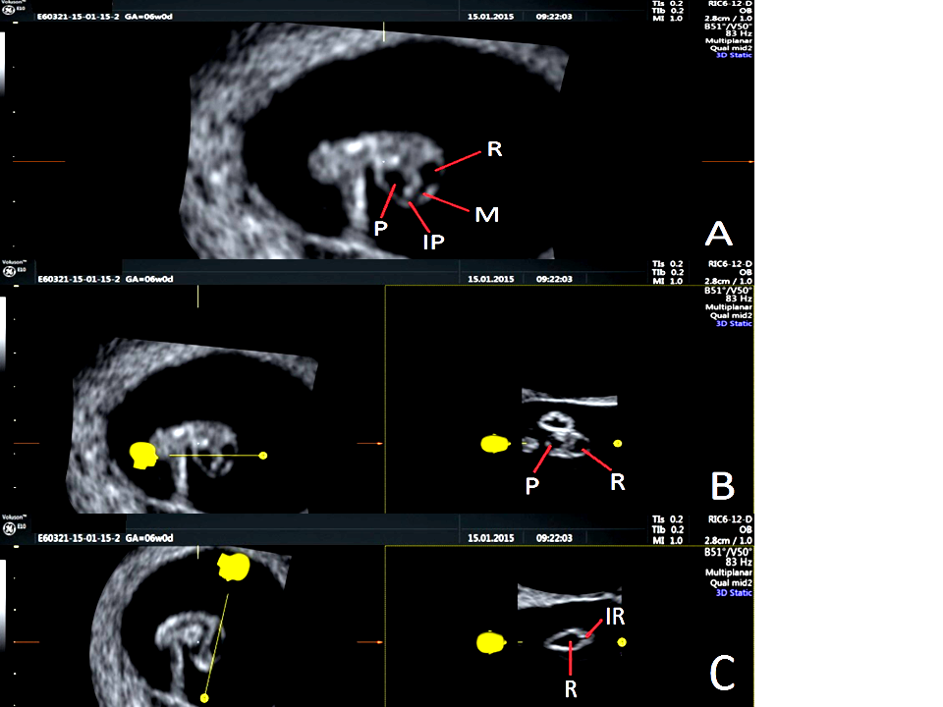
Figure 1. Human embryo 9 mm CRL 7 GW examined by transvaginal ultrasound. Sagittal (A), coronal (B) and axial (C) sections obtained from 3D volume are presented. P: prosencephalon, M: mesencephalon, R: rhombencephalon, IP: isthmus prosencephali. IR: isthmus rhombencephali.

  - Human embryo 17 mm CRL 8 GW.
The prosencephalon is divided into the median diencephalon and two telencephalic vesicles, which are partially separated by the falx cerebri (figure 2, panel C). The cavities of rhombencephalon, mesencephalon and diencephalon are clearly seen on a sagittal section (figure 2, panel A). The pontine flexure begins to form as the rhombencephalon bends ventrally and reduces its longitudinal axis. While the rhombencephalon bends, the metencephalon and the myelencephalon are evident and the 4th ventricle becomes deeper (figure 2, panel B).
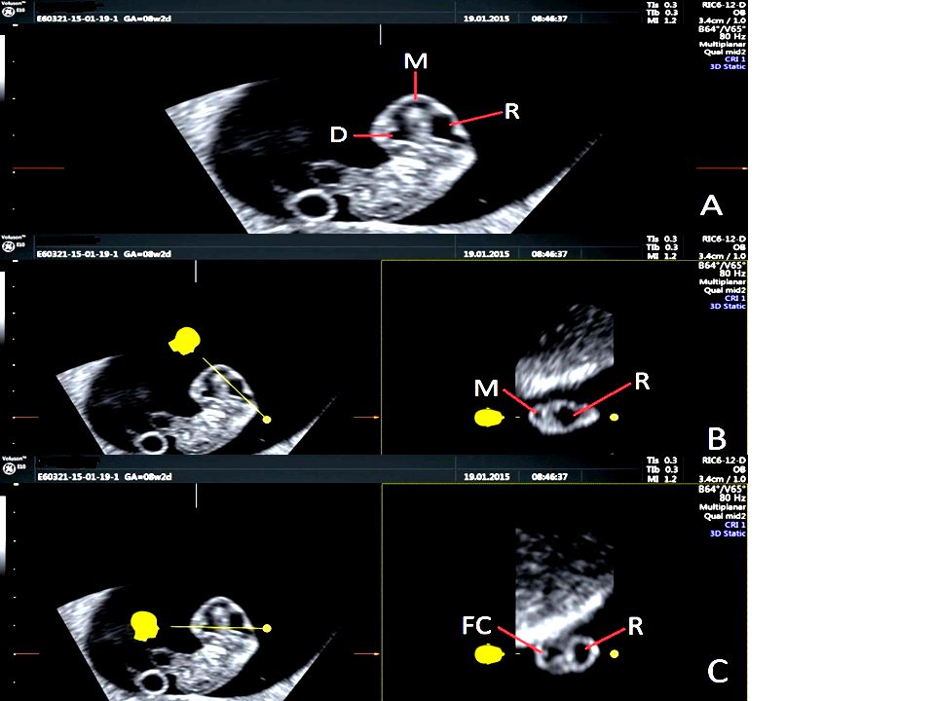
Figure 2. Human embryo 17 mm CRL 8 GW assessed by vaginal ultrasound. Sagittal (A), axial (B) and coronal (C) slices obtained from 3D volume are presented. P: prosencephalon, M: mesencephalon, R: rhombencephalon, D: diencephalon, FC: falx cerebri.

  - Human embryo 23 mm CRL 9 GW.
The brain consists of the cerebral hemispheres, diencephalon, mesencephalon, metencephalon and myelencephalon. The “C”-shaped cerebral hemispheres develop and they are completely separated by the falx cerebri (figure 3, panel A). The choroid plexus are evident inside the lateral ventricles (figure 3, panel B).
The future ventricular system is formed by the lateral ventricles (into the telencephalic vesicles), the 3rd ventricle (into the diencephalon), the cerebral aqueduct (into the mesencephalon) and the 4th ventricle (into the former rombencephalon) as seen in figure 3, panels C and D. The size of the lateral ventricles increases and the 3rd ventricle becomes narrower. In the 4th ventricle the choroid plexus begins to form (figure 3, panel C).
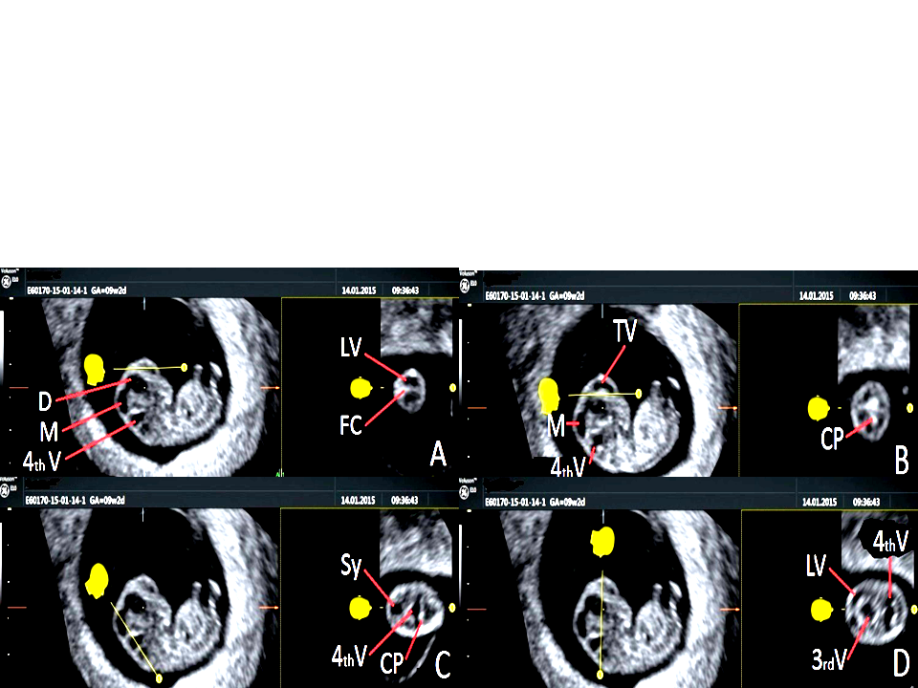
Figure 3. Human embryo 23 mm CRL 9 GW assessed by vaginal ultrasound. Sagittal (A), slightly parasagittal (B), coronal (A, B), axial (D) and oblique (C) sections obtained from 3D volume are shown. D: diencephalon, M: mesencephalon, LV: lateral ventricle, 4thV: fourth ventricle, FC: falx cerebri, TV: telencephalic vesicles, CP: choroid plexus, Sy: cerebral aqueduct, 3rd V: third ventricle.

  - Human embryo 31 mm CRL 10 GW.
The cerebral hemispheres are large and cover the diencephalon. They are dominant in the brain. The ganglionic eminence, as the precursor of the basal ganglia, is well seen on the floor of the telencephalon (figure 4, panels B-D and figure 5, panels A, B). The choroid plexus are developed and bulge into the lateral ventricles (figure 4, panel A).
In the diencephalon the ventral thalamus is evident. The 3rd ventricle becomes narrower (figure 4, panel B). The thalamus is clearly separated from the ganglionic eminence as shown in figure 5, panel A.
In the mesencephalon the cerebral aqueduct is still wide (figure 4, panel A).
The rhombic lips, as precursors of the cerebellum, are separated in the midline and they are closed to the choroid plexus of the 4th ventricle. These structures are obvious on a coronal slice passing through the posterior fossa. The 4th ventricle is deep (figure 4, panel F).

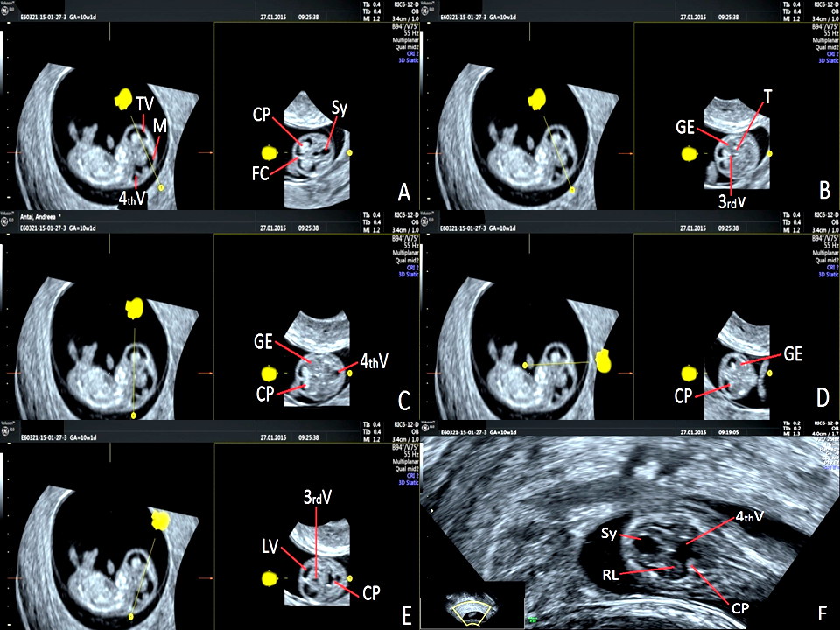
Figure 4. Human embryo 31 mm CRL 10 GW assessed by vaginal ultrasound. Sagittal (A-E), axial (C), coronal (D, F) and “anyplane” (A, B, E) slices obtained from 3D volume are presented. TV: telencephalic vesicles, M: mesencephalon, 4th V: fourth ventricle, CP: choroid plexus, FC: falx cerebri, Sy: aqueduct of Sylvius, GE: ganglionic eminence, T: thalamus, 3rd V: third ventricle, LV: lateral ventricle, RL: rhombic lips.

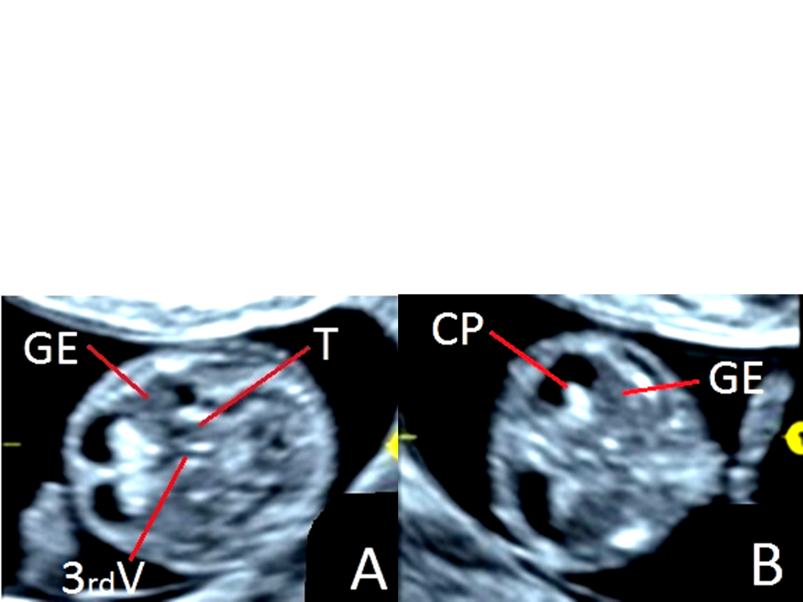
Figure 5. Human embryo 31 mm CRL 10 GW. Details of the images shown in fig. 4, panels B and D. GE: ganglionic eminence, T: thalamus, 3rd V: third ventricle, CP: choroid plexus.

- Discussion
Our study describes the morphology of the embryonic brain at different moments of its development as it is imaged by 3D sonography using a high-frequency vaginal ultrasound transducer. This method allows imaging of early structures in the embryonic brain.
Transvaginal high-resolution 3D ultrasound has enabled increasingly accurate and objective prenatal diagnoses in the first trimester [22]. Some authors identified the rhombencephalon at 6 completed weeks as a hypoechogenic shallow oblong cavity found at the top of the embryo [1]. For other authors, it was impossible to get the inversion-rendered images before 7 weeks because there was not enough fluid in the neural tube for the transducer to detect, so the earliest gestational age at which they could get the brain volume was 7 weeks 4 days, corresponding to a CRL of 13.6 mm [23].
We demonstrate that the developing brain can already be assessed by vaginal sonography at an embryo of 9 mm CRL, corresponding at 7 completed weeks. At this age, the ultrasound morphology of the brain is simple, since only the hypoechoic cavities of the cerebral vesicles are evident. After that, the brain becomes more and more complex. For example, we were able to demonstrate the ganglionic eminence at a 31 mm CRL embryo, which corresponds at 8 post-conceptional weeks (the end of the embryonic period).
It was reported that the lateral ventricles, third ventricle, aqueduct and fourth ventricle are visible at 7 weeks [2]. We demonstrated the cavities of the cerebral vesicles, i.e prosencephalon, mesencephalon and rhombencephalon, at a 9 mm CRL embryo, but not the lateral ventricles. In our opinion, this is because the age of 7 completed weeks may correspond to embryos ranging from 9 to 14 mm CRL.
We could image the choroid plexuses in the lateral ventricles and fourth ventricle at an embryo of 23 mm CRL, corresponding at 9 completed weeks. We didn’t found that the choroid plexuses are evident by ultrasound imaging at a 17 mm CRL embryo of 8 completed weeks as reported in some studies [2]. This supports the idea that the brain undergoes dramatic changes and in a period of a week the embryo may express different morphological characteristics. On the other hand, two embryos with identical CRL may have not identical morphology. This presumption led to the description of Carnegie stages by O’Rahilly and Müller in 1987, revised in 2010 [24]. In the future it would be suitable to establish an ultrasound staging system of the embryos based on the sonographic morphology, like the Carnegie stages is based on the morphology of embryos [25].
The morphology of the embryos in our study is labeled as “normal” considering the similarity between the features that we encountered and those reported in other studies [23, 26, 1, 25]. The definition of the “normal anatomy” of the human embryo provides the basis for the identification of congenital anomalies at the earliest stages of human development [22].
The knowledge of the ultrasound morphology of the embryonic brain is useful for the sonographers as well as for the clinicians, considering that the detection of the congenital anomalies tends to be made as early as possible in pregnancy [27]. The detection of brain abnormalities by ultrasonography during early pregnancy is therefore a challenge [28]. Visualisation of normal anatomy in the first trimester, along with a low risk aneuploidy screening result, would afford patients reassurance and reduction in anxiety [7]. It is also important to define the time when the various diagnoses can be made with adequate certainty, in order to offer women at risk an examination at the appropriate gestational age [1].
The quality of the sonographic images depends on an adequate access to equipment and on a proper training of sonographers [7]. The high-frequency transvaginal transducers provide a good resolution, while the acquisition of a 3D volume allow for slicing the region of interest with a convenient plane. The sensitivity of the first-trimester anatomy scan seems to increase with experience [29]. The quality of the scans declines rapidly with increasing depth and is affected by the artefacts due to embryonic or maternal movements [28].
Transvaginal ultrasound is preferred for the first trimester scanning. It can result in improved visualisation in certain patients in whom the transabdominal ultrasound is not suitable, either as a result of fetal position, maternal habitus [7] or interposition of the placenta [15]. The transvaginal scanning has been shown to be of particular benefit in obese women in whom the abdominal wall may represent a barrier to ultrasound transmission [30].
In the past, it was thought that vaginal ultrasound could have been an important tool in embryological researches because structures of only a few millimeters could have been imaged in vivo in three-dimensions with an acceptable quality [31]. After that, the micro-magnetic resonance imaging (MRI) provided more accurate and detailed images of small embryos. Ultrasound is less effective for morphological studies in embryology. It can’t assess the fine internal structures of the embryos because of the limited wavelength of clinical ultrasound machines [32]. Even if the quality of achieved images is poor comparing to the microMRI, the ultrasound remains the standard method for the in vivo assessment of embryos because it is inoffensive and affordable. For now, the intense magnetic fields of 7 Tesla or more of the modern MRI machines are not used for in vivo embryological studies. On the other hand, 3D/4D transvaginal sonography brought embryology from the ex vivo studies to the in vivo environment even in the first trimester of pregnancy [27].
The development of a standardized first-trimester anatomical ultrasound protocol with specific targets and visualization rates was proposed [7]. For example, by 9 weeks of gestation the cerebral hemispheres should be visualized in all embryos. In our opinion, such protocols must not rely on the CRL or on the age of the embryos calculated as the number of weeks elapsed from the last menstrual period, which is very uncertain and source of errors [33], but on precise morphological characteristics of the embryos. It was assumed that the development of a discrete structure is a more reliable marker of the stage of embryonic development than size or putative age [25].

- Conclusions
Studies of embryology are still needed for a complete understanding of the developing brain.
Early diagnosis of the congenital anomalies requires a good knowledge of the anatomy and sonographic semeiology of the embryonic brain.
3D sonography using a high-frequency vaginal ultrasound transducer is feasible for imaging the embryonic brain with an acceptable quality for clinical studies. This method has an important contribution to the early diagnosis of congenital anomalies and could be part of routine ultrasound examination.
In the future, establishing of an ultrasound-based staging system of the human embryos will be a challenge.

References
- Blaas HGK, Eik-Nes SH. Sonoembryology and early prenatal diagnosis of neural anomalies. Prenat Diagn 2009; 29: 312–325.
- Blaas HGK. Detection of structural abnormalities in the first trimester using ultrasound. Best Pract Res Clin Obstet Gynaecol 2014;28:341-353.
- Timor-Tritsch IE, Peisner DB, Raju S. Sonoembryology: an organ-oriented approach using a high-frequency vaginal probe. J Clin Ultrasound 1990;18:286-298.
- Rottem S, Bronshtein M, Thaler I et al. First trimester transvaginal sonographic diagnosis of fetal anomalies. Lancet 1989;1:444–445.
- Bronshtein M, Wiener Z. Early transvaginal sonographic diagnosis of alobar holoprosencephaly. Prenat Diagn 1991;11:459–462.
- Achiron R, Tadmor O. Screening for fetal anomalies during the first trimester of pregnancy: transvaginal versus transabdominal sonography. Ultrasound Obstet Gynecol 1991;1:186–191.
- Donnelly JC, Malone FD. Early fetal anatomical sonography. Best Pract Res Clin Obstet Gynaecol 2012;26:561–573.
- Pretorius DH, Nelson TR. Three-dimensional ultrasound. Ultrasound Obstet Gynecol 1995;5:219-221.
- Merz E. Three-dimensional ultrasound-a requirement for prenatal diagnosis. Ultrasound Obstet Gynecol 1998;12:225-226.
- Kurjak A, Kupesic S, Banovic I, Hafner T, Kos M. The study of morphology and circulation of early embryo by three-dimensional ultrasound and power Doppler. J Perinat Med 1999;27:145-157.
- Pooh RK, Pooh K. Assessment of Fetal Central Nervous System. Donald School J Ultrasound Obstet Gynecol 2013; 7(4):369-384.
- Filho SMZ, Araujo jr. E, Filho HAG, Pires CR, Nardozza LMM, Moron AF. Sonoembryology by three-dimensional ultrasonography: pictorial essay. Arch Gynecol Obstet 2007;276:197–200.
- Merz E, Pashaj S. Current role of 3D/4D Sonography in Obstetrics and Gynecology. Donald School J Ultrasound Obstet Gynecol 2013;7(4):400-408.
- Kurjak A, Pooh RK, Merce LT, Carrera JM, Salihagic-Kadic A, Andonotopo W. Structural and functional early human development assessed by threedimensional and four-dimensional sonography. Fertil Steril 2005;84:1285-1299.
- Pooh RK. Contribution of Trans-Vaginal High-Resolution Ultrasound in Fetal Neurology. Donald School J Ultrasound Obstet Gynecol 2011;5(2):93-99.
- Timor-Tritsch IE, Monteagudo A, Warren WB. Transvaginal ultrasonographic definition of the central nervous system in the first and early second trimesters. Am J Obstet Gynecol 1991;164:497–503.
- Blaas HG, Eik-Nes SH, Berg S, Torp H. In-vivo three-dimensional ultrasound reconstructions of embryos and early fetuses. Lancet 1998;352:1182–1186.
- Berg S, Torp H, Blaas HG. Accuracy of in-vitro volume estimation of small structures using three-dimensional ultrasound. Ultrasound Med Biol 2000;26:425–432.
- Timor-Tritsch IE, Monteagudo A, Santos R. Three-dimensional inversion rendering in the first- and early second-trimester fetal brain: its use in holoprosencephaly. Ultrasound Obstet Gynecol 2008;32(6):744-750.
- Tanaka H, Senoh D, Yanagihara T, Hata T. Intrauterine sonographic measurement of embryonic brain vesicle. Hum Reprod 2000;15(6):1407-1412.
- Tanaka H, Hata T. Intrauterine sonographic measurement of the embryonic brain mantle. Ultrasound Obstet Gynecol 2009;34:47–51.
- Pooh RK. Neurosonoembryology by three-dimensional ultrasound. Semin Fetal Neonatal Med 2012;17:261-268.
- Kim MS, Jeanty P, Turner C, Benoit B. Three-dimensional sonographic evaluations of embryonic brain development. J Ultrasound Med 2008; 27:119-124.
- O’Rahilly R, Muller F. Developmental stages in human embryos: revised and new measurements. Cells Tissues Organs 2010;192(2):73-84.
- Pooh RK, Shiota K, Kurjak A. Imaging of the human embryo with magnetic resonance imaging microscopy and high-resolution transvaginal 3-dimensional sonography: human embryology in the 21st century. Am J Obstet Gynecol 2011;204-216.
- Hata T, Dai SY, Kanenishi K, Tanaka H. Three-dimensional volume-rendered imaging of embryonic brain vesicles using inversion mode. J Obstet Gynaecol Res 2009; 35:258-261.
- Pooh RK, Kurjak A. 3D/4D sonography moved prenatal diagnosis of fetal anomalies from the second to the first trimester of pregnancy. J Matern Fetal Neonatal Med 2012;25(5):433-455.
- Gijtenbeek M, Bogers H, Groenenberg IAL et al. First trimester size charts of embryonic brain structures. Hum Reprod 2014;29(2):201–207.
- Taipale P, Rovamo L, Hiilesmaa V. First-trimester diagnosis of imperforate anus. Ultrasound Obstet Gynecol 2005; 25: 187–188.
- Hendler I, Blackwell SC, Treadwell MC et al. Does advanced ultrasound equipment improve the adequacy of ultrasound visualization of fetal cardiac structures in the obese gravid woman? Am J Obstet Gynecol 2004; 190: 1616–1619.
- Blaas HG, Eik-Nes SH, Kiserud T, Berg S, Angelsen B, Olstad B. Three-dimensional imaging of the brain cavities in human embryos. Ultrasound Obstet Gynecol 1995;5:228-232.
- Matsuda Y, Ono S, Otake Y et al. Imaging of a Large Collection of Human Embryo Using a Super-Parallel MR Microscope. Magn Reson Med Sci. 2007;6(3):139-146.
- O’Rahilly R, Muller F. Prenatal ages and stages–measures and errors. Teratology 2000;61:382-384.

