Effects of CO-CR Discrepancy in Daily Orthodontic
Treatment Planning
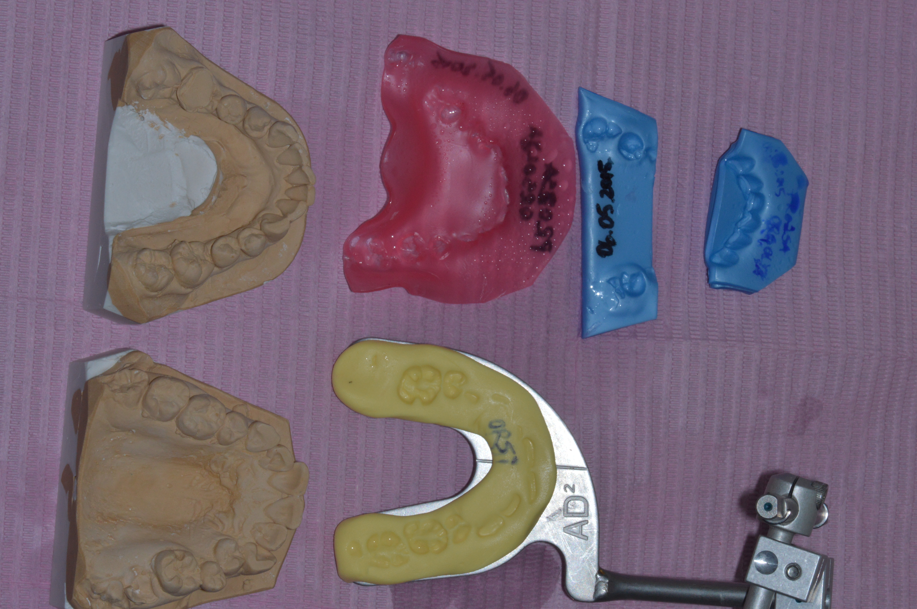

List of figures.

Figure 1. Part of the registrations taken in order to fully diagnose each case: study cast models in class IV plaster, CO and CR wax registrations, facebow bitefork.
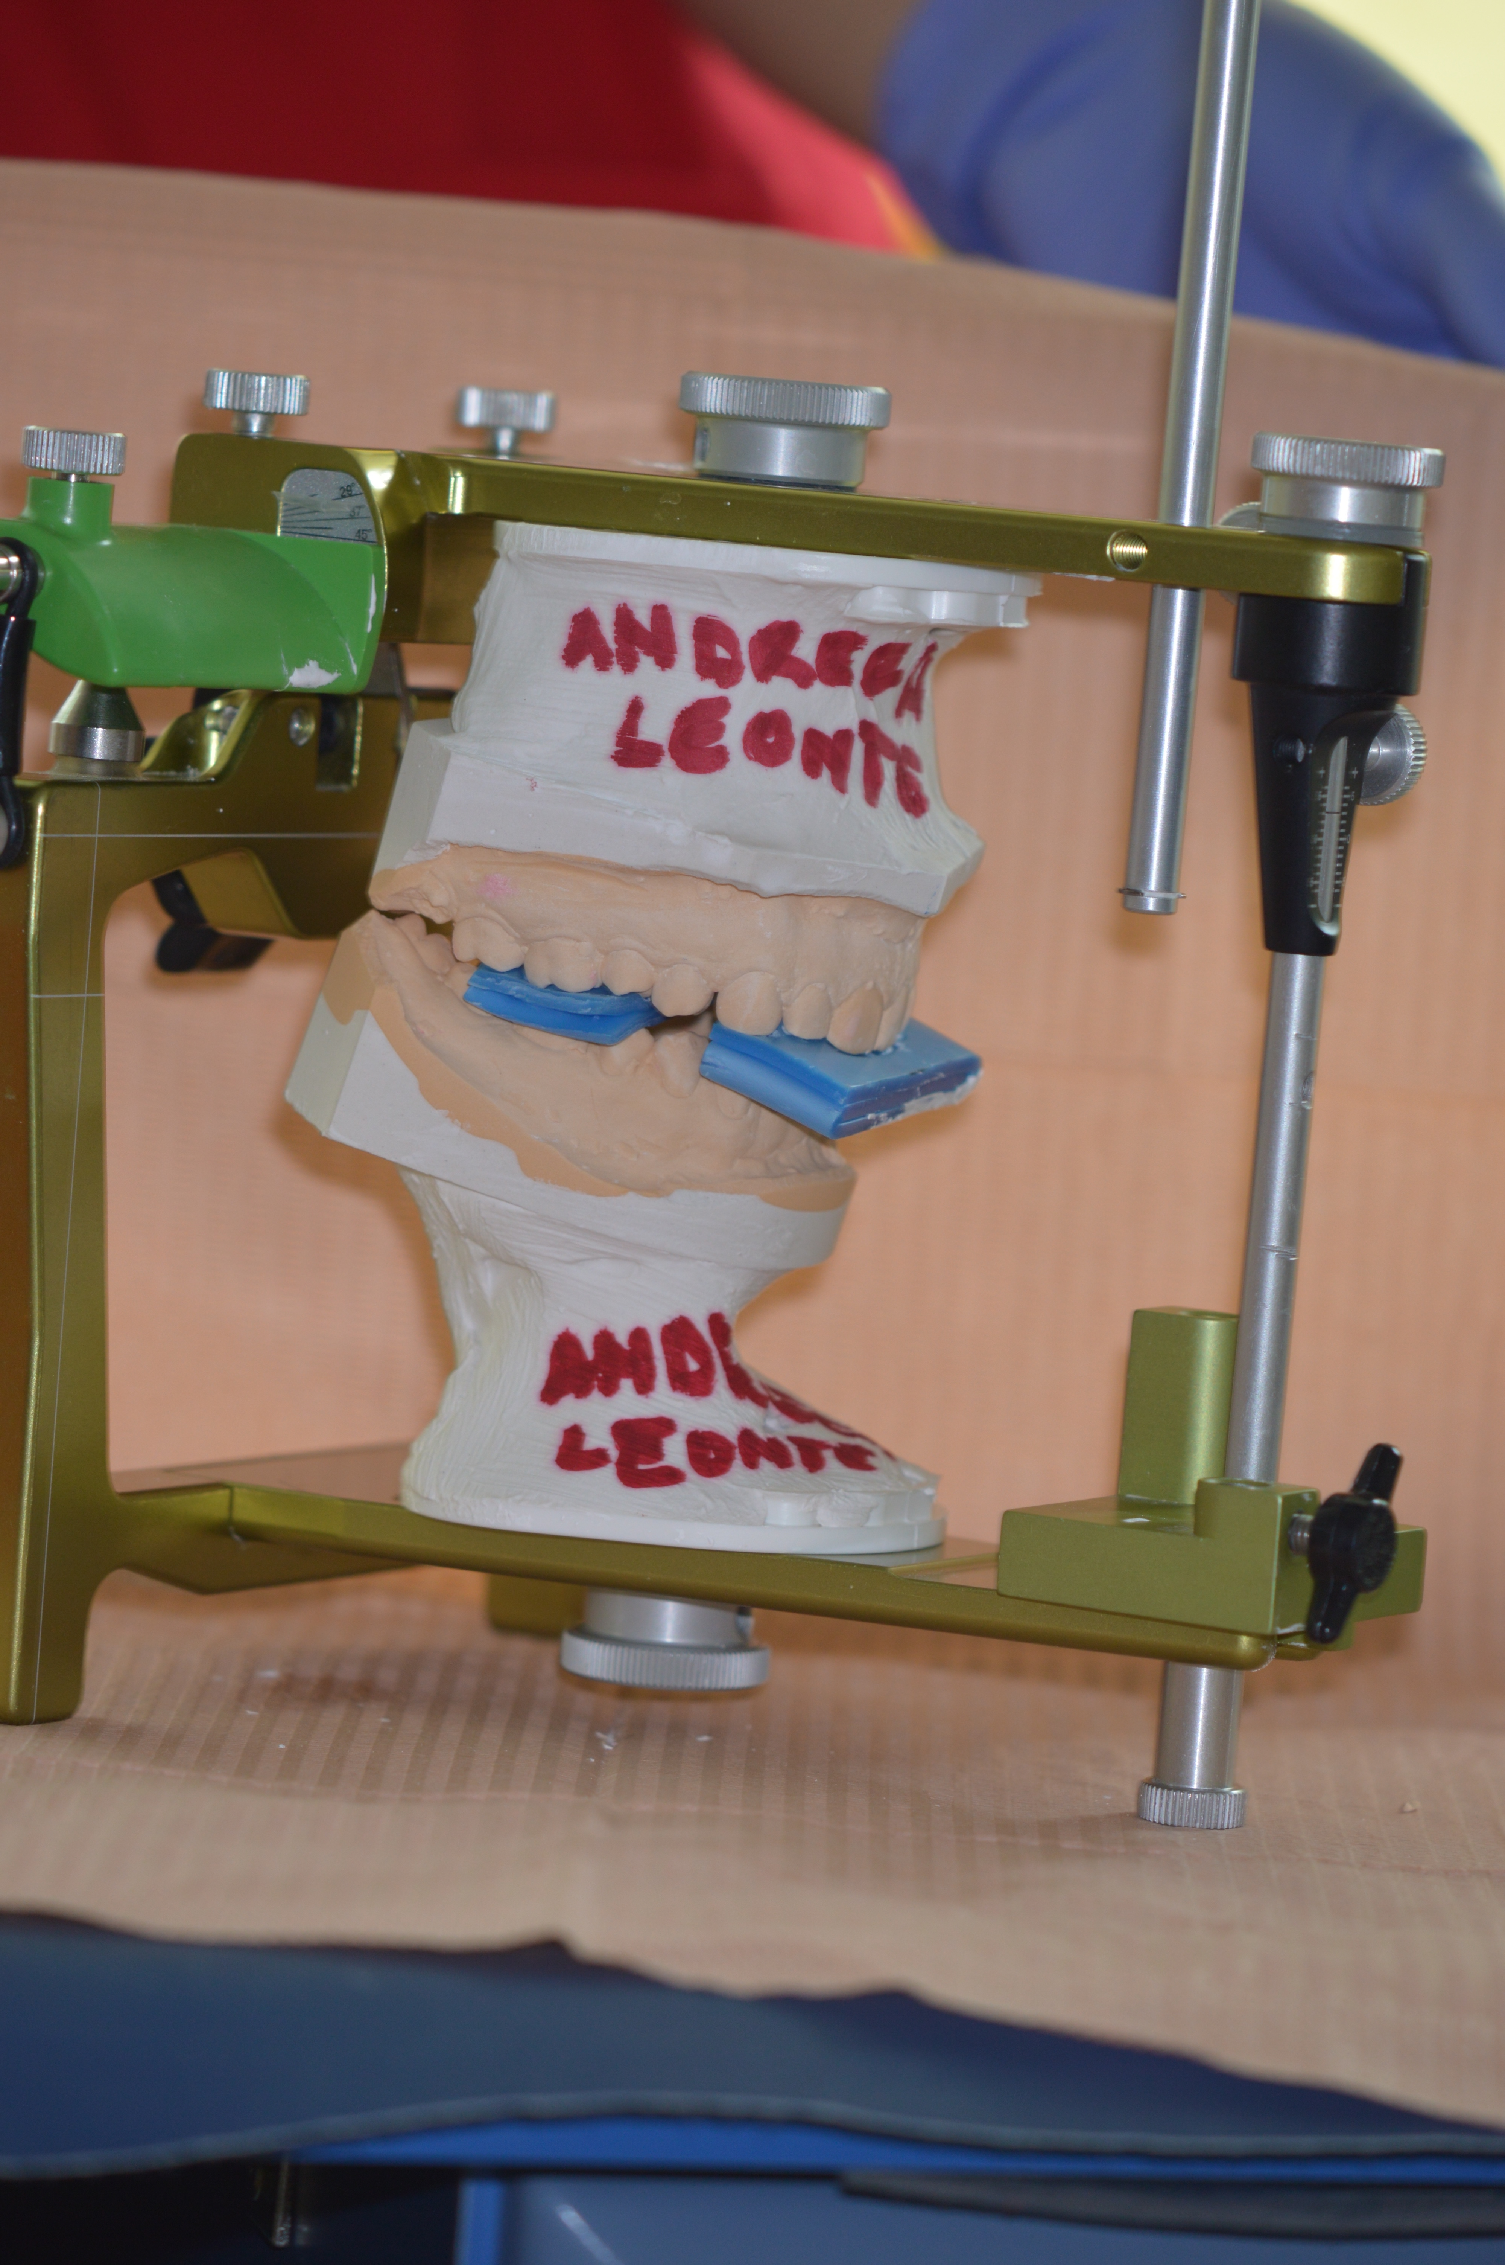

Figure 2. AD2 articulator mounted models with the CR bite registration in place.
C
D

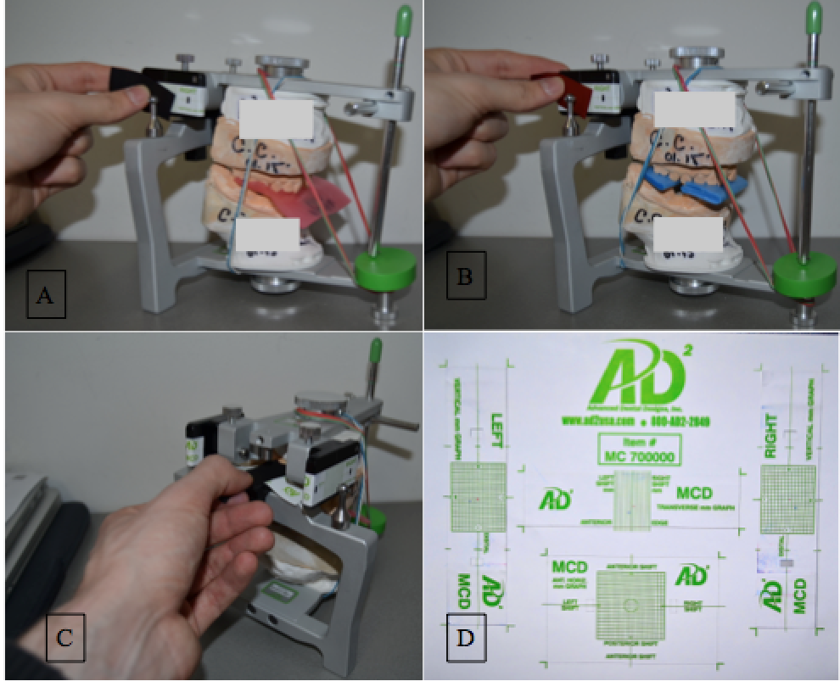

Figure 3. Condylar position evaluation with the use of MCD: A. CO condylar position in the vertical and horizontal planes; B. CR condylar position in the vertical and horizontal planes; C. Transverse condylar position evaluation in CO; D. MCD paper graph after CO-CR discrepancy registration. The paper stickers are being placed back on the individual patient chart once the registration is done, in order to keep the records safe.

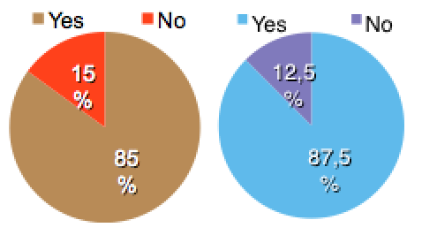
Figure 4. The CO-CR discrepancy: A.Vertical discrepancy; B.Horizontal disprepancy.

Figure 5. Vertical condylar displacement between CO-CR.

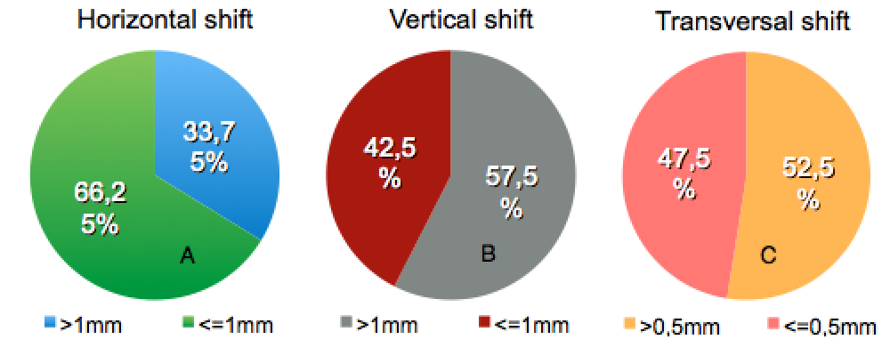

Figure 6. The distribution of the CO-CR shift: A.Horizontal condylar shift ; B. Vertical condylar shift; C.Transversal condylar shift.

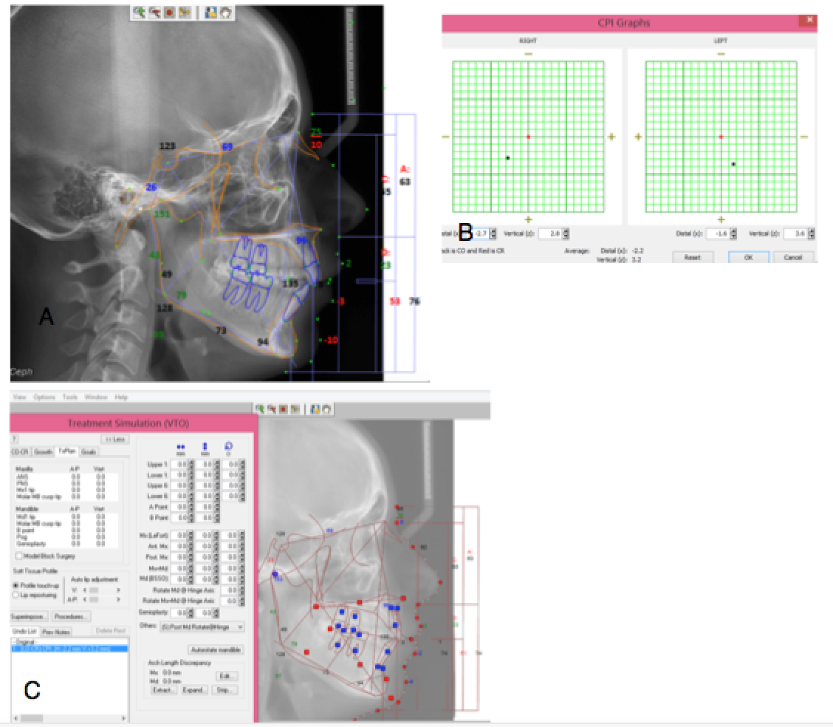

Figure 7. Lateral cephalometric radiograph changes when adding the CO-CR discrepancy in a orthodontics software; A. Initial analysis; B.CO-CR discrepancy ; C. Changes occurring after the CO-CR correction.

