Effects of CO-CR Discrepancy in Daily Orthodontic
Treatment Planning

List of figures and tables
Figures
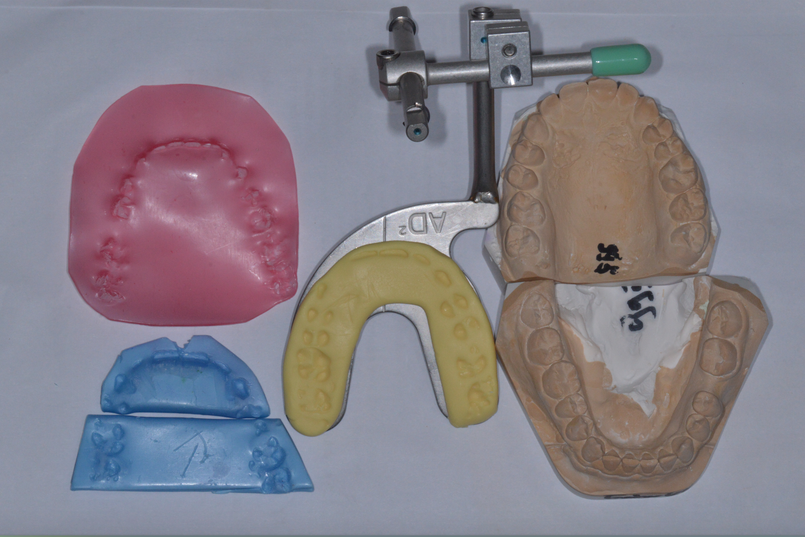

Figure 1. Part of the registrations taken in order to fully diagnose each case: study cast models in class IV plaster, CO and CR wax registrations, facebow bitefork.

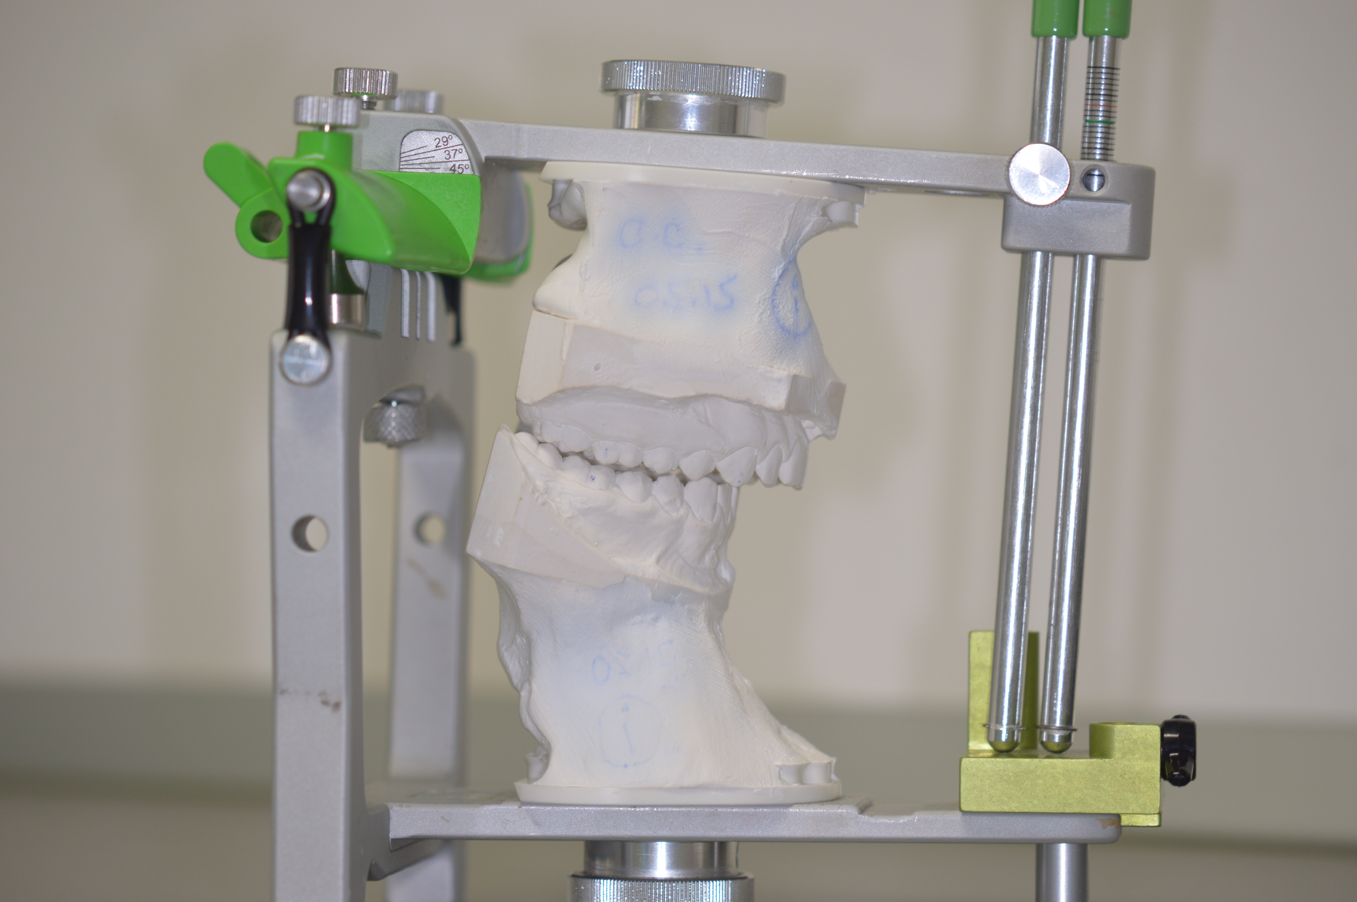

Figure 2. AD2 articulator mounted models.

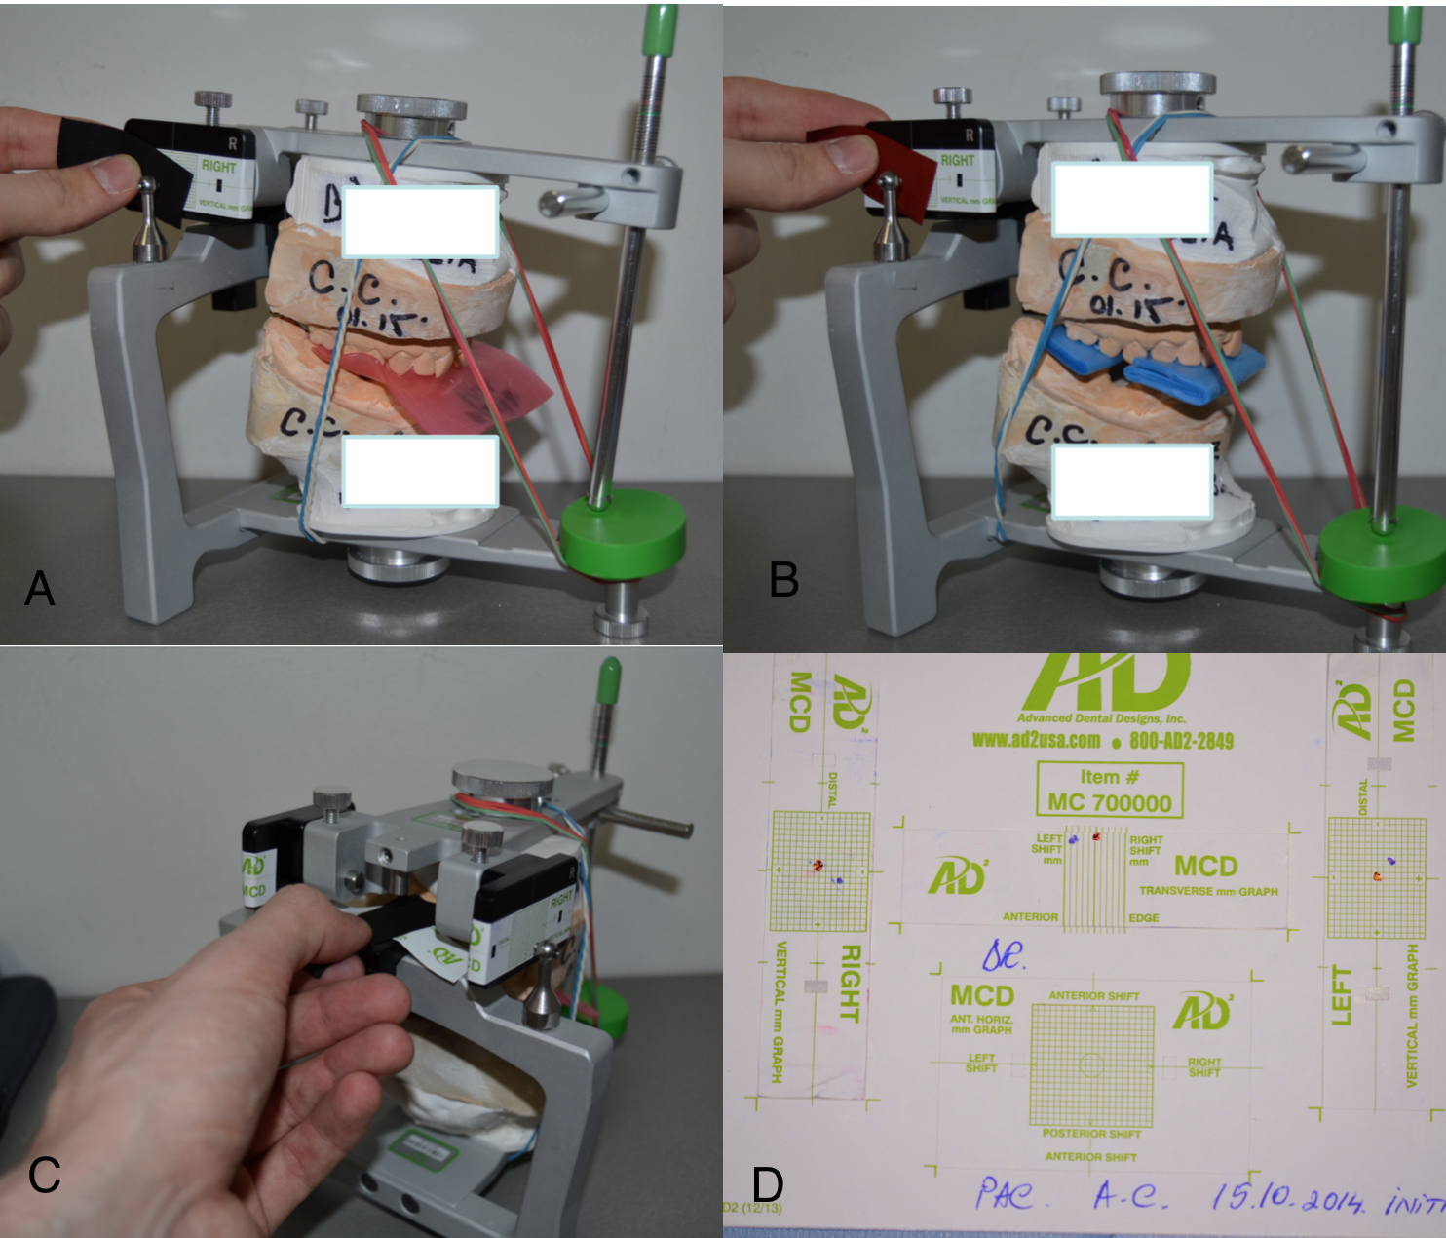

Figure 3. Condylar position evaluation with the use of MCD: A. CO condylar position in the vertical and horizontal planes; B. CR condylar position in the vertical and horizontal planes; C. Transverse condylar position evaluation in CO; D. MCD paper graph after CO-CR discrepancy registration.

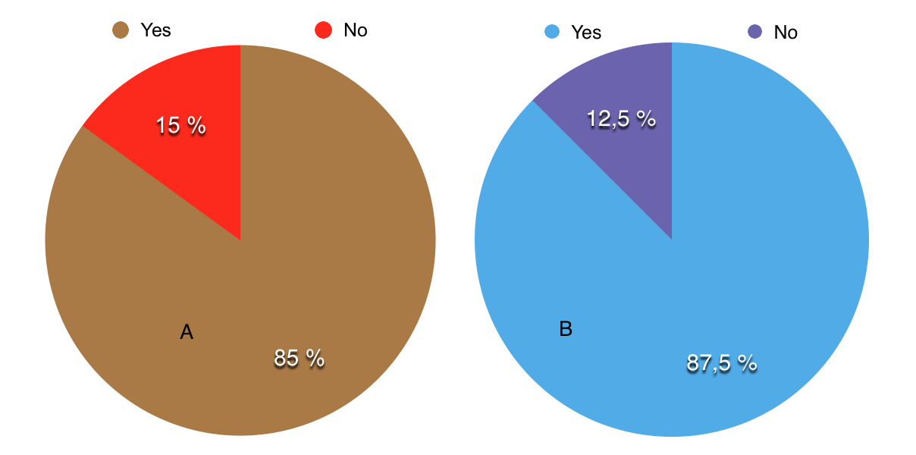
Figure 4. The CO-CR discrepancy: A.Vertical discrepancy; B.Horizontal disprepancy.

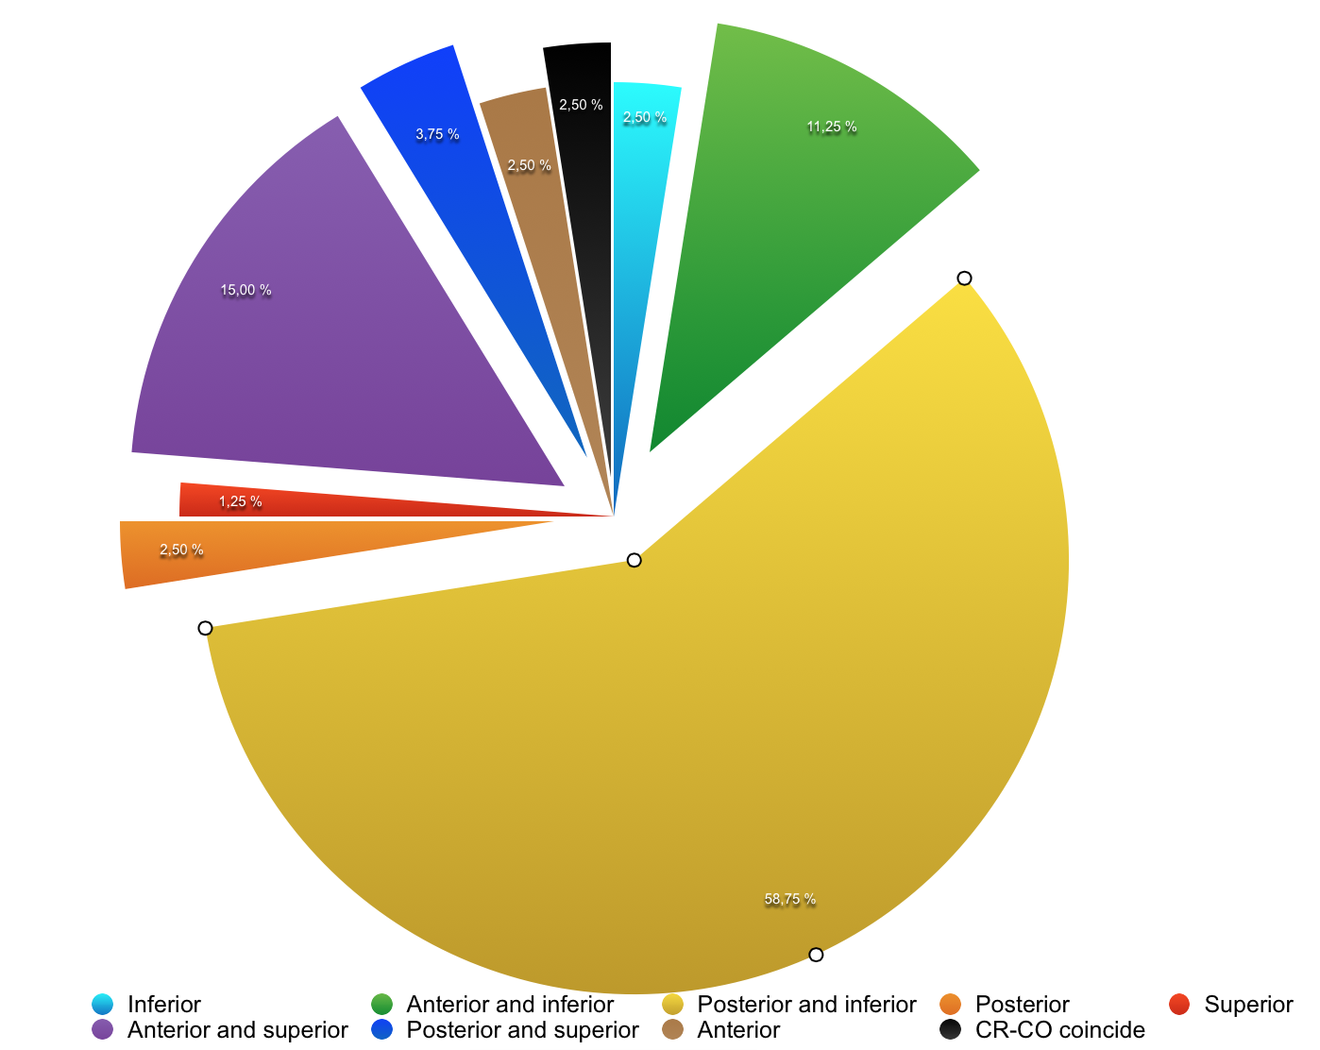

Figure 5. Vertical and horizontal condylar displacement between CO-CR.

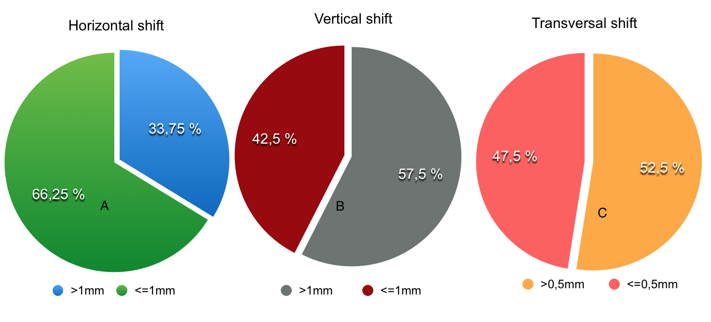

Figure 6. The distribution of the CO-CR shift: A.Horizontal condylar shift ; B. Vertical condylar shift; C.Transversal condylar shift.

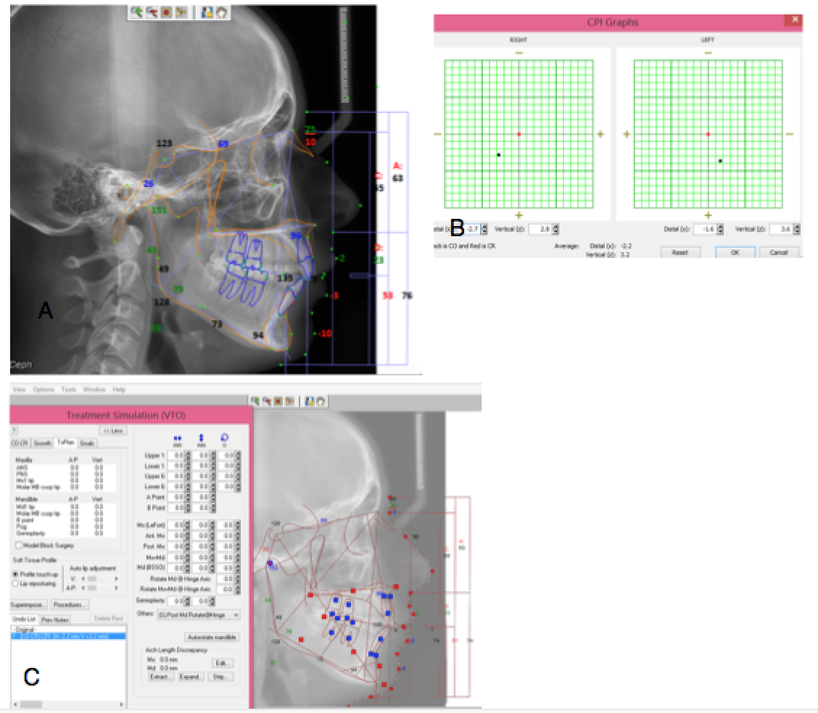

Figure 7. Lateral cephalometric radiograph changes when adding the CO-CR discrepancy in Dolphin software; A. Initial analysis; B.CO-CR discrepancy ; C. Changes occurring after the CO-CR correction.

Tables

Table I. Condylar displacement measurements obtained in our study (absolute values);

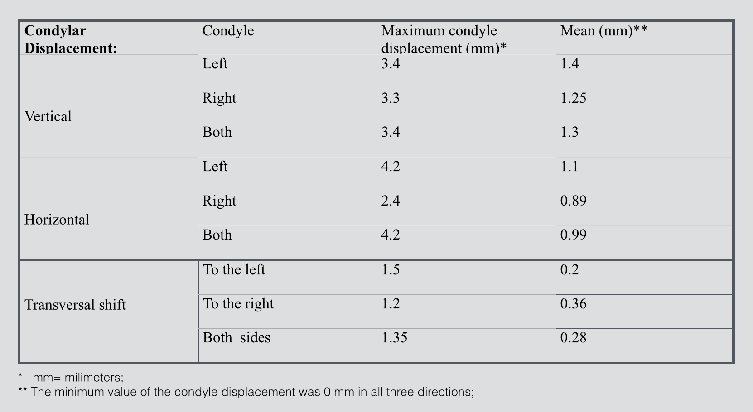

Table II. Comparision between our results and other studies.

