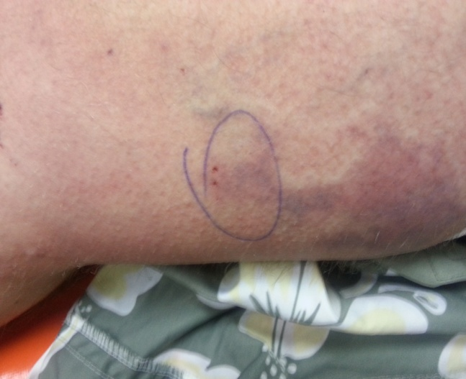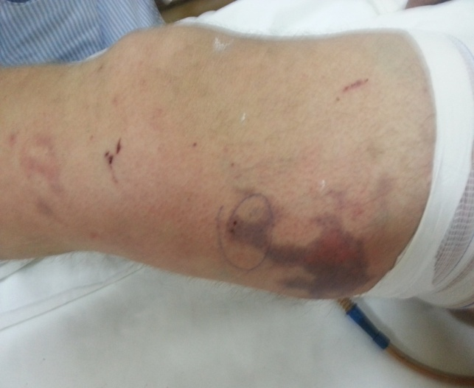

a) b)

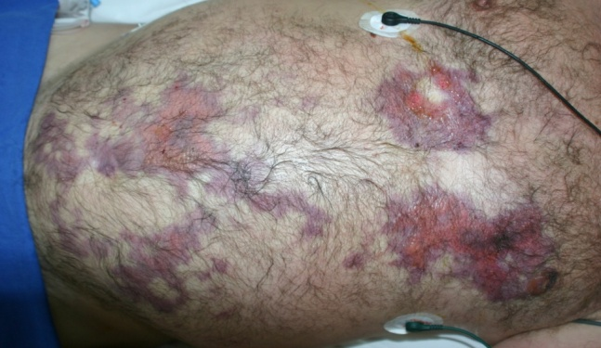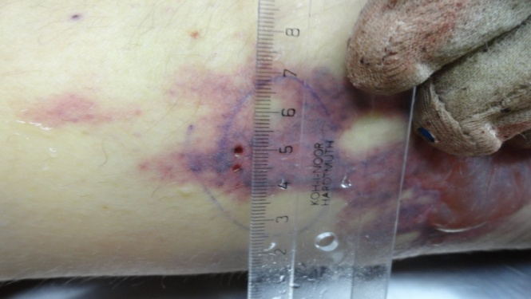

c) d)

Fig. 1 Bite aspect a) at admission 7 PM, b) at 11.30 PM, c) 24 hours after admission, d) postmortem