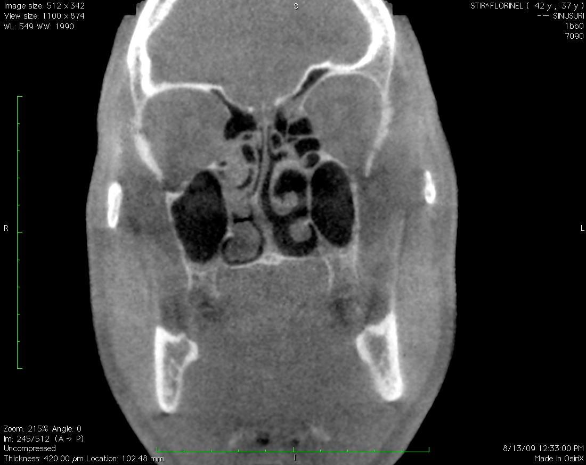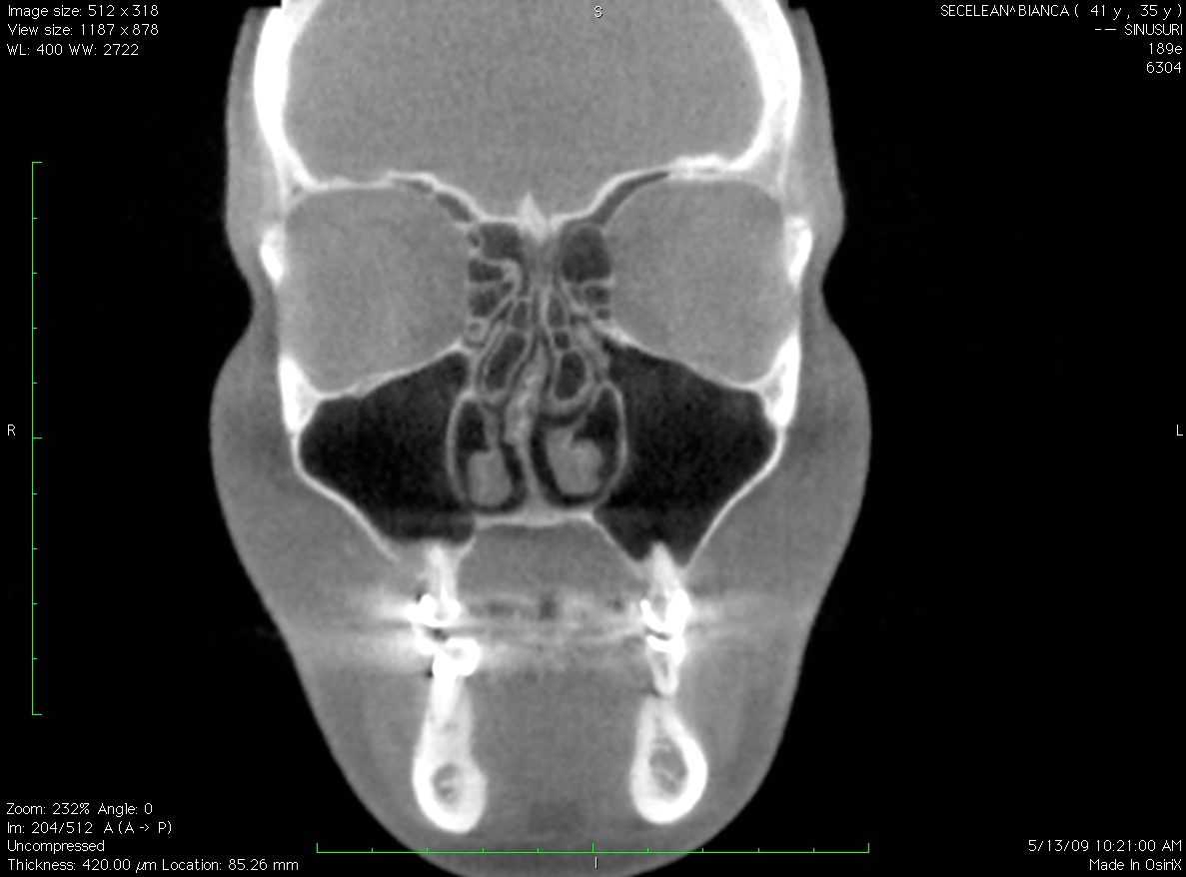

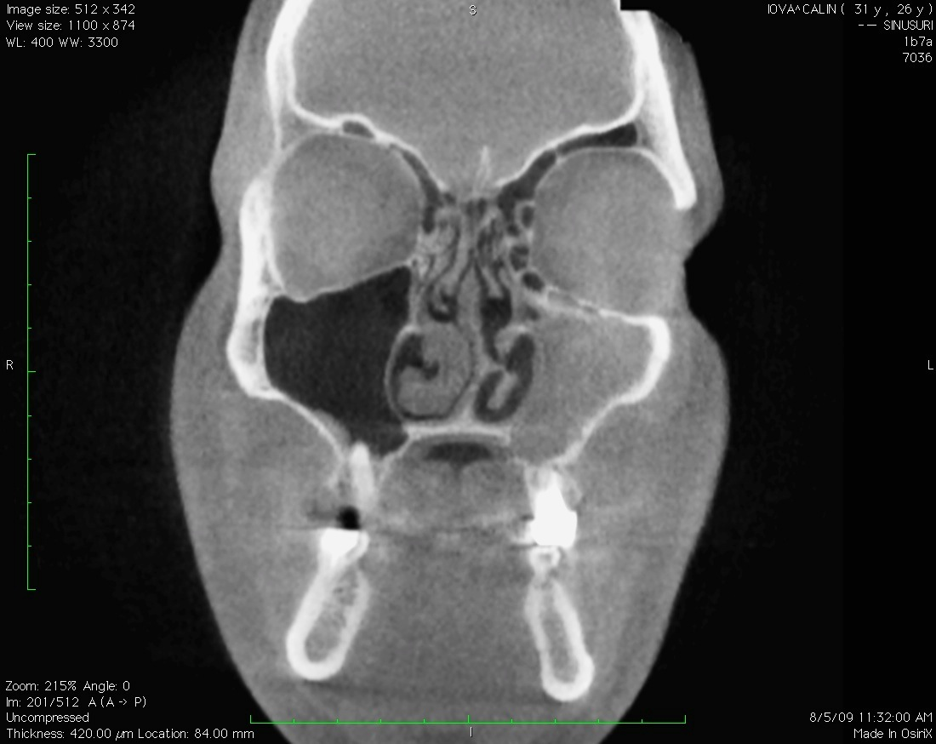**Fig 1 a,b**. Midlle turbinate variations **a**. Right Inverted middle turbinate with a right nasal septal deviation. **b.** Bilateral pneumatized middle turbinate associated right nasal septum deviation

Fig 2. CBCT coronal section. Left visibly occupied Haller cell and right inverted middle turbinate. Left sinus inflammation

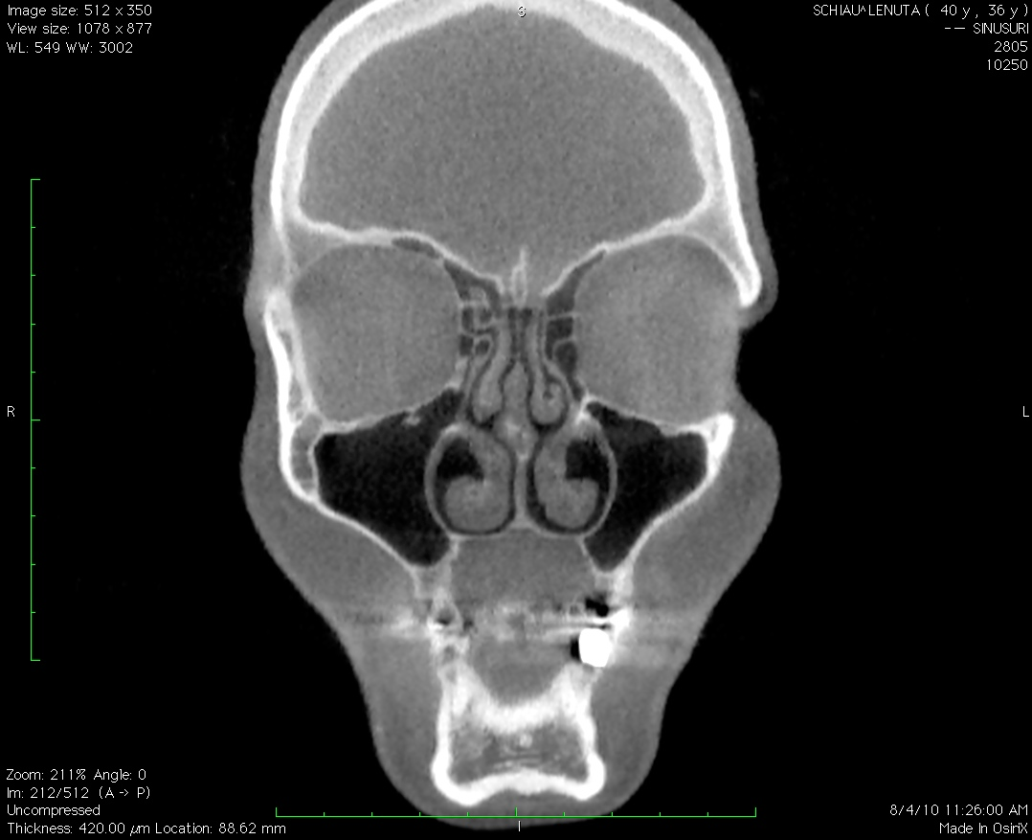

Fig 3. CBCT coronal section. Pneumatised UP

Fig 4. CBCT coronal section. Cribriform plate attachment of the uncinate process in a case with ipsilateral concha bullosa

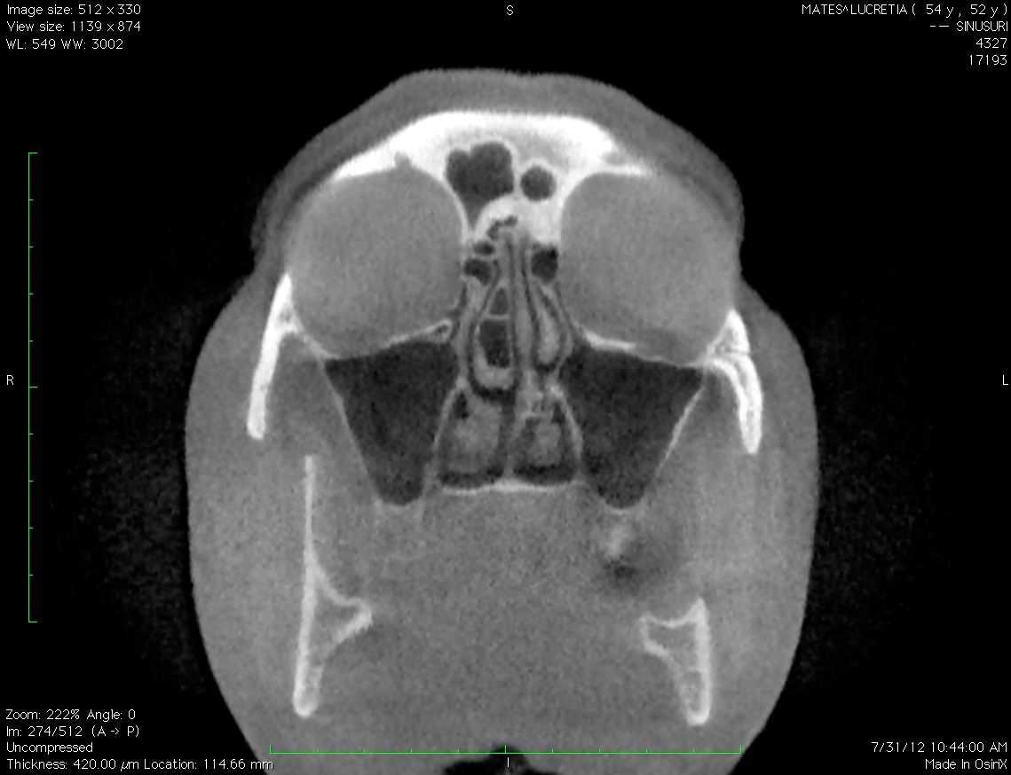

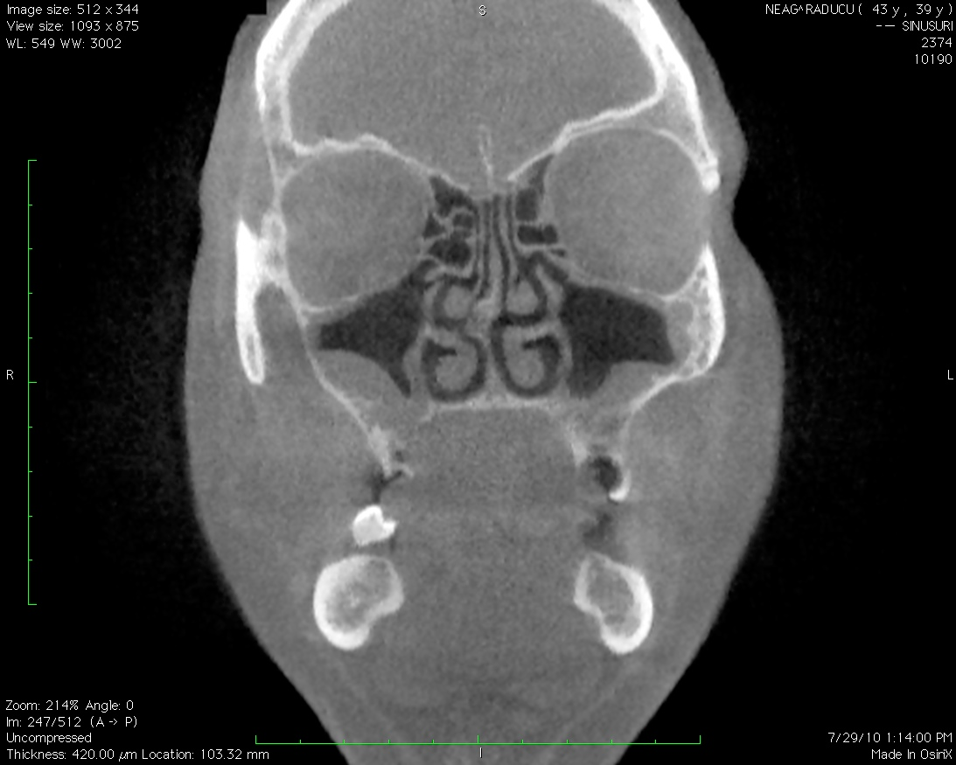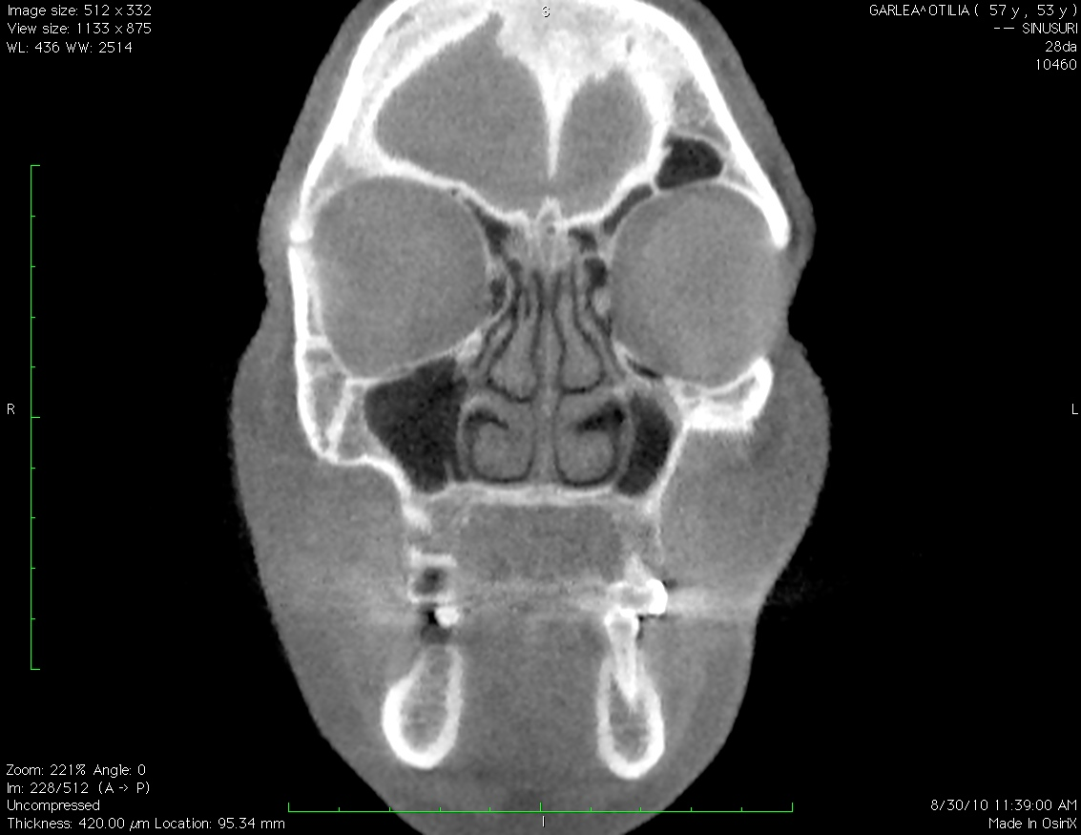Fig 5. CBCT coronal section, superior insertion of the uncinate process

Fig 6. CBCT coronal view. Ethmoidal roof asymmetry with bilateral maxillary sinus inflammation

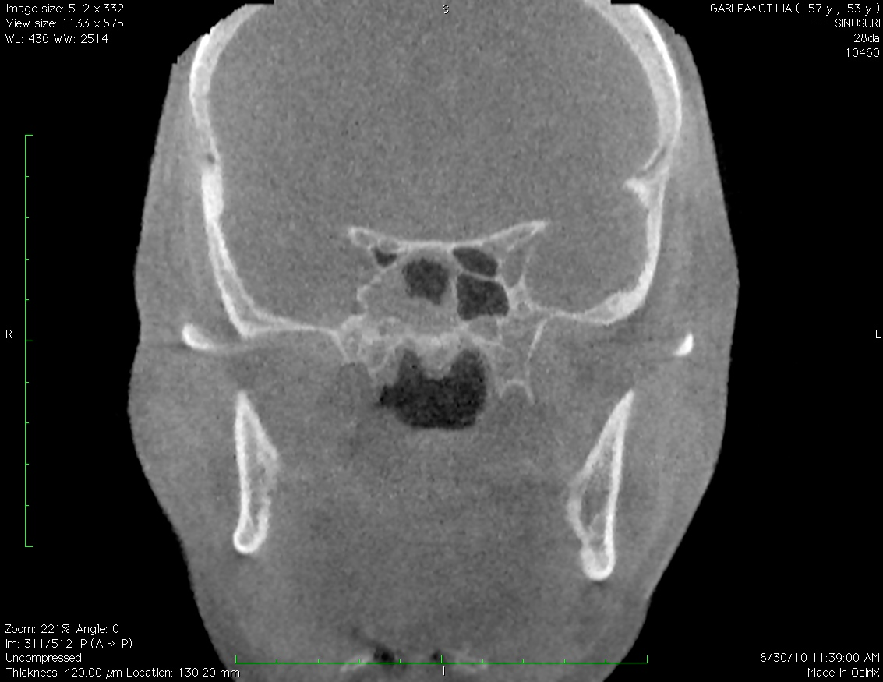

Fig.7 CBCT coronal section. The presence of Onodi cells in conjunction with right sphenoid sinus

