Global chemical reactivity parameters for several chiral beta-blockers from Density Functional Theory Viewpoint

- Background & Aim
Beta-adrenergic antagonists have been established as first line of treatment in the medical management of hypertension [1], as well as acute coronary syndrome, in patients with recent myocardial infarction (<3 years) and/or left ventricular systolic dysfunction (left ventricular ejection fraction ≤40%); in congestive heart failure, where one of three beta-blockers were proven to reduce mortality (e.g., bisoprolol, carvedilol, and sustained-release metoprolol succinate); it is recommended for all patients with current or prior symptoms of HFrEF (Heart Failure with a preserved Ejection Fraction), unless contraindicated, to reduce morbidity and mortality [2]. Beta-blockers have also been well established for the prevention of initial episodes of gastrointestinal bleeding in patients with cirrhosis and esophageal varices [3, 4], glaucoma, and have recently become the main form of treatment of infantile hemangiomas.
In the pharmaceutical field, molecular chirality is a propriety which plays a main role in the activity of drugs, which is also the case of beta-blockers, making the identification and separation of enantiomers extremely important. The activity of enantiomeric forms of pharmaceuticals is known to be often distinctly different, one of the enantiomers may be biologically active while the other may be inactive, toxic or ballast. Furthermore, stereochemistry plays an important role for biodegradability of chemical species but there are no specific rules for how to decide which enantiomer will be preferably degraded. [5, 6] This is particularly important from an environmental point of view, considering the presence of active pharmaceutical ingredients in the aquatic environment is increasingly seen as one of the major challenges to the sustainable management of water resources. Stereochemical features of a molecule can have an influence on its stability and reactivity to other chiral molecules. In 2012, five quantum chemical descriptors were applied to pyrrolidin-2-one compounds: HLG (gap between E_{HOMO} and E_{LUMO}), hardness (η), softness (σ) and electronegativity (χ), total energy (E_{total}), for the prediction of retention factors [7]. Based on Koopmans’ theorem, the chemical potential χ_{m} and chemical hardness η can be calculated as: η= +0.5(E_{LUMO} – E_{HOMO}) and χ_{m}= -0.5(E_{HOMO} + E_{LUMO}). Acebutolol, metoprolol and atenolol were investigated by applying quantum mechanical computer codes and comparison of the same to study the properties associated with their electronic structure. HOMO (Highest Occupied Molecular Orbital), LUMO (Lowest Unoccupied Molecular Orbital), stability, sensitivity and chemical hardness were calculated on the optimized structures [8].
The aim of the present study is to calculate several quantum chemical descriptors (HOMO, LUMO, HLG, electronegativity, chemical potential, hardness and softness, electrophilicity) in order to interpret various molecular properties such as electronic structure, conformation, reactivity in the interest of determining how such descriptors could have an impact in our understanding of the experimental observations and describing various aspects of chemical binding of beta-blockers in terms of these descriptors.
- Methods
  - Analytes
The studied molecules are fourteen beta-adrenoceptor blocking agents with the chemical structures depicted below in Table I:
Table I Chemical structure of beta-adrenoceptor blocking agents (a- acebutolol, b- alprenolol, c- atenolol, d- betaxolol, e- bisoprolol, f- carazolol, g- carvedilol, h- esmolol, i- metoprolol, j- oxprenolol, k- pindolol, l- propranolol, m- sotalol, n- timolol) * - asymmetric C
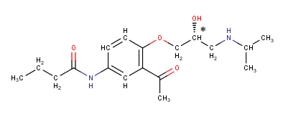  a | 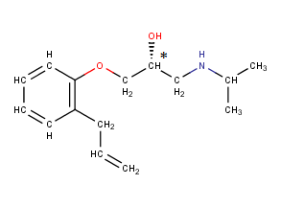  b | 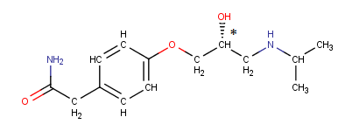  c
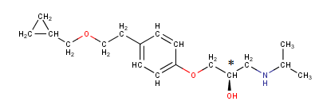  d | 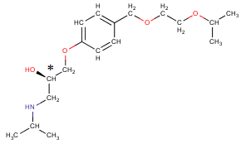  e | 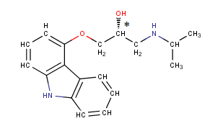  f
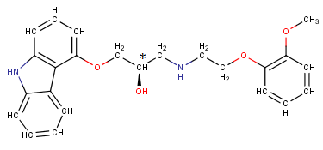  g | 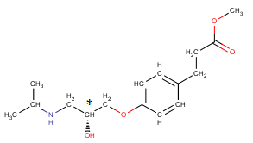  h | 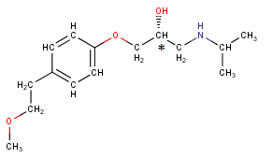  i
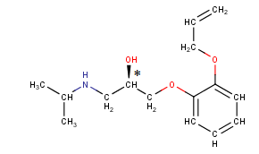  j | 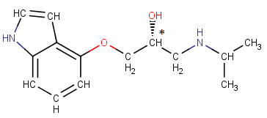  k | 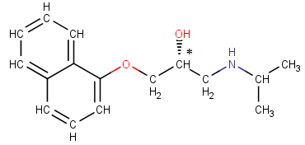  l
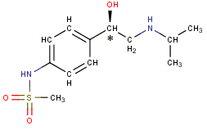  m | 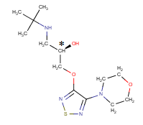  n
  - Computational details
    - Molecular Modelling and Geometry Optimization
The 2D chemical structures of the beta-blockers (14 molecules with one stereogenic center) were downloaded from ChemicalBook, the chemistry of the structures was checked and they were consequently cleaned in 3D before generating the 3D structures of the stereoisomers using MarvinView (Chemaxon). The chirality at the stereogenic centres was verified in accordance to Cahn-Ingold-Prelog priority rules. Then the structures were preoptimized using the software MOPAC2012, by PM6 method. The resulting geometries were further refined by means of a low mode dynamics (LMD) conformational search using the MMFF94x force field and standard settings in MOE (Molecular Operating Environment software). The lowest energy conformations were chosen to further calculate E_{total}, HOMO and LUMO descriptors. Using these, the remaining desired descriptors were subsequently calculated.
    - Generation of Descriptors
HOMO and LUMO descriptors were calculated for each conformation of each enantiomer with MOE and then the values corresponding to the conformation with the lowest energy were chosen. Calculations were performed with MOE (Molecular Operating Environment, v. 2014.09 on an Intel ® Core(TM) i3-4005U CPU @ 1.7 GHz personal computer with 12 GB of RAM running under Microsoft Windows 8.1).
Further, several quantum chemical descriptors were calculated: HLG (gap between E_{HOMO} and E_{LUMO}), hardness (η, η=E_{LUMO}-E_{HOMO}=HLG), softness (σ, σ=$\frac{1}{η}$), electronegativity (χ, χ=- $\frac{1}{2}$(E_{HOMO} + E_{LUMO})) or chemical potential (µ, µ= $\frac{1}{2}$ (E_{HOMO} +E_{LUMO})), global electrophilicity (ω°, ω°= $\frac{1}{2}$µ²σ). HOMO and LUMO are calculated using three different methods (AM1, MNDO and PM3).

- Results
HOMO represents the ability to donate an electron, while LUMO as an electron acceptor represents the ability to accept an electron. HOMO and LUMO are considered to be the main orbitals taking part in chemical stability, also known as frontier orbitals [9]. HOMO energy is closely related to reactivity to electrophilic attack, being the highest energy orbital containing electrons; LUMO energy is closely related to reactivity to nucleophilic attack, since it is the lowest energy orbital that can accept electrons.
The HOMO-LUMO band gap (HLG) explains the structure and conformation barriers in many molecular systems. The HLG for each representative of the set of studied beta-blockers calculated using values of HOMO and LUMO energy can be visualized in Table II; the values for the orbital energies were obtained using semi-empirical molecular orbital methods AM1, MNDO and PM3.
Table II Values of HOMO-LUMO gap (HLG)/ Hardness and values of Softness
Molecule | AM1_ | PM3_ | MNDO_ | MNDO_  Softness | PM3_  Softness | AM1_  Softness
 | HLG | HLG | HLG
Acebutolol | 8.465 | 8.566 | 8.753 | 0.114 | 0.117 | 0.118
Alprenolol | 9.370 | 9.405 | 9.023 | 0.111 | 0.106 | 0.107
Atenolol | 9.259 | 9.279 | 8.994 | 0.111 | 0.108 | 0.108
Betaxolol | 9.355 | 9.360 | 9.007 | 0.111 | 0.107 | 0.107
Bisoprolol | 9.378 | 9.375 | 9.052 | 0.110 | 0.107 | 0.107
Carazolol | 8.229 | 8.132 | 8.092 | 0.124 | 0.123 | 0.122
Carvedilol | 8.230 | 8.123 | 8.056 | 0.124 | 0.123 | 0.121
Esmolol | 9.341 | 9.345 | 9.045 | 0.111 | 0.107 | 0.107
Metoprolol | 9.363 | 9.351 | 9.008 | 0.111 | 0.107 | 0.107
Oxprenolol | 9.267 | 9.343 | 9.020 | 0.111 | 0.107 | 0.108
Pindolol | 8.491 | 8.411 | 8.346 | 0.120 | 0.119 | 0.118
Propranolol | 8.215 | 8.227 | 8.034 | 0.124 | 0.122 | 0.122
Sotalol | 8.519 | 8.703 | 7.600 | 0.132 | 0.115 | 0.117
Timolol | 8.347 | 8.048 | 8.825 | 0.113 | 0.124 | 0.120

The energy and symmetry type and the charge distribution in HOMO and in LUMO are known to determine the structures of molecules. Moreover, Pearson showed that the HOMO-LUMO gap represents the chemical hardness of the molecule. Increases in hardness lead to increases in the movement of the system towards a more stable configuration. The chemical hardness is related to the resistance towards deformation or polarisation of the electron cloud of our study molecules [10]. Bearing this in mind, and the results given in Table I it is shown that according to HOMO-LUMO gap and the chemical hardness the most stable compounds are alprenolol, bisoprolol and esmolol. High values of softness would translate into increased chemical reactivity. It is correlated with complex stability with respect to bonding in the molecule, chemical reactivity and solubility of molecules. The softness values calculated for the study molecules revolve around 0.1, suggesting low reactivities.
Associated within the framework of SCF MO (Self-Consistent Field Molecular Orbital) theory, the ionization energy (I) and electron affinity (A) can be expressed through HOMO and LUMO orbital energies as I = -E_{HOMO} and A= -E_{LUMO}. The electron affinity can be used in combination with ionization energy to give electronic chemical potential, µ=$\frac{1}{2}$ (E_{HOMO} +E_{LUMO}).
The global electrophilicity, ω°= $\frac{1}{2}$µ²σ, where σ represents the softness is also calculated. The values for electrophilicity, calculated with AM1, MNDO and PM3 methods are illustrated in Table III.

Table III Global Electrophilicity indexes
Molecule | MNDO_Global  Electrophilicity | AM1_Global  Electrophilicity | PM3_Global  Electrophilicity
Acebutolol | 0.123 | 0.126 | 0.126
Alprenolol | 0.115 | 0.111 | 0.112
Atenolol | 0.120 | 0.116 | 0.116
Betaxolol | 0.114 | 0.109 | 0.110
Bisoprolol | 0.116 | 0.111 | 0.112
Carazolol | 0.130 | 0.127 | 0.129
Carvedilol | 0.129 | 0.127 | 0.130
Esmolol | 0.118 | 0.112 | 0.114
Metoprolol | 0.115 | 0.110 | 0.111
Oxprenolol | 0.118 | 0.114 | 0.114
Pindolol | 0.123 | 0.121 | 0.124
Propranolol | 0.131 | 0.128 | 0.130
Sotalol | 0.158 | 0.131 | 0.127
Timolol | 0.125 | 0.127 | 0.138

As seen in Table III, propranolol, sotalol and timolol have among the highest electrophilicity index of the studied beta-blocker molecules.
Table IV Electronegativities
Molecule | AM1_ | MNDO_ | PM3_
 | Electronegativity | Electronegativity | Electronegativity
Acebutolol | 4.526 | 4.624 | 4.638
Alprenolol | 4.292 | 4.313 | 4.433
Atenolol | 4.598 | 4.634 | 4.631
Betaxolol | 4.150 | 4.239 | 4.278
Bisoprolol | 4.357 | 4.379 | 4.446
Carazolol | 4.346 | 4.453 | 4.429
Carvedilol | 4.353 | 4.341 | 4.485
Esmolol | 4.401 | 4.585 | 4.525
Metoprolol | 4.235 | 4.298 | 4.293
Oxprenolol | 4.447 | 4.500 | 4.574
Pindolol | 4.194 | 4.243 | 4.348
Propranolol | 4.424 | 4.442 | 4.607
Sotalol | 4.972 | 5.779 | 4.880
Timolol | 4.492 | 4.849 | 4.933

Results obtained show that acebutolol, atenolol, timolol and sotalol have the highest values for the electronegativity index.
Useful theoretical insights into chemical reactivity and selectivity parameters may be obtained by determining global qualitative chemical concepts such as the electronegativity (χ), chemical potential (μ), hardness (η), softness (σ), and electrophilicity index (ω).
In order to analyse molecular stability, we calculated the global hardness value, which is calculated as the HLG, considering that the charge transfer resistance equals the energy gap between the highest occupied and lowest unoccupied molecular orbital. The large band gap means that a high-energy is needed to be fed into a molecule to kick it from the ground state into an excited state. This large gap implies good stability of the beta-blocker molecule. The high stability in turn indicates low chemical reactivity, which could probably mean that the interactions of molecules from the beta-blocker class with other molecules, for example polysaccharides or cyclodextrins, would result in very weak bonds, like van der Waals or possibly hydrogen bonds. According to HOMO-LUMO gap and the chemical hardness the most stable compounds are alprenolol, bisoprolol and esmolol.
To gain insight into the molecular reactivities of the studied beta-blockers we calculated the global softness values of each molecule. The low values for softness, all revolving around 0.1 eV, support the fact that the reactivity of these molecules is very low.
Among the studied beta-blockers the highest electronegativities are exhibited by atenolol, acebutolol, timolol and sotalol. This could probably be due to the presence of a C = O double bond and one other electronegative element attached to the same C atom, in the case of atenolol and acebutolol, where we have an amide functional group in the side chain, the heteroatom attached to the same C atom is nitrogen. In the case of sotalol and timolol, it is probably explained by the presence of highly electronegative heteroatoms such as sulphur, nitrogen and oxygen. The lowest calculated value for electronegativity is that of betaxolol, which has only one oxygen heteroatom in the molecule, apart from the heteroatoms of the substructure common to all beta-blocker molecules. The differences in electronegativity between the lowest and highest value vary between the methods of calculation used. Using AM1, the difference between betaxolol and timolol is 0.655 eV, while using PM3, the difference between betaxolol and sotalol is 1.540 eV, but between betaxolol and timolol is 0.610 eV.
The electrophilicity contains information about structural, reactivity and selectivity patterns of many electron systems in both ground and excited electronic states. It represents the stabilization energy of the system when it becomes saturated by electrons coming from the surroundings. A good electrophile is characterized by a high value of µ (chemical potential) and a low value of η (chemical hardness). The chemical potential and chemical hardness are key indicators of the overall reactivity of the molecule and are the most fundamental descriptors of charge transfer during a chemical reaction. The lowest electrophilicity index was obtained for betaxolol and metoprolol, so they are the most likely to accept electrons until the molecule is saturated with electrons from its surroundings, thus energetically stabilizing the molecule. The highest values were obtained for propranolol, sotalol and timolol molecules, meaning these are the least chemically reactive of all the selected molecules.

- Conclusions
The large band gap means high excitation energies, good stability and a large chemical hardness for the beta-blocker enantiomer molecules. The most stable compounds are alprenolol, bisoprolol and esmolol. The high stability in turn indicates low chemical reactivity, supported by the fact that the softness values calculated for the studied molecules revolve around 0.1. A high electronegativity was obtained in case of atenolol, acebutolol, timolol and sotalol, probably due to the functional groups and electronegative heteroatoms present in these molecules. In the future, the aim is to determine whether it is possible to find a valid correlation between these descriptors and the physicochemical behaviour of the molecules from this class. The HLG could be correlated to the experimentally recorded electrochemical properties of the molecules. HOMO could be correlated to the observed oxidation potential, since the required voltage is related to the energy of the HOMO, because only the electron from this orbital is involved in the oxidation process. The values obtained in the study were calculated in silico/ in vacuum, and as such the real significance is limited. Nevertheless, for comparative purposes within the same class of substances (beta-blockers), they could be used successfully, for example for obtaining correlations between chromatographic behaviour and chemical structure (molecular descriptors).

