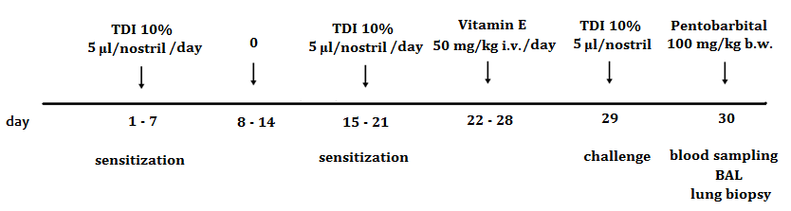

Figure 1. Schematic diagram of the experimental TDI-induced asthma protocol and vitamin E treatment.

