changes observed in ERYTHROCYTE cells exposed to an ALTERNATING CURRENT

IONUT ISAIA JEICAN, HOREA MATEI, ALEXANDRU ISTRATE, EUGEN MIRONESCU, ŞTEFANA BÂLICI
Department of Cell and Molecular Biology, “Iuliu Haţieganu” University of Medicine and Pharmacy Cluj-Napoca

Corresponding author:
Ionuț Isaia Jeican
Department of Cell and Molecular Biology
“Iuliu Hațieganu” University of Medicine and Pharmacy Cluj-Napoca
E-mail: ionutjeican@yahoo.com

Abstract.
Background and aims. Appliance of electric pulses induces red blood cells (RBCs) membrane poration, membrane aminophospholipid perturbation and alteration of the normal flip-flop process, resulting in various shape changes of the RBCs. We studied morphological and water permeability changes of RBCs bombarded with electrons in an alternating current circuit.
Methods. We used three venous blood samples of 100mL and a alternating current device. The harvested blood was divided into four experimental sets to be used for various exposure times: 0 hours (control RBCs), 0.5h, 3h and 6h (electric-stimulated RBCs).
Following the electric current each of the four sets were further divided into three samples: one for the assessment of the echinocytes/RBCs ratio, another for the electron microscopy study of ultrastructural changes induced by the alternating electrical current and a larger third one for determining water permeability of RCBs by ¹H-NMR spectroscopy and morphological measurements.
Results. There is a small but statistically significant effect of the RBC exposure to alternating electric current on cell diameters. Exposure to electric current is positively and strongly correlated with the percentage of echinocytes in a duration-dependent manner. There is a strong and statistically significant correlation between electric current exposure and permeability to water as measured by 1H-NMR spectroscopy.
Conclussion. Following interactions between electric current and RBC membrane certain modifications were observed in the erythrocyte structure. We attribute the increased cell size to a higher permeability to water and a decreased tonicity. This leads to the transformation of the RBCs into echinocytes.

Key words: erythrocyte, alternating current, echinocyte, water permeability

1. Background and aims
Human red blood cells (RBCs) are flattened disc-shaped cells formed by a lipid bilayer mainly composed of asymmetrically distributed proteins and phospholipids attached to a cytoskeleton. [1].
The RBC membrane presents a very high permeability to water [2, 3]. The molecular basis of transport across the RBC membranes became much clearer after the identification and characterization of water channel proteins. The protein known as aquaporin 1 (AQP1) was first purified from red blood cell membranes and exist as a tetramer with intracellular N- and C-termini [4, 5]. AQP1 is uniformly distributed on the red cells’ surface [6].
Appliance of electric pulses induces membrane poration, membrane aminophospholipid perturbation and alteration of the normal flip-flop process, resulting in various shape changes of the RBCs [7].
We studied morphological and water permeability changes of RBCs bombarded with electrons in an alternating current circuit.

2. METHODS

2.1 Experimental setting
In this experiment we used three venous blood samples of 100mL harvested in standard conditions at the Regional Blood Transfusion Center in Cluj-Napoca. The three healthy male contributors (later reffered as subjects) aged 20 to 25 years provided informed consent files prior to their enrollment in the study. We prepared three solutions of 25 mL of 3.4% sodium citrate solutions according to the manufacturer’s instructions to use a 1:4 anticoagulant/blood volume ratio, based on the observation that the cytomorphological examination is more accurate when using citrate rather than Na₂EDTA [8].
The alternating current device we assembled (see fig. 1) consisted in a 12V alternating current power supply, an ammeter, a voltmeter, an oscilloscope, two carbon electrodes (5 cm apart) and a Ø 5.6 x 1.8 cm³ crystallizer. The 25 mL venous whole blood samples were deposited in the crystallizer and subjected to a 10 mA alternating electric current at a constantly monitored frequency of 50 Hz.

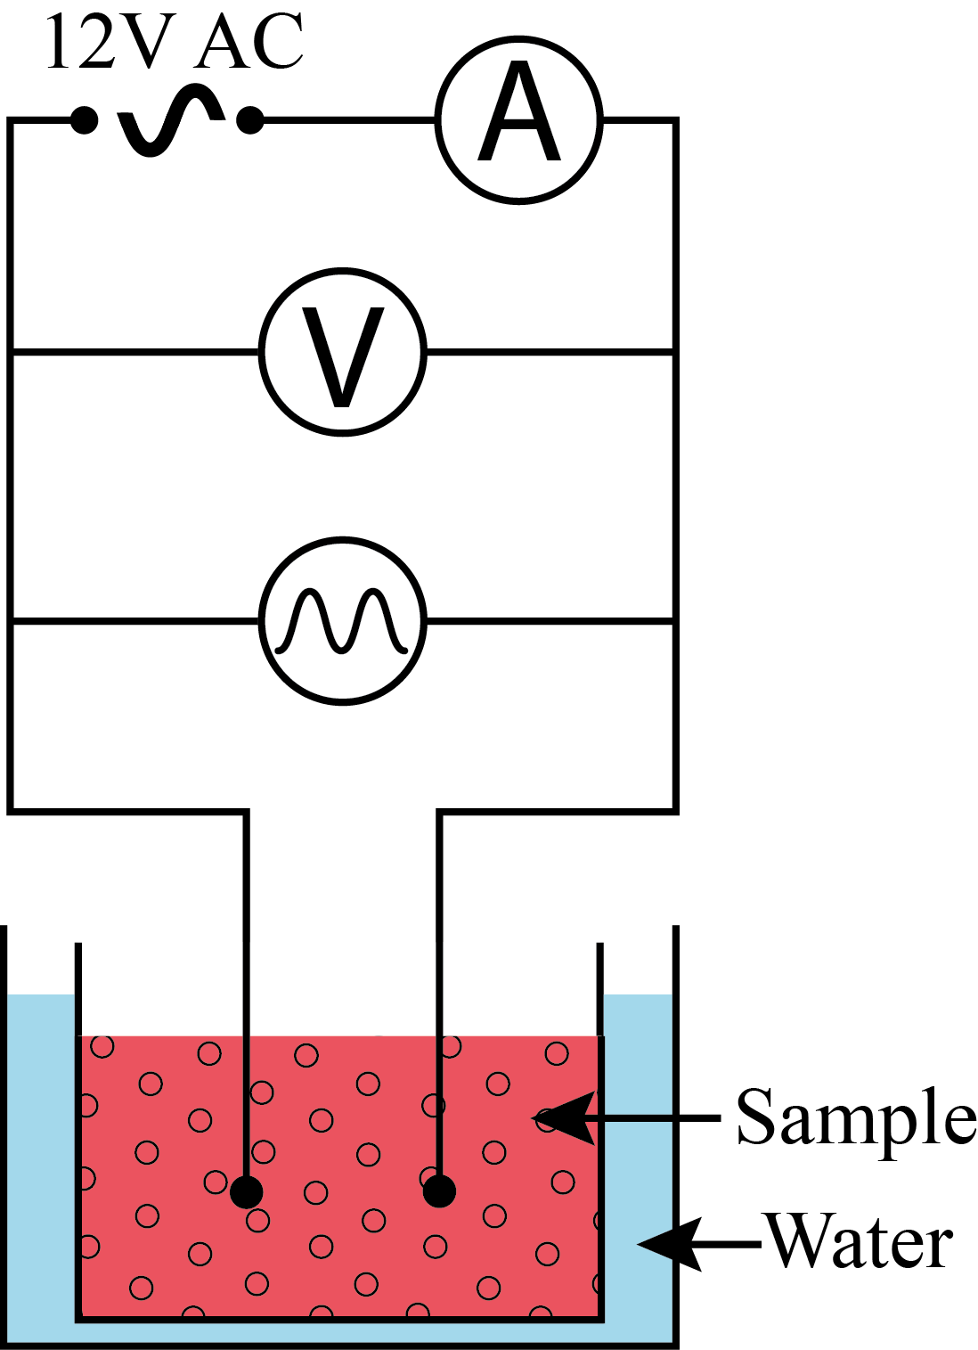
Figure 1 – Schematic representation of the device used for the study of RBCs subjected to alternating current

The harvested blood was divided into four experimental sets to be used for various exposure times: 0 hours (control RBCs), 0.5h, 3h and 6h (electric-stimulated RBCs). Sample stimulation was performed in identical conditions using the device presented in Figure 1. Following the electric current each of the four sets were further divided into three samples: one for the assessment of the echinocytes/RBCs ratio, another for the electron microscopy study of ultrastructural changes induced by the alternating electrical current and a larger third one for determining water permeability of RCBs by ¹H-NMR spectroscopy and morphological measurements.

2.2 Cytomorphological examination in light and scanning electron microscopy

2.2.1 Preparation and examination of the blood smears
The blood smears were fixed with 8-a May-Grünwald working solution and stained with a Giemsa solution [9]. We examined the aspect (shape and color) of the RBC membranes with the 100× objective and determined the echinocytes/RBCs ratio (%).

2.2.2 Preparation and examination of RBCs by used scanning electron microscopy
We centrifuged the RBCs for 10 minutes at 7,000 g and 4°C, removed the supernatant (along with the plateletes) and a thin leukocyte layer to obtain a rich erythrocyte suspension which was further pre-fixed with 1.7% glutaraldehyde, washed two times with 0.1M phosphate buffer and post-fixed with 1% osmium tetraoxide. Cell dehydration was progressively reached by dipping in gradually concentrated ethanol solutions of 30%, 50%, 80%, 90% and 100%, after which the samples were metalized [10] in a Polaron E–5100 plasma-magnetron sputter coater (Polaron Equipment Ltd., UK). We examined the samples with a JEOL JSM-25S (Jeol, Japan) scanning electron microscope and performed a qualitative ultrastructural analysis of the RBC surfaces.

2.2.3 Preparation and examination of the native microscopic specimens
We mixed bovine serum albumin (BSA) with isotonic RBC washing medium (WM) consisting in 150 mM NaCl, 5 mM HEPES [4-(2-hydroxyethyl)-1-piperazinethanesulphonic acid] and 5.5 mM glucose (pH=7.4) to obtain a 0.5% (w/v) BSA solution. 5 µL of each current-stimulated/control blood samples mixed with 50 µL of the BSA solution were then poured onto a microscopic glass slide, sealed with a cover slip and examined with a Nikon Eclipse 80i microscope (Nikon, Japan). A Color View I CCD camera (Olympus, Japan) and a Cell^D® software were used to record minimum 15 images/sample with a 100× objective. The RBC diameters were manually measured [11, 12].

2.3 The determination of water permeability of the RBCs membrane

2.3.1 Preparation of the NMR samples
A RBC rich suspension was obtained through whole blood centrifugation for 10 minutes at 21,000 g and 4°C, followed by removal of the supernatant (plasma and leukocytes) and washing in WM. The washing/centrifugation steps were repeated three times [11]. A quota of the resulting RBC samples were further centrifuged for 60 minutes at 50,000 g and 4°C to obtain a RBC sediment with a final hematocrit of 95% (the Carr-Purcell-Meiboom-Gill method). The sediment was used for determining the transverse relaxation time, T_{2i}, of the “intracellular” water. The rest of was dipped (1:1 volumes) into a BSA solution and divided in four samples: one to be used for morphological measurements and three for determining the water proton relaxation time, T′_{2a}, of the “extracellular” water [11, 12].
In order to determine T_{2i} and T′_{2a} we used a 20MHz ¹H-NMR (Bruker, Germany) spectrometer with MINISPEC® data acquisition software connected to a HD-F25 Julabo (Julabo GmbH, Germany) thermostat progressively set to reach temperatures of 15, 20, 25, 30, 37 and 42ºC. A number of ten T_{2i} and T′_{2a} readings were recorded and averaged for each sample at all the preset temperatures. For T′_{2a} measurements all current-stimulated/control samples were doped with paramagnetic ions (Mn²⁺) by adding ½ volumes of doping solution (100 mM NaCl and 40 mM MnCl₂) for a final hematocrit of 30-40% (1:1:1 volume ratios for RBC/BSA solution/doping solution) only when the thermostated bath had reached the temperatures of 15, 25 and 37 ºC [11, 12].

2.3.2 Determination of water permeability of RBCs membranes
The water diffusion exchange time (T_{e}) and the water diffusion permeability (P_{d}) of the erythrocyte membranes were determined from nuclear magnetic resonance spectroscopy (¹H-NMR) results at 20 MHz and different temperatures, and morphological measurements.
T_{e} was calculated using the Conlon-Outhred equation:

1/T_{e} = 1/T′_{2a} – 1/T_{2i} (1)

where T′_{2a} and T_{2i} are the water proton relaxation time of the RBC membrane and the transverse relaxation time of the cell interior, respectively [13].
The RBC membrane water permeability (P_{d}) was determined based on the water diffusion exchange time (T_{e}), cell surface areas (A) and the cells’ water volume (V_{a}), using the relationship [12]:

P_{d} = (1/T_{e}) × (V_{a}/A) (2)

In this equation V_{a} was estimated as 0.7 × V, where the mean cell volume V (in mm³) was calculated as:

V = Ht*10/N_{RBC} (3)

based on hematocrit (Ht) capillary readings on the Hawksley scale and cell counts (N_{RBC}) using a Thoma counting chamber [12].
In order to estimate the RBCs’ cell surface area (A) based on mean cell volumes (V) and mean diameters (D) as measured according to the procedure described in paragraph 2.2.3 we used the following relation [12]:

A = (πD²/2) + (4V/D) (4)

2.4 Statistical analysis

The influence of exposure time to electric current on cell diameters was tested by means of ANOVA analysis followed by Bonferroni and Dunnett post-hoc analysis. Correlation between exposure duretion and the percentage of echinocytes resulted as well as between exposure times and water permeability of RBC membranes as resulted from ¹H-NMR spectrometry. Multiple regression analysis allowed the quantifying of temperature influence on permeability. The Microsoft® Excel 2013 raw datasets were preprocessed to a StatSoft® Statisica 10 compatible data format. All subsequent analyses were performed in StatSoft® Statisica 10. Only P-values below 0.05 were considered statistically significant.

3. RESULTS

3.1 Cytomorphological examinaton

3.1.1 The cellular diameter variance
Variations of the cellular diameters were studied on the microscopic preparations (Figure 2). A total of 717 living diameters were measured (Table I).

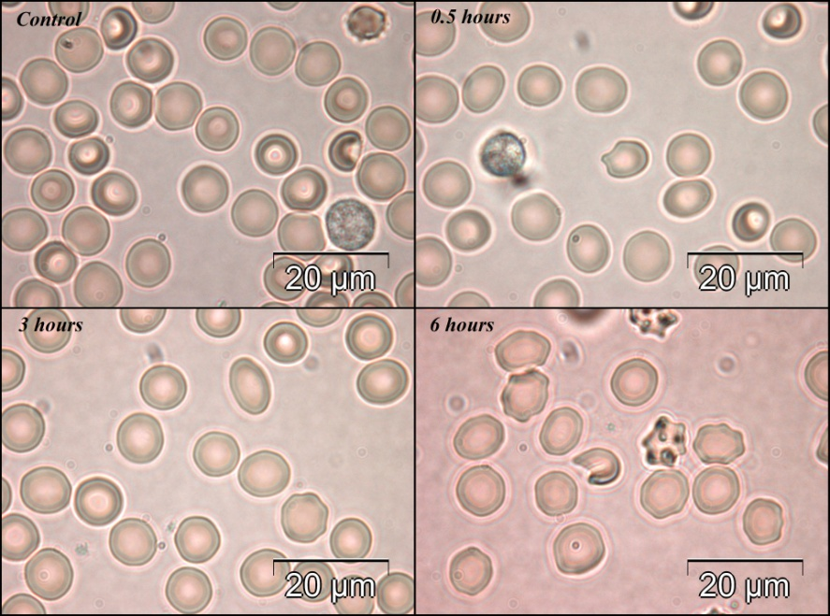
Figure 2 – Native microscopic specimens images of control and 0.5 hours, 3 hours and 6 hours samples; objective: 100×. Bar: 20 µm

Table I
Mean RBC diameters prior to and following electrical stimulation
Exposure time (hours) | Number of valid measurements (n) | Mean values (μm) [95% Confidence Interval]
0 | 128 | 7.47 [7.37, 7.57]
0.5 | 195 | 7.63 [7.56, 7.70]
3.0 | 211 | 7.76 [7.69, 7.83]
6.0 | 183 | 7.76 [7.70, 7.81]

Variance analysis among subgroups highlighted statistically significant inhomogeneities (P = 0.0003 for the Levene’s test). This should be taken into consideration when interpreting the results. The overall result of the ANOVA test showed statistically significant differences among subgroups (P < 0.0001) with adjusted R-squared = 9.3% (variance explained by time). F-ratio = 15.694 (P < 0.0001).

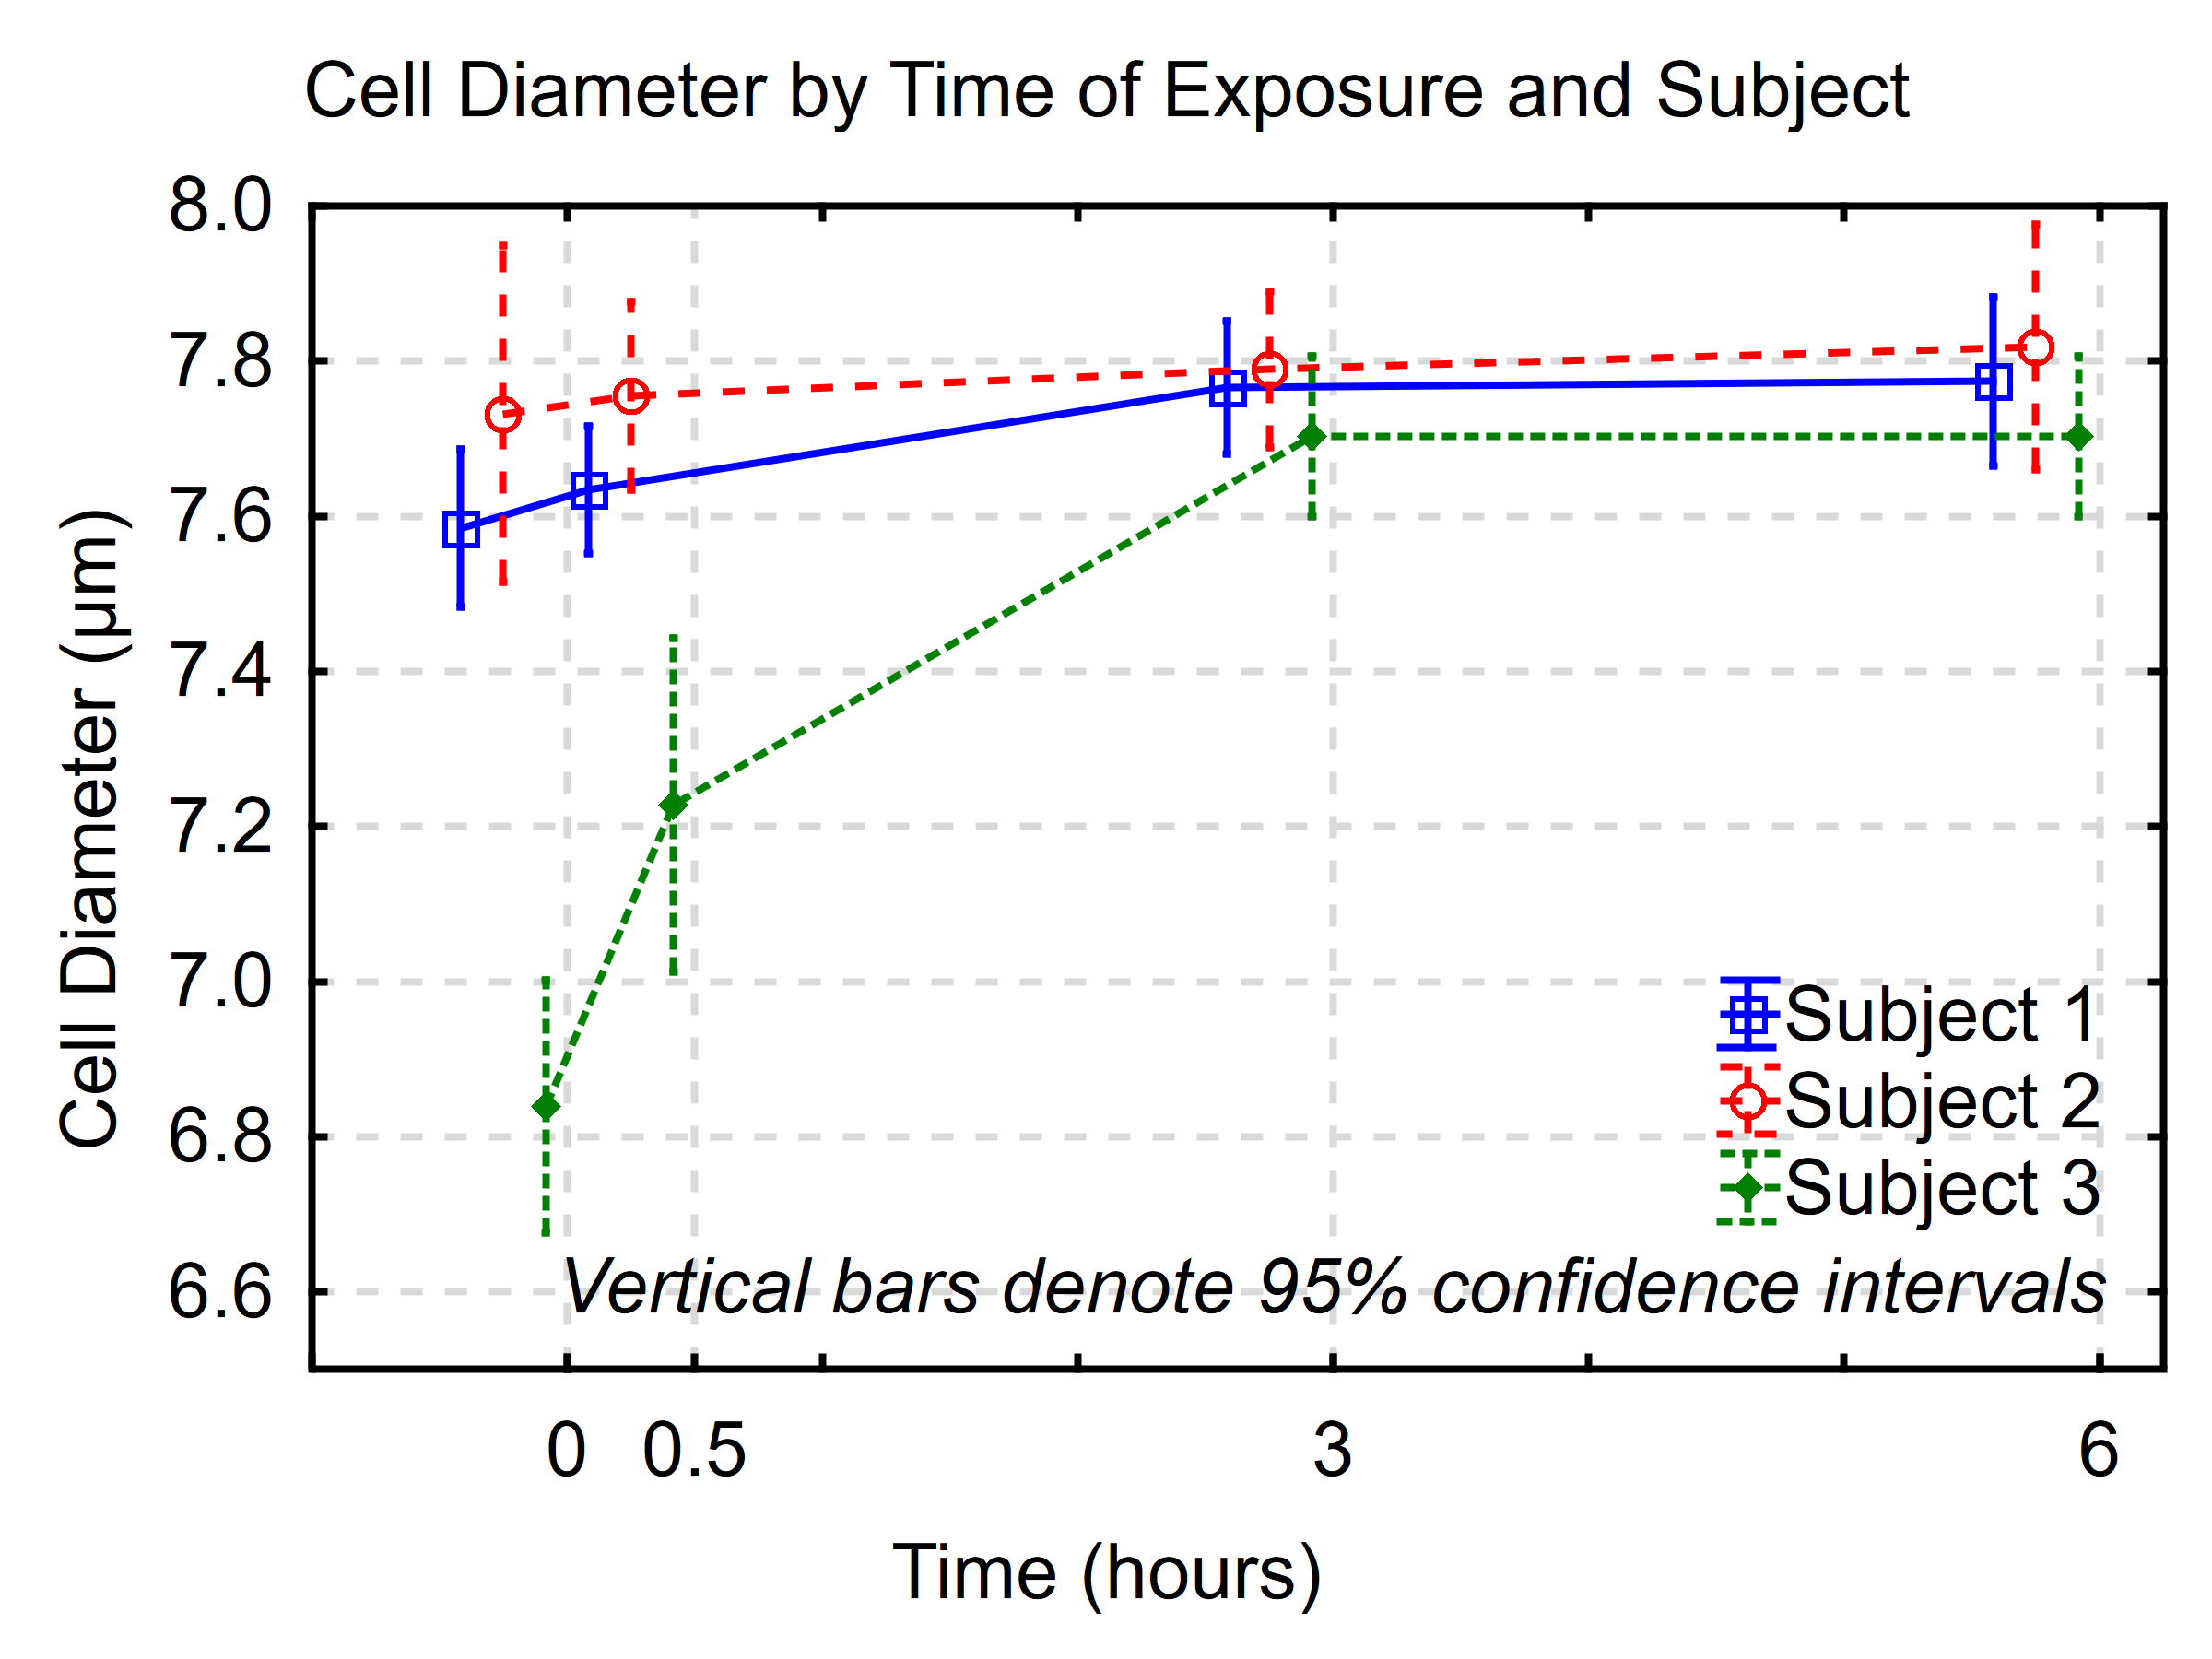
Figure 3 – Influence of current exposure times on RBC diameter.
Cell diameters in µm; exposure times in hours for the three subjects (see methods). Time 0 is considered as control.

As we explored the individual differences among the subgroups using post-hoc analysis (Bonferroni and Dunnet test) we found significant differences between the controls’ diameters and each of the exposed subgroups. Also, we found statistically significant differences in average cell diameter between all groups except for the 3 vs. 6 hours pair.

3.1.2 Variations in the level of echinocytosis

Echinocytes are cells with serrated outlines presenting small projections more or less evenly spaced over the circumference of the red cells [14].
We studied the magnitude of the echinocytosis on May-Grünwald-Giemsa smears (Figure 4) which offered the advantage of highlighting modifications in RBCs’ contours and color. Other shape or colour variations were not observed.

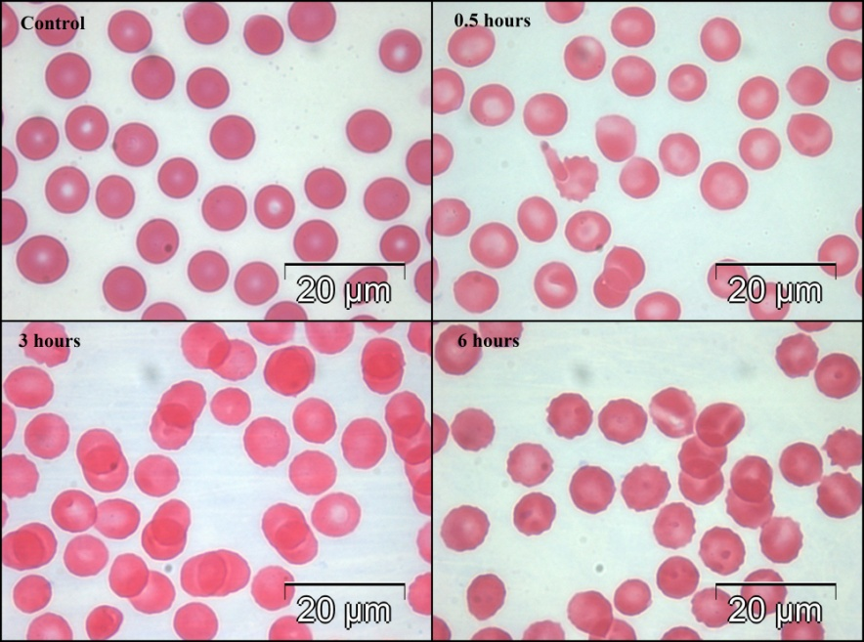
Figure 4 – Blood smears May-Grünwald-Giemsa images of control and 0.5 hours, 3 hours and 6 hours samples; objective: 100×. Bar: 20 µm

We determined the correlation between exposure times and the percentage of echinocytes found in the samples. The overall Pearson’s correlation coefficient was 0.8886 (P < 0.0001) (Figure 5) and it increased to 0.9556 (P < 0.0001) when controls were ignored.

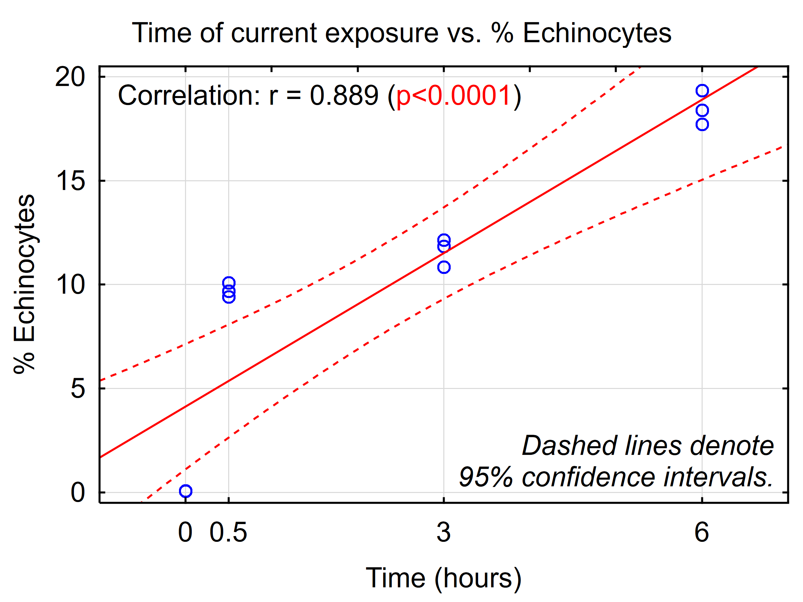
Figure 5 – Scatterplot of echinocytes % exposure vs. times and fitted regression line (solid red line) with a 95% confidence interval (dashed red lines). Each point represents the percent of echinocytes resulting after exposure to electrical current, for each of the 3 subjects.

We then checked if there are any statistically significant differences between the percentage of echinocytes in controls versus stimulated samples for 0.5, 3, and 6 hours (Figure 6). The overall result of the general linear model presented statistically significant differences among subgroups (P < 0.0001), indicating that sensibly more echinocytes were found in the treated samples, as compared to controls. Levene test for equality of variances produced a P = 1.000 for time of exposure, F-ratio = 27.216, adjusted R-squared = 0.695, and P < 0.0001.

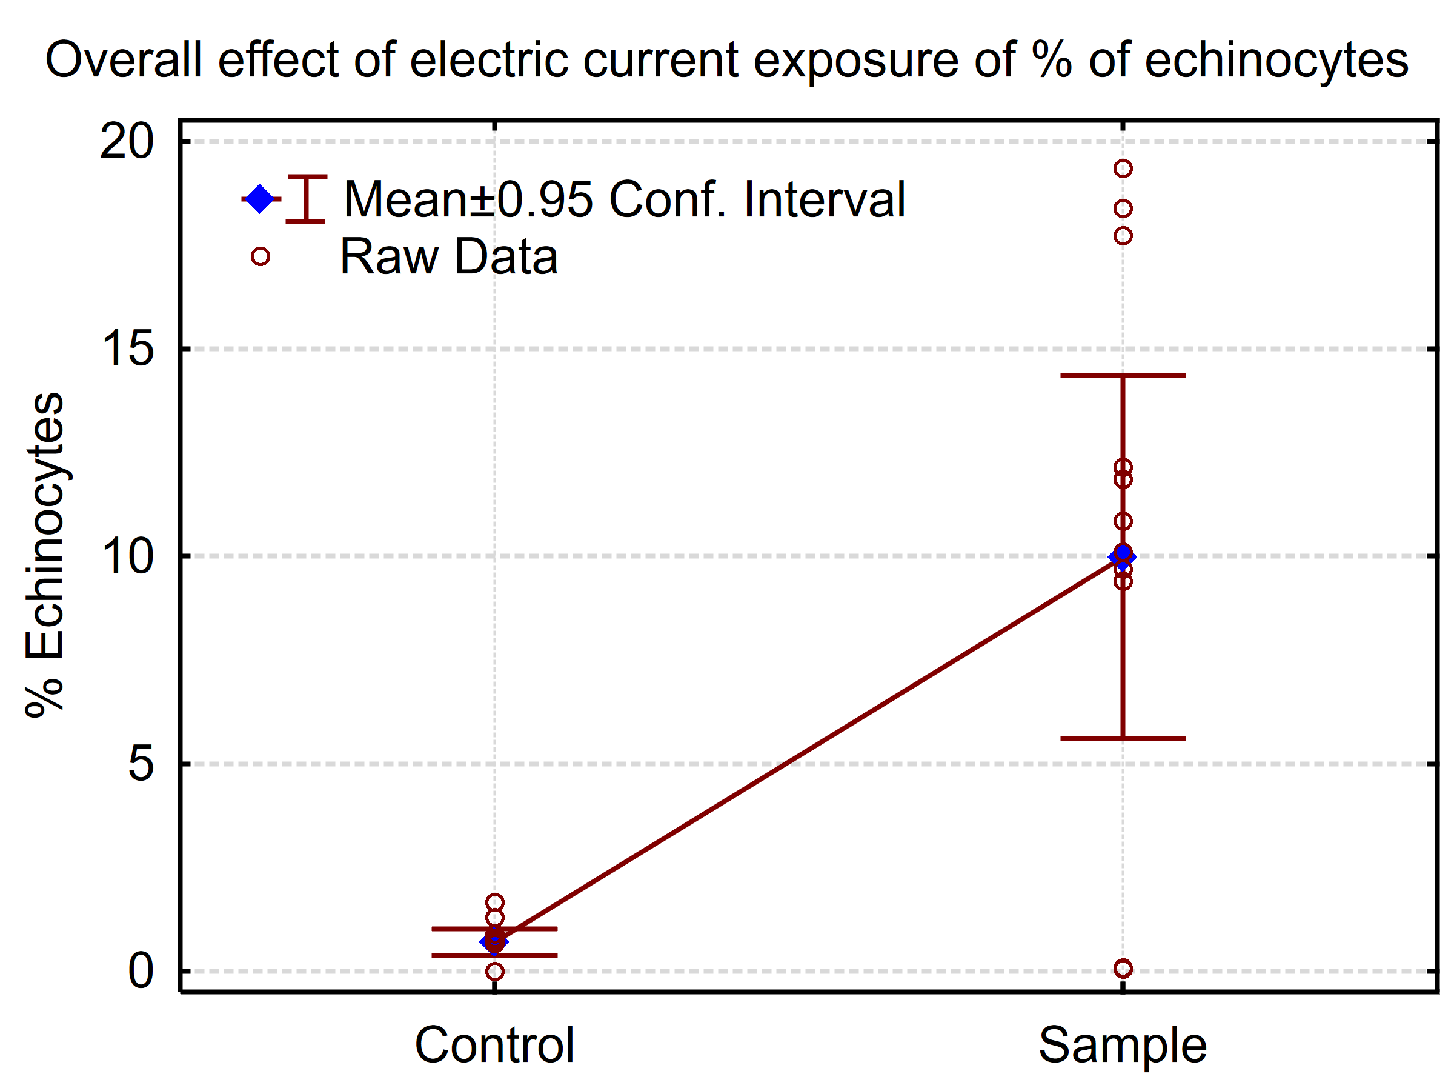
Figure 6 – Differences in adjusted mean % of echinocytes between exposed and control

3.1.3 The RBC membrane aspect
For a qualitative analysis of the RBC membrane we used the scanning electron microscopy which offers the possibility of a three-dimensional ultrastructural examination.
The control set presented normal RBCs ultrastructure (Figure 7A). In the 0.5 h exposure test, a significant number of the cells exhibited discrete outline changes of the membrane, but the normal cell shape was preserved (Figure 7B). In the 3h set most of the cells presented small spikes on their surface. The cell shape was slightly changed but it still remained flat (Figure 7C). In contrast, the 6 h test produced cells with uniformly spread spikes around the cellular surface (Figure 7D).
In other words, the 0.5 and 3 hours tests reflected early to medium stages in the formation of echinocytes, while the 6 hours one indicated multiple echinocytosis.

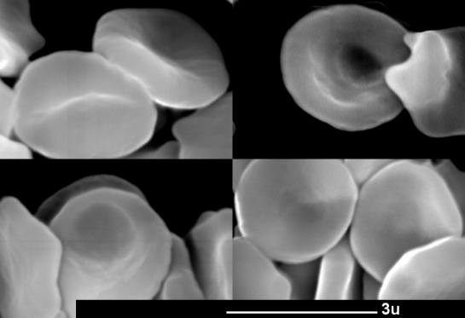 A 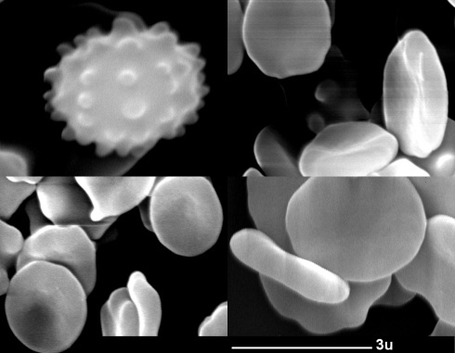 B
A

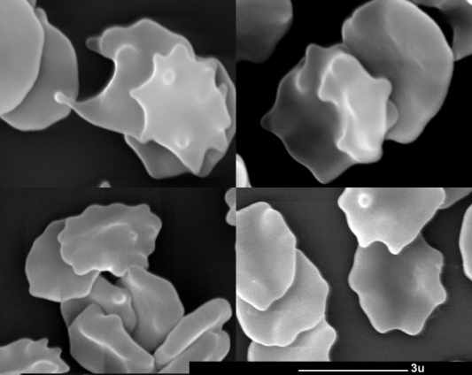 C 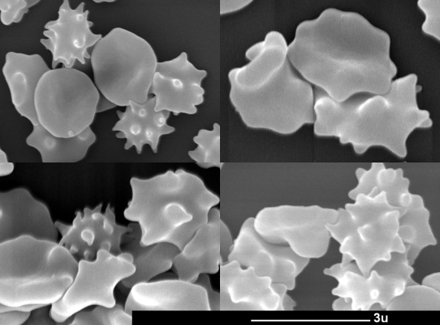 D
C
Figure 7 – Scanning electron microscope images of RBCs. Bar: 3 µm
A. control, and exposure time of B. 0.5 hours, C. 3 hours, D. 6 hours exposure. Bar: 3µm

3.2 Water permeability of the erythrocyte membranes

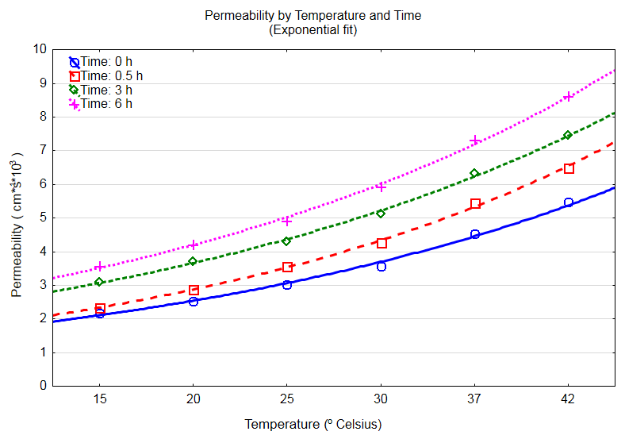
Figure 8 – Influence of temperature and time on permeability

We tested the influence of exposure times (controls vs. 0.5, 3, and 6 hours) on the membrane permeability to water. The correlation coefficient between permeability and exposure times was 0.4755 (P < 0.0001) but increased to over 0.9 in the case of certain temperature groups (Table II).

Table II.
Correlation coefficients between permeability coefficient and time of exposure, at each temperature point.
All P-values were < 0.0001.

Temperature  (°C) | Correlation coefficient
15 | 0.947
20 | 0.942
25 | 0.932
30 | 0.941
37 | 0.9245
42 | 0.931

Multiple regression showed R-squared = 93.915% of the variation in permeability explained by the regression model below: F-ratio = 548.86, P < 0.0001 (standardized beta for time = 0.48 and for temperature: 0.85; all P < 0.0001).

4. DISCUSSION
The RBC membrane acts as the main control of the cell's morphology and mechanics [15-16]. Various external agents (drugs, changes in the medium pH or temperature) can alter the erythrocytes’ shape [17]. Mechanisms of erytrocyte-echinocyte transformation involve redistribution of the bilayer lipids [18], modification of Donnan equilibrium and interaction of band 3 protein under the influence of different external factors [19]. Echinocyte formation is most likely caused by the reorientation of endofacial aminophospholipids towards the outer leaflet of the bilayer, suggesting participation of the electric charges to the phospholipid polar head groups [20-21]. Such cell deformations were attributed by other authors to the medium hypertonicity induced by ion concentration gradients in the spatially non-uniform alternating electric fields [22]. Na⁺ concentration inside the human red blood cells was sensibly reduced when the cells were exposed to weak alternating electric fields of different frequencies [23].
The echinocyte cell stores the least electromagnetic energy and therefore from an energetic perspective it seems to be the most stable structure [24-25].
Our results concur with other studies that reported changes in proton transport through water under the influence of electric fields [26].

5. CONCLUSIONS
Our results prove that there is a small but statistically significant effect of the RBC exposure to alternating electric current on cell diameters. An exponential increase in the cells’ diameters was observed prior to stabilization to a maximal plateau after approximately 3 hours. This effect, although observable in all current-stimulated samples, was highly variable in magnitude.
Our results indicate that exposure to electric current is positively and strongly correlated with the percentage of echinocytes in a duration-dependent manner: the more exposure to current, the higher the proportion of echinocytes. There is a strong and statistically significant correlation between electric current exposure and permeability to water as measured by ¹H-NMR spectroscopy.
Following interactions between electric current and RBC membrane certain modifications were observed in the erythrocyte structure. We attribute the increased cell size to a higher permeability to water and a decreased tonicity. This leads to the transformation of the RBCs into echinocytes.

Acknowledgments. IJ thanks A. Florea – associate professor from Dept. of Cell and Molecular Biology, “Iuliu Haţieganu” University of Medicine and Pharmacy Cluj-Napoca, for guidance.

REFERENCES

1. Singer SJ, Nicolson GL. The fluid mosaic model of the structure of cell membranes. Science. 1972; 175(4023): 720–731.

2. Benga G. Water transport in red blood cell membranes. Prog Biophys Mol Biol. 1988; 51(3): 193–245.
3. Benga G. Water exchange through the erythrocyte membrane. Int Rev Cytol. 1989; 114; 273–316.
4. Smith BL, Agre P. Erythrocyte Mr 28,000 transmembrane protein exists as a multisubunit oligomer similar tochannel proteins. J Biol Chem. 1991; 266(10): 6407–6415.
5. Agre P, Sasaki S, Chrispeels MJ. Aquaporins - A Family Of Water Channel Protein Am J Physiol. 1993; 265(3 Pt 2):F461.
6. Cho MR, Knowles DW, Smith BL, Moulds JJ, Agre P, Mohandas N, Golan DE. Membrane dynamics of the water transport protein aquaporin-1 in intact human red cells. Biophys J. 1999; 76(2): 1136–1144.
7. Baumann M. Early stage shape change of human erythrocytes after application of electric field pulses. Mol Membr Biol. 2001; 18(2): 153–160.
8. Perrotta G, Roberts L, Glazier J, Schumacher HL. Use of sodium citrate anticoagulant for routine hematology analysis on the CELL-DYN®4000: an opportunity to enhance efficiency in the clinical laboratory. Lab Hematol. 1998; 4: 156–162.
9. M. Ţiţeica M, S. Halunga-Marinescu. Practica laboratorului clinic. București: Editura Academiei R. S. România, 1984: 159–160.
10. Ploaie PG, Petre Z. Introducere în microscopia electronică cu aplicaţii la biologia celulară şi moleculară. București: Editura Academiei R. S. România, 1979: 139–143, 146–149, 165–167, 173–174.

11. Benga G, Pop VI, Popescu O, Borza V. On measuring the diffusional water permeability of human red blood cells and ghosts by nuclear magnetic resonance. J Biochem Biophys Methods. 1990: 21(2): 87–102.

12. Benga G, Frenţescu L, Matei H, Ţigan S. Comparative nuclear magnetic resonance studies of water permeability of red blood cells from maternal venous blood and newborn umbilical cord blood. Clin Chem Lab Med. 2001; 39(7): 606–611.
13. Conlon T, Outhred R. Water diffusion permeability of erythrocytes using an NMR technique. Biochem Biophys Acta. 1972; 288(2): 354–361.
14. Brecher G, Bessis M. Present status of spiculated red cells and their relationship to the discocyte-echinocyte transformation. A critical reviex. Blood. 1972; 40(3): 333–344.

15. Park Y, Best CA, Badizadegan K, Dasari R, Feld MS, Kuriabova T, et al. Measurement of red blood cell mechanics during morphological changes. Proc Natl Acad Sci USA. 2010; 107(15): 6731–6736.

16. Lim HWG, Wortis M, Mukhopadhyay R. Stomatocyte-discocyte-echinocyte sequence of the human red blood cell: evidence for the bilayer- couple hypothesis from membrane mechanics. Proc Natl Acad Sci USA. 2002; 99(26): 16766–16769.
17. Etcheverry S, Gallardo MJ, Solano P, Suwalsky M, Mesquita ON, Saavedra C. Real-time study of shape and thermal fluctuations in the echinocyte transformation of human erythrocytes using defocusing microscopy. 2012; 17(10): 106013.
18. Lichtman M, Bentler E, Kipps TJ. Williams Hematology. 7th ed., McGraw-Hill, 2005: 369–382.

19. Stasiuk M, Kijanka G, Kozubek A. [Transformations of erythrocytes shape and its regulation]. Postepy biochem. 2009; 55(4): 425–433.

20. Henszen MM, Weske M, Schwarz S, Haest CW, Deuticke B. Electric field pulses induce reversible shape transformation of human erythrocytes. Mol Membr Biol. 1997; 14(4): 195–204.

21. Fujii T. Role of membrane lipids and proteins in discocyte-echinocyte and -stomatocyte transformation of erythrocytes. 1981; 40: 361–367.
22. An R, Wipf DO, Minerick AR. Spatially variant red blood cell crenation in alternating current non-uniform fields. 2014; 8(2): 021803.
23. Chen G, Cai G, Zhang R, Tu P, Zhao N. Effects of the weak alternating electric field on Na⁺concentration inside human red blood cells. Bioelectrochemistry and Bioenergetics. 1998; 45(1): 127–130.

24. Muñoz S, Sebastián JL, Sancho M, Martínez G. Analysis of radiofrequency energy stored in the altered shapes: stomatocyte-echinocyte of human erythrocytes. Bioelectrochemistry. 2010; 77(2): 158–161.

25. Iglic A. A possible mechanism determining of stability of spiculated red blood cells. J Biomech. 1997; 30(1): 35-40.

26. Hassan SA, Hummer G, Lee YS. Effects of electric fields on proton transport through water chains. J. Chem. Phys. 2006; 124(20): 204510.

