Redacţia revistei
CLUJUL MEDICAL
Str. Moţilor nr. 33
RO-400 001 Cluj-Napoca, ROMANIA
Tel/ Fax: 0040 - 264- 596086
clujulmedical@umfcluj.ro

Declaration of Conflict of Interest

Manuscript number …

Title: History of Medicine between tradition and modernity.

Names of all authors in the order in which they appear in the article: Cristian Bârsu

Conflict of Interest disclosure

No | X

Yes

If yes, please specify…………………………………………………………………….
……………………………………………………………………………………………

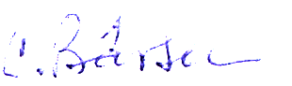
……………………………………………………………. March 16th, 2017
(signature) date

The filled in, signed and scanned image of this file has to be uploaded at the last step of the submission process (Step 4. Uploading Supplementary Files)

