- Average of TNF-α serum values (pg/ml) in the 4 groups, day 1 and day 7 | - Average of IL-1α serum values (pg/ml) in the 4 groups, day 1 and day 7

Figure 1. Average of TNF-α and IL-1α serum values.

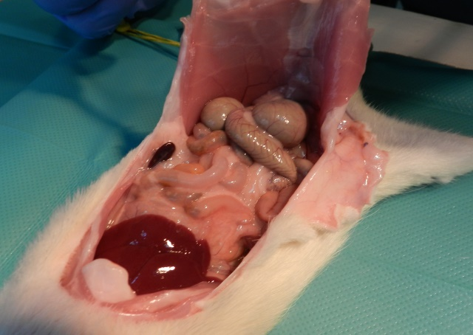 | 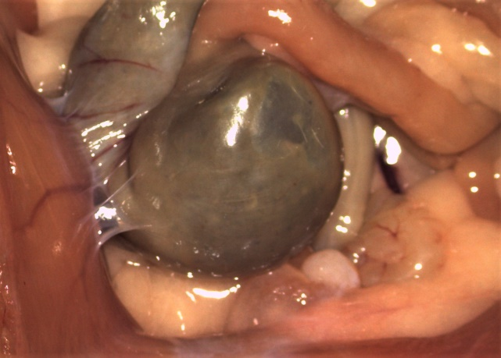
- No adhesions | - First degree adhesion
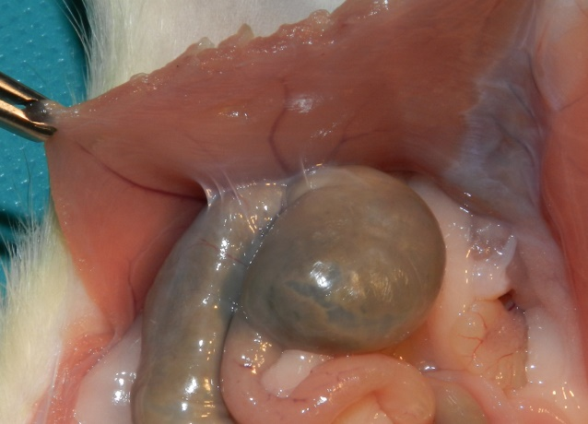 | 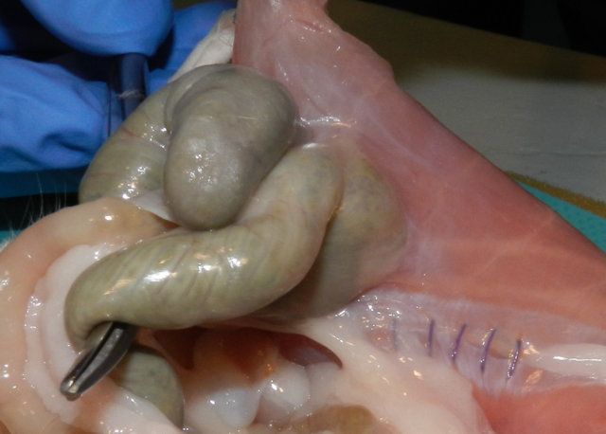
- Second degree adhesion | - Third degree adhesion

Figure 2. Macroscopic appearance of peritoneal adhesions

Figure 3. The evolution of the TNF-α serum values in the 4 groups, on day 1 and day 7 postoperatively as compared to the macroscopic degree of severity and the area covered by adhesions

