Redacţia revistei
CLUJUL MEDICAL
Str. Moţilor nr. 33
RO-400 001 Cluj-Napoca, ROMANIA
Tel/Fax : 0040 - 264- 596086
clujulmedical@umfcluj.ro

Declaration of Conflict of Interest

Manuscript number …

Title Focal Achalasia – Case Report and Review of the Literature

Names of all authors in the order in which they appear in the article
Marcus Joachmin Ulrich Herzig
Radu Tutian

Conflict of Interest disclosure

No

Yes | X

If yes, please specify…………………………………………………………………….
……Radu. Tutuian: education programs for Laborie Inc …………………………
Marcus Herzig: no conflicts of interest…………………………………
…………………………………………………………………………………………………………………………………………………………………………………………

……………………………………………………………. 28.07.2017
(signature) date

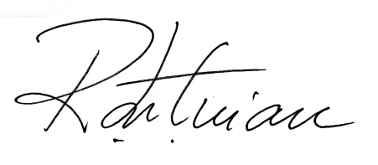

The filled in, signed and scanned image of this file has to be uploaded at the last step of the submission process (Step 4. Uploading Supplementary Files)

