 **Redacţia revistei**

**CLUJUL MEDICAL**

**Str. Moţilor nr. 33**

**RO-400 001 Cluj-Napoca, ROMANIA**

**Tel. / Fax : 0040 - 264- 596086**

**clujulmedical@umfcluj.ro**

**Copyright Assignment Form**

Manuscript number ……………..

 Title BOOK REVIEW: DECANI ŞI RECTORI AI UNIVERSITǍŢII DE MEDICINǍ ŞI FARMACIE “GRIGORE T. POPA” DIN IAŞI (1879-2016) [Deans and Rectors of the “Grigore T. Popa” University of Medicine and Pharmacy in Jassy (1879-2016) By Dana Baran

 Corresponding author’s name Cristian Bârsu

 The article has only 1 author - Cristian Bârsu

I certify that this article is an original work, has not been published before, and is not being considered for publication elsewhere. To the best of my knowledge, the article contains no statement that is unlawful or in any other way actionable.

Each author identified in the manuscript confirms that she/he is fully familiar with the final form of the article and agrees for its publication.

I hereby assign and transfer the copyright of this paper to Clujul Medical.

Signature     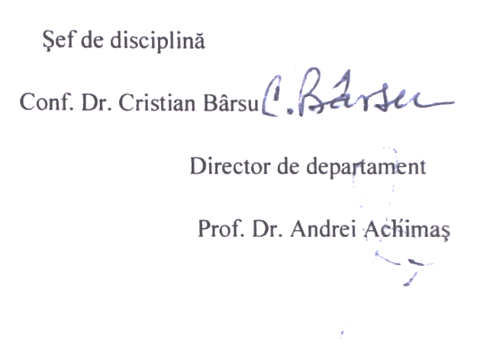     date 6 September 2017

*The filed in, signed and scanned image of this file has to be uploaded at the last step of the submission process (Step 4. Uploading Supplementary Files)*