 **Redacţia revistei**

**CLUJUL MEDICAL**

**Str. Moţilor nr. 33**

**RO-400 001 Cluj-Napoca, ROMANIA**

**Tel/Fax : 0040 - 264- 596086**

**clujulmedical@umfcluj.**

**Declaration of Conflict of Interest**

 Manuscript number …

Title BOOK REVIEW: DECANI ŞI RECTORI AI UNIVERSITǍŢII DE MEDICINǍ ŞI FARMACIE “GRIGORE T. POPA” DIN IAŞI (1879-2016) [Deans and Rectors of the

“Grigore T. Popa” University of Medicine and Pharmacy in Jassy (1879-2016) By Dana Baran

 The article has only 1 author - Cristian Bârsu

Conflict of Interest disclosure

|  |  |
| --- | --- |
| No X |  |
|  |  |

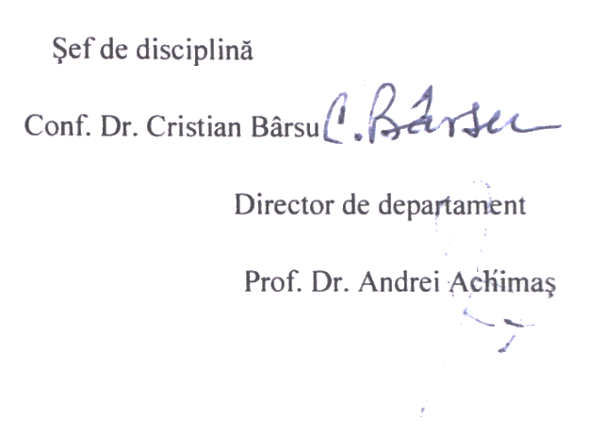 6 September 2017

(signature)             date

*The filled in, signed and scanned image of this file has to be uploaded at the last step of the submission process (Step 4. Uploading Supplementary Files)*